УДК 633.111.1
V.A. Goyenko, master student
Innovative University of Eurasia (Pavlodar, Kazakhstan Republic)
Е-mail: goenko@rubikom.kz
E.B.Nikitin, doctor of veterinary science, Professor of veterinary science, Professor of food technology
Innovative University of Eurasia (Pavlodar, Kazakhstan Republic)
Е-mail: prorpau@mail.ru

The study of nutritional values and organoleptic properties of poly-grain extruded mixture

Annotation. Among many environmental conditions that affect a person, the most important factor is nutrition. Today, there is no doubt that there is a direct link between nutrition, health and disease. Proper nutrition ensures normal growth and development of a person, contributes to the prevention of diseases, has a positive impact on life expectancy and creates conditions for adaptation to the environment. A very actual topic for public catering in the Republic of Kazakhstan, namely for fast food companies, is the development of new recipes and culinary products from relatively inexpensive vegetable raw materials, as well as qualitatively new food products with a purposefully changed chemical composition. One of the main ways of solving problems of expanding the production of products for quick service, as well as products for dietary and therapeutic and preventive nutrition is the use of sprouted grains and beans.
In this article, poly-grain mixtures of sprouted wheat and extruded soy beans in different ratios are studied and considered. Poly-grain mixtures developed by us are balanced in nutrients, vitamins and amino acids. The research was carried out on the basis of the accredited testing laboratory of RUBICOM enterprise LLP and the scientific laboratory of the Innovative Eurasian University.
The purpose of this work is to study a promising method for increasing the nutritional value of grain mixtures by extruding them at different temperature conditions. To achieve this goal, the following tasks were planned:
- to study the grain of soy beans and sprouted wheat on the organoleptic characteristics and chemical composition of the poly-grain mixture;
- examine the chemical composition of the poly-grain mixture before extrusion;
- choose the optimal mode of the extrusion process;
- study and analyze the chemical composition of poly-grain extruded mixture;
It should be noted that we have developed for the first time the optimal technological mode of extrusion of poly-grain mixture from sprouted wheat and soy beans, and the physical and chemical composition of the poly-grain mixture was studied.
The results of the research presented in this paper are the basis for the development of recipes and technologies for fast food products.
The reliability and validity of scientific statements is confirmed by the choice of modern methods of chemical composition analysis.
Key words: New types of food, poly-grain mixture, extrusion, formulation, assortment, grain raw materials, soy bean, sprouted wheat, wheat, food industry, humidity, smell, colors, weed admixture in the whole grain, testing laboratory, extruder, extruder mixing zone, catalyst, raw ash, raw protein, soluble protein.

Introduction. An important task of the modern food industry is to study and develop scientific, theoretical and practical bases for the production of new types of food. In this regard, the expansion of the range of food production is definitely a new direction. In this article, poly-grain mixtures of sprouted wheat and extruded soy beans in different ratios are studied and considered [1,2].
Materials and methods. The research was carried out on the basis of an accredited testing laboratory of RUBICOM enterprise LLP, according to the following methods of GOST: GOST 13586.5-2015 Grain. Method for determining humidity, GOST 10967-2019 Grain. Methods for determining smell and color, GOST 30483-97 Grain [3,4]
2 samples of poly-grain mixture were taken for the study. The formula of poly-grain mixtures is shown in table 1.

Table 1 - The formula of poly-grain mixtures
№ of the sample | soy beans | sprouted wheat | wheat
Sample № 1 | 30% | 50% | 20%
Sample №2 | 50% | 20% | 30%

1 sample – 30% of extruded soy bean, 20% of wheat, 50% of sprouted wheat.
2 sample – 50% of soy bean extruded, 30% of wheat, 20% of sprouted wheat.
Previously, the samples were examined for the following indicators: humidity, color, smell, and the content of weed admixture in the whole grain. Results of determination of humidity, color, smell, total and fractional content of weed and grain impurities; content of small grains and size are presented in table 2.

Table 2 - Results of research on humidity, color, smell, and weed content in the whole grain.
№ of the sample | Humidity | Color | Smell | determination of weed impurity in the whole grain
 |  |  |  | soy beans | wheat | sprouted wheat
Sample 1 | 14 | light yellow | proper | 3,8 | 1,3 | 1,8
Sample 2 | 13,8 | Light yellow | proper | 5,2 | 1,6 | 2,2

The extrusion process is a technology for producing extrudates as a result of obtaining raw materials from the feedstock under the influence of high temperatures and pressure, and then pushing it through the forming hole with a disk screw. All grains and beans, without exception, can be extruded, which leads to improvements in technological, biochemical and chemical properties. For the extrusion of grain raw materials in this experiment, a screw extruder, TRN 200D type (produced in China, Myang) was used. It consists of a drive section, a loading hopper for grain raw materials and a cylindrical shaft, inside which the auger is located in the working chamber. At the end of the housing is a head with a molding hole. The extruded grain raw material, pre-prepared, through the loading hopper, enters the working chamber, where the extrusion process takes place, and is given to the auger. Crushed grain raw materials are moved along the screw channel of the auger, additionally being able to be homogenized and crushed. This zone of the working chamber of the extruder is called the mixing zone (figure 1). The capacity of this equipment is 1200-2000 kg / hour. During extrusion, under the influence of pressure (2-3 MPa) created by the screw, the pressure of the poly-grain mixture gradually increases, and under the influence of friction of grain raw materials on the screw, its temperature increases, resulting in the process of tearing the protein structure. As a result of extrusion, a poly-grain mixture was obtained for sprouted wheat-Biosafety, for soy beans-reduction of the trypsin inhibitor and improvement of protein digestibility. The temperature of the grain mixture in the mine zone reaches 90-110°C. In the dosing zone (picture 1), the heated raw material is homogenized. The temperature of the material in the mine zone reaches 120-150°C. When it leaves the matrix under the influence of a sharp change in pressure (from 3-5 MPa to atmospheric), there is almost instantaneous evaporation of both free and part of the bound moisture, and a change in the physical structure of the poly-grain mixture, in particular, a sharp increase in its volume and porosity, which leads to the final formation of the extruded product [5,6].

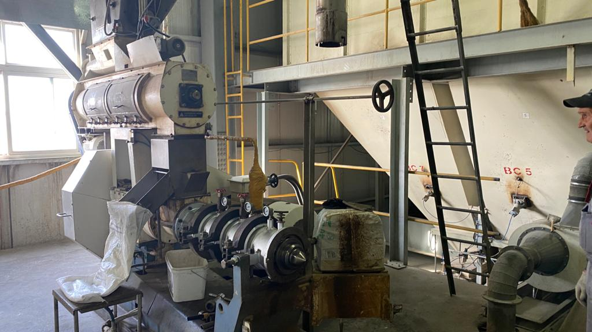

Рicture 1 – Extruder

The experiment method was as follows: pre - prepared crushed grain mixture was given to the receiving hopper of the extruder and was exposed to extrusion at several fixed values:
1-the temperature in the shaft of the mine is 120 C, the pressure is 3 MPa, the capacity is 1000 kg / hour;
2-the temperature in the shaft is 140 C, the pressure is 3 MPa, the productivity is 1800 kg / hour.
Figure 2-Results of physical and chemical studies in the mode: the temperature in the shaft of the mine is 120 C, the pressure is 3 MPa, the capacity is 1000 kg / hour.
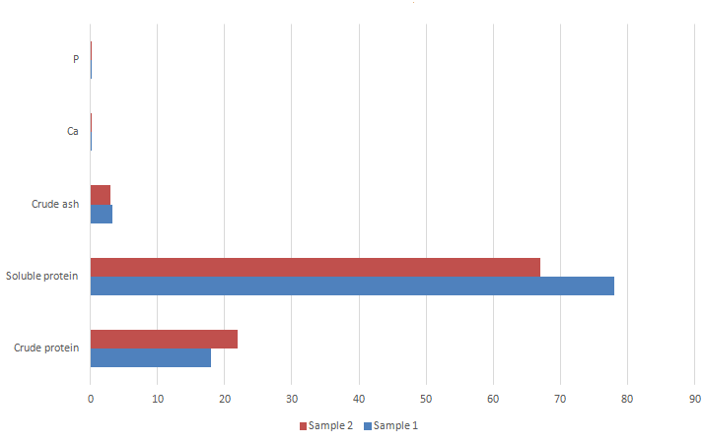

Рicture 2 - Results of physical and chemical studies in the mode: the temperature in the shaft of the mine is 120 C, the pressure is 3 MPa, the capacity is 1000 kg / hour

Studies of raw protein were conducted in accordance with GOST 32044.1-2012 (ISO 5983-1: 2005) Feed, mixed feed, feed raw materials. Determination of the mass fraction of nitrogen and calculation of the mass fraction of crude protein. The essence of the method consists in ashing of the organic matter of the sample with sulphuric acid in the presence of a catalyst, alkalization of the reaction product, distilling and titration of releasing ammonia calculate the mass fraction of nitrogen and calculation of mass fraction of crude protein by multiplying the result by the conversion factor of the mass fraction of nitrogen to mass fraction of crude protein is 6.25. Soluble protein was determined according to GOST 13979.3-68 Oil- press cake and meal.

Picture 3 - Results of physical and chemical studies in the mode: temperature in the shaft 140 C, pressure 3 MPa, productivity 1800 kg / hour
Method of determining the total mass fraction of soluble proteins: The essence of the method is in isolating water-and alkali-soluble proteins and quantify them using the Kjeldahl method. Determination of the ash indicator was carried out by testing in accordance with GOST 10847-74 Grain.
Methods for determining ash content. Ash content is called the number of mineral substances expressed in percents, remaining after the complete combustion of organic substances.
The essence of the method is in ashing of organic substances of the analyzed sample, processing of the resulting ash with a solution of hydrochloric acid, sediment of calcium in the form of oxalate.
Determination of phosphorus was carried out according to the method of GOST 26657-97, the interstate standard for feed, compound feed, feed raw materials.
Methods for determining the phosphorus content. Photometric method for determining the phosphorus content (main method). The essence of the method consists in the mineralization of the sample by dry or wet ozolization with the formation of orthophosphoric acid salts and the subsequent photometric determination of phosphorus in the form of a yellow - colored compound-heteropolyacid, formed in an acidic environment in the presence of Vanadate and molybdenum.
Results. As a result of the study, 2 types of poly-grain mixture with different content of soy beans, class 3 wheat and sprouted wheat were compiled. These samples were examined for the following indicators: humidity, color, smell, and the content of weed admixture in the whole grain. According to the results of the study, samples of wheat of class 3 and soy beans met the standards, according to GOST. These samples were exposed to extrusion process with multiple operating modes, in the result positive results on the model of poly-grain mixture No. 2 was obtained under the conditions of the technological regime – the temperature in the shaft 120 C, pressure 3 MPa, a capacity of 1000 kg/hour.
Discussion. During the extrusion process, the mixture has undergone profound changes in the structure of nutrients, which has increased its energy value and taste:
- starch gelatinizes and its digestibility increases;
- protein digestibility increases and availability of amino acids due to the destruction of secondary bonds in protein molecules;
- due to the short duration of the process, the amino acids and vitamins contained in the mixture are preserved to a greater extent; the energy value of the mixture increases due to the rupture of the walls of fat cells, the stability of fat increases;
- increases the digestibility of fiber due to attrition and crushing it during the extrusion process;
- pathogenic micro flora is destroyed;
- the taste of the finished product improves due to the decomposition of starch into simple sugars, the formation of aromatic substances, the elimination of a specific smell characteristic of soy beans, the formation of a homogeneous porous structure of the product, more accessible to the effects of enzymes.
Conclusion. Soy in its composition differs favorably from other legumes. Soy grain contains 85.6% of dry matter, including 32.0% of protein, 17.4% of fat, 5.7% of fiber and 4.6% of ash. Soy protein is a full-fledged amino acid content, and sprouted wheat is a storehouse of vitamins A, E, and B. This mixture can be used to balance diets for protein and amino acids. According to scientific research, due to intensive processing in the extruder, the carbohydrate composition changes – in the extruder, the starch content decreases by 1.6-3.2 times, the dextrin content increases by 1.5-6.2 times, and the sugar content increases by 1.2 - 2.1 times. Carried out researches have allowed to obtain basic recipe of poly-grain mixture for making product, the grain mixture of the sample 2 has the highest quality in terms of indicators , under the conditions of experiment 1. The extrudates of the poly-grain mixtures are characterized by a high content of metabolizable energy, crude protein and fat. The technological operation of extrusion allows you to process effectively new types of plant raw materials. The purpose of this study was to expand the range of extruded products of complex shapes that meet the standards of balanced nutrition.

THE LIST OF SOURCES

1 Технологии и оборудование для экструдирования растительного сырья: учеб. пособие / В.И. Пахомов, Д.В. Рудой, Т.И. Тупольских, А.Н. Соловьев, С.В. Брагинец, О.Н. Бахчевников. – Ростов-на-Дону: ДГТУ, 2018. – 108 с.
2 Технологический регламент экструдирования смеси зерновых и зеленых кормов при внутрихозяйственном приготовлении комбикормов [Электронный ресурс]. – Режим доступа: https://www.academia.edu/35491927/
3 ГОСТ 26657-97, Межгосударственный стандарт корма, комбикорма, комбикормовое сырье. Жмыхи и шроты. Метод определения суммарной массовой доли растворимых протеинов.
4 ГОСТ 32044.1-2012 (ISO 5983-1:2005) Корма, комбикорма, комбикормовое сырье.
5 Остриков А.Н., Абрамов О.В., Рудометкин А.С. Экструзия в пищевых технологиях. – СПб.: ГИОРД, 2004. – 288 с.
6 Хоренжий Н.В. Дослідження процесу екструдування комбікормів із вмістом вологих кормових трав (часть 2) // Зерновые продукты и комбикорма. – 2014. – № 2. – С. 32-37.

REFERENCES

1 Pahomov, V.I., Rudoj, D.V., Tupol'skih, T.I. et al.(2018). Tekhnologii i oborudovanie dlya ekstrudirovaniya rastitel'nogo syr'ya [Technologies and equipment for extruding plant materials]. Rostov-na-Donu. DGTU, P 108 [in Russian].
2 Tekhnologicheskiy reglament ekstrudirovaniya smesi zernovykh i zelenykh kormov pri vnutrikhozyaystvennom prigotovlenii kombikormov [The technological regulations for the extrusion of a mixture of grain and green feed during on-farm preparation of animal feed]. (n.d.). (www.academia.edu) Retrieved from https://www.academia.edu/35491927/ [in Russian].
3 Mezhgosudarstvennyj standart korma, kombikorma, kombikormovoe syr'e. Zhmyhi i shroty. Metod opredeleniya summarnoj massovoj doli rastvorimyh proteinov. GOST 26657-97 [GOST 26657-97, Interstate standard of feed, animal feed, animal feed. Cake and meal. Method for determining the total mass fraction of soluble proteins] [in Russian].
4 Korma, kombikorma, kombikormovoe syr'e. GOST 32044.1-2012 (ISO 5983-1:2005) [Feed, compound feed, compound feed raw materials. GOST 32044.1-2012 (ISO 5983-1: 2005)] [in Russian].
5 Ostrikov, A.N., Abramov O.V., Rudometkin A.S. (2004). Ekstruziya v pishchevyh tekhnologiyah [Food Extrusion]. SPb, GIORD, P 288 [in Russian].
6 Horenzhij N.V. Doslіdzhennya procesu ekstruduvannya kombіkormіv іz vmіstom vologih kormovih trav (chast' 2) (2014) [Investigation of the process of extrusion of compound feeds containing wet fodder grasses (part 2)]/ Zernovye produkty i kombikorma, 2, 32-37 [in Ukrainian].

В.А. Гоенко, магистрант
Инновациялық Еуразия университеті (Павлодар қ, Қазақстан Республикасы)
Е-mail: goenko@rubikom.kz
Е.Б. Никитин, ветеринария ғылымдарының докторы, ветеринария профессоры, азық-түлік өнімдері технологиясының профессоры
Инновациялық Еуразия университеті (Павлодар қ, Қазақстан Республикасы)
Е-mail: prorpau@mail.ru

Полизлак экструдирленген қоспаның тағамдық құндылығын және органолептикалық
қасиеттерін зерттеу

Адамға әсер ететін көптеген экологиялық жағдайлардың ішінде тамақтану факторы өте маңызды. Бүгінгі таңда тамақтану, денсаулық пен аурудың арасында тікелей байланыс бар екендігі күмән тудырмайды.
Дұрыс тамақтану адамның қалыпты өсуі мен дамуын қамтамасыз етеді, аурулардың алдын алуға ықпал етеді, өмір сүру ұзақтығына оң әсер етеді және қоршаған ортаға бейімделуге жағдай жасайды. Қазақстан Республикасының қоғамдық тамақтануындағы, атап айтқанда фаст-фуд кәсіпорындары үшін өте өзекті тақырып - салыстырмалы түрде арзан өсімдік материалдарынан жаңа рецептер мен аспаздық өнімдерді, сонымен қатар химиялық құрамы өзгерген сапалы жаңа тамақ өнімдерін жасау. Жылдам қызмет көрсету үшін өнімдер өндірісін кеңейту, сонымен қатар диеталық және емдік тамақтану өндірісін кеңейту мәселелерін шешудің негізгі әдістерінің бірі өскін дәнді және бұршақты дақылдарды пайдалану
Бұл мақалада әр түрлі пропорцияда өсірілген бидай мен экструдталған соядан алынған полислаг қоспалары зерттелді және зерттелді. Біз жасаған поли-жарма қоспалары қоректік заттарда, дәрумендерде және аминқышқылдарда теңгерімді. Зерттеулер «РУБИКОМ» ЖШС аккредиттелген сынақ зертханасы және Инновациялық Еуразия университетінің ғылыми зертханасы негізінде жүргізілді. Бұл жұмыстың мақсаты - астық қоспасын әр түрлі температура жағдайында экстрадициялау арқылы олардың қоректік құндылығын арттырудың перспективті әдісін зерттеу. Осы мақсатқа жету үшін келесі міндеттер жоспарланды:
- органолептикалық сипаттамасы және полислаг қоспасының химиялық құрамы үшін өсірілген соя бұршақтары мен бидай дәндерін зерттеу;
- экструзия алдында полислаг қоспасының химиялық құрамын зерттеу;
- экструзия процесінің оңтайлы режимін таңдаңыз;
- полислаг экструдталған қоспаның химиялық құрамын зерттеу және талдау;
Айта кету керек, біз алғаш рет полиглаг қоспасын өсірілген бидай мен соя бұршағынан бөліп алудың оңтайлы технологиялық режимін жасадық, полислаг қоспасының физика-химиялық құрамы да зерттелді.
Жұмыста ұсынылған зерттеу нәтижелері лездік аспаздық өнімдердің рецептері мен технологиясын жасауға негіз болып табылады.
Ғылыми ережелердің сенімділігі мен негізділігі химиялық құрамды талдаудың заманауи әдістерін таңдау арқылы расталады.
Түйін сөздер: Азық-түліктің жаңа түрлері, полизлак қоспасы, экструдирлеу, рецептура, ассортименті, астық шикізаты, бұршақ сояы, өскен бидай, тамақ өнеркәсібі, ылғалдық, иіс, түс, жалпы дәннің арамшөпті қоспасы, сынақ зертханасы, экструдер, экструдер араластыру аймағы, катализатор, шикі күл, шикі протеин, еритін протеин.

В.А. Гоенко, магистрант
Инновационный Евразийский университет (г. Павлодар, Республика Казахстан)
Е-mail: goenko@rubikom.kz
Е.Б. Никитин, доктор ветеринарных наук, профессор ветеринарии, профессор технологии продовольственных продуктов
Инновационный Евразийский университет (г. Павлодар, Республика Казахстан)
Е-mail: prorpau@mail.ru

Исследование пищевой ценности и органолептических свойств полизлаковой эструдированной смеси

Среди многих условий окружающей среды, которые влияют на человека, наиболее важным фактором является питание. Сегодня нет никаких сомнений в том, что существует прямая связь между питанием, здоровьем и болезнями. Правильное питание обеспечивает нормальный рост и развитие человека, способствует профилактике заболеваний, оказывает положительное влияние на продолжительность жизни и создает условия для адаптации к окружающей среде. Актуальной темой для общественного питания в Республике Казахстан, а именно для предприятий быстрого питания, является разработка новых рецептов и кулинарных изделий из относительно недорогого растительного сырья, а также качественно новых продуктов питания с целенаправленно измененным химическим составом. Одним из основных способов решения проблем расширения производства продуктов для быстрого обслуживания, а также продуктов для диетического и лечебно-профилактического питания является использование пророщенных зерен и бобов.
В статье изучены и рассмотрены полизлаковые смеси проросшей пшеницы и экструдированных соевых бобов в различных соотношениях. Разработанные нами полизлаковые смеси сбалансированы по питательным веществам, витаминам и аминокислотам. Исследование проводилось на базе аккредитованной испытательной лаборатории ТОО «Предприятие РУБИКОМ» и научной лаборатории Инновационного Евразийского университета.
Целью данной работы является изучение перспективного метода повышения питательной ценности зерновых смесей путем их экструдирования при различных температурных условиях. Для достижения этой цели были запланированы следующие задачи:
- изучить зерна соевых бобов и проросшей пшеницы по органолептическим показателям и химическому составу многозерновой смеси;
- изучить химический состав полизерновой смеси перед экструзией;
- выбрать оптимальный режим процесса экструзии;
- изучить и проанализировать химический состав многозернистой экструдированной смеси;
Следует отметить, что нами впервые разработан оптимальный технологический режим экструзии полизерновой смеси из пророщенной пшеницы и соевых бобов, а также изучен физико-химический состав полизерновой смеси.
Результаты исследований, представленные в этой статье, являются основой для разработки рецептов и технологий для продуктов быстрого приготовления.
Достоверность и обоснованность научных утверждений подтверждается выбором современных методов анализа химического состава.
Ключевые слова: Новые виды продуктов питания, полизлаковая смесь, экструдирование, рецептура, ассортимент, зерновое сырье, соя бобовая, проросшая пшеница, пшеница, пищевая промышленность, влажность, запах, цвета, сорная примесь в целом зерне, испытательная лаборатория, экструдер, зона смешивания экструдера, катализатор, сырая зола, сырой протеин, растворимый протеин.

