UDC 372.6420
MRNTI 16.01.45

A.K. Meyirbekov¹, G.B. Sarsenbek ¹* S.Kh. Apaeva²
¹Khoja Akhmet Yassawi International Kazakh-Turkish University, Kazakhstan
²Kyrgyz National University named after J. Balasagyn
*(e-mail: gulmira.sarsenbek@ayu.edu.kz)

Effectiveness of using the testing method in teaching English

Annotation
Main problem: This article provided a comprehensive description of testing method as one of the forms of control of students' knowledge of a foreign language. The article dedicated to the need to use testing as an effective way to assess knowledge in teaching English to students.
Purpose: To determine the effectiveness of the use of testing method as a tool for assessing students in foreign language teaching.
Methods:In this research work were used theoretical and empirical research methods. From theoretical methods were used analysis, qualitative, deduction, etc. methods. And from empirical methods were used quantitative, questionnaire, comparison methods.
Results and their significance: Practical significance of the work is related to the following circumstances:
At the present stage, pedagogical control of students' learning is carried out mainly in the form of testing. Testing as a method of assessing knowledge has been gaining popularity in recent years. It is the tasks in the test form that are the most clear, correct, suitable qualitative and objective way of evaluating various types of speech activity in a foreign language. It is impossible to evaluate the actions of students without various forms of control, namely testing of students.
Keywords: English, testing, effectiveness, students, method, education.

Introduction
The test (from English means "trial" and investigation") is a system of tasks that are performed and allow you to characterize the level of English language proficiency on a special results scale.
In the world, testing the quality and level of education through tests is considered a high technology. In many developed countries, the method of testing is used as an effective tool for predicting the level of training of young people and the quality of general education, which has become an integral part of modern education.
One of the ways to organize the control of students` compliance with the requirements of state standards is a test control system. It enhances students` ability to work independently, achieves effective teaching, and stimulates thinking and creativity. Textbooks identify students` education and allow them to use their time more effectively. Test tasks are created by the teacher at will, according to the topic, section. However, it is not possible to monitor the creativity of students with the help of tests. In order to achieve a full pedagogical purpose, we can see the real level of readiness of students in the learning process through all other types of testing and the development of practical, seminar lessons, abstracts, reports.
According to Bogatyrskaya, V.A., Sergushina, E.S., & Khamidullova, D.RC: "Testing should not replace traditional control methods, it should only add to the existing system to solve existing problems. One of the disadvantages of the test control method is that students have the ability to guess the correct answer. Since students provide only answer numbers, the teacher will not be able to assess the depth of knowledge and the chosen solution method. Note that this drawback covers only those tests that contain tasks for choosing the correct answer from among the proposed ones"[1].
Materials and methods
The purpose of the article is to determine the effectiveness of the use of testing method as a tool for assessing students in foreign language teaching.
Depending on the purpose of this article, the following objectives are set:
- identify the benefits of testing as a tool for assessing knowledge;
- to determine whether the use of different types of tests helps to comprehensively assess the student`s progress in learning English throughout the learning process;
- conduct research on actions that have a positive impact on the quality of education as a result of testing.
In this article were used theoretical and empirical research methods. From theoretical methods were used analysis, qualitative, deduction, etc. methods. Qualitative information on the effectiveness of testing method was collected using the qualitative method. The analytical method was used to analyze the types of tests for students. In addition, we used the deduction method to draw new conclusions from the gathered information.
And from empirical methods were used quantitative, questionnaire, comparison methods. The study was conducted using the questionnaire method. Results were given to the data obtained by the quantitative method of the study. We compared the research work of domestic and foreign scientists on testing by the method of comparison.
Phuong V. V. (2021): Testing plays a very important role in the teaching and learning process. It is considered as an integral part of any teaching process. If teaching is a process of helping learners discover “new” ideas and “new” ways of organizing what they learn, testing is an important tool to measure what learners achieve through process of teaching. Therefore, testing makes a remarkable contribution to the success of teaching and learning activities. Furthermore, tests are used not only to evaluate teaching and learning results but also to promote teaching and learning activities in such a way that it helps teacher understand his/her students’ ability, interest, attitudes and needs in order to teach and motivate them [2].
Teaching and testing are interrelated. Teachers are obliged not only to teach their students well, but also to measure their achievements accurately. Additionally, the pace of development of knowledge and skills in the language are also to be observed. In view of these facts, tests become a natural extension of classroom work providing both teachers and students with beneficial information that serves as a basis for improvement. This establishes that testing is an important part of every teaching and learning experience with advantages for both students and teachers. As far as students are concerned, tests help to create a positive attitude to learning by providing a sense of accomplishment [3].
Ibad (2019): "Other advantages are that students are encouraged to examine what they have learned and what needs to be re-learned. They also develop good methods of organization and preparation as a result of confidence in the teachers; fairness and desire to help them. These are steps towards acquiring mastery over the language. Teachers, on the other hand, are able to assess what students have learned, and the areas where they require help. They also find out the effectiveness of their teaching methods. This professional self-education helps in classifying students in terms of ability so that their future efforts can be directed to those who need help. All in all, good tests sustain or enhance class morale and aid teaches [3].
Smith M. L., Edelsky C., Draper K, Rottenberg C, Cherland M (2019): "Although schools have administered standardized tests of achievement for decades, only recently have such tests been used as instruments of social policy. Originally such tests were used to gauge the progress of pupils and compare their accomplishments with nationally representative samples. Tests also gave information about pupil achievement in relation to defined objectives. Teachers could use information from the tests to plan or modify instruction and correct deficiencies. Testing programs, including decisions about what characteristics to measure, which standardized tests to purchase, and how to use the test results were voluntary and controlled by local school districts. Testing was internal" [4].
Ramadan (2014): There are six different types of tests. They are as follow:
1. Placement test. It is used to place new students in the right class in a school. It assesses students’ productive and receptive skills. It is designed to show how good a student is in English in relation to a previously agreed system of levels.
2. Diagnostic test. It is used to discover student problems, difficulties or deficiencies in a course. We use this type of tests to know students’ strengths and weaknesses so as to be able to do something about them.
3. Progress/Achievement test. It is designed to measure students’ language and their skill progress in relation to the syllabus they have been following. This type is directly related to language courses and done during the course.
4. Final progress/achievement test. It is done at the end of the course to measure students’ achievement of the course objectives or goals.
5. Proficiency test. It is not necessarily based on certain courses that students may have previously taken. Most students take this type of tests to admit to a foreign university, get a job or obtain some kind of certificate. It is designed to measure students’ knowledge and ability in a language.
6. Aptitude test. It is designed to discover whether a student has a talent or basic ability for learning a new language or not" [5].
Such a control method as testing can be successfully applied for the current, intermediate and final testing of knowledge. With the help of tests, you can test the knowledge of students, both selectively and in general. Testing is important to consolidate, improve the acquired knowledge, skills and abilities, identify gaps in knowledge. Students of higher educational institutions are more conscious and thorough in testing their knowledge, since their training makes higher demands on their mental activity and independence.
"The testing system as an element of the system for assessing the quality of training of competitive specialists at the university should include a set of standardized test tasks and software and tools that allow:
- Objectively assess the quality of students' academic achievements and the level professional preparedness of graduates;
- To process and analyze test results for various users, identify shortcomings in the teaching methodology of certain disciplines and training of specialists;
- To determine the directions of improving the educational process at the university (Trigub, 2017) [6].
Mirolyubova (2012): "The test always presupposes measurement. The most effective form of control today is control in the form of test items. Test control in a foreign language is the level of language proficiency achieved by students for a specific period of study" [7].
In the modern educational process, the main thing is not to teach the student, but to teach him to independently acquire knowledge. This is the reason for the significant increase in the number of hours devoted to independent work in the curricula of all areas. Obviously, it is possible to count on a positive result in such an educational system only if strict quality control of students' independent work is established. The way to organize such control can be regular testing as the most important part of the educational process.
Ozherelyeva (2013) concludes that: "The use of testing allows to form in the taught systematic approach to the task, to consolidate the basic and professional knowledge obtained by the lecture-seminar method, to acquire skills to work in the production team" [8].
Results and discussion
The research was conducted through a questionnaire. A total of 30 respondents participated in the study, of which 20% (6) were men and 80% (24) were women. 16 people aged 16-25, 7 people aged 26-35, 4 people aged 36-45 participated. Also, the number of respondents over 45 years was 3 people.
During the study, students were given a test consisting of 8 questions. In accordance with the instructions, it was recommended to choose one of 4 answers ("agree", "completely agree", "disagree", "completely disagree") to the comments given in the test. Respondents' responses showed the following results (Table 1).

Table 1- Questionnaire results for research testing as an assessment tool

 | Testing is one of the most important tools for testing students' knowledge and language skills | I do not think that the test method is more effective than other methods of control and evaluation |  | I do not think that this type of knowledge assessment can measure the actual progress of students | In my opinion, testing can be used not only for control and verification, but also during training | The purpose of the test is to help students to master the grammar of the English language and thus teach them to speak and write English correctly | The use of different types of tests in teaching a foreign language to students increases their interest in learning a foreign language | I think that the test in English lessons is a very effective way to monitor the level of speaking, reading and writing | In my opinion, the most effective tests for teaching foreign languages in high school are listening tests, because listening to a foreign language is very important in order to learn to speak a foreign language
agree | 17 |  | 8 | 7 | 19 | 17 | 16 | 16 | 19
completely agree | 3 |  | 2 | 4 | 6 | 5 | 7 | 7 | 7
disagree | 6 |  | 14 | 12 | 2 | 5 | 4 | 4 | 2
completely disagree | 4 |  | 7 | 8 | 4 | 4 | 4 | 4 | 3

Among respondents, 17 people (57%) considered testing as one of the most important tools for monitoring students' knowledge and language skills, and 6 students (20%) did not consider testing as a tool for assessing knowledge. And 3 respondents (10%) completely agreed with this opinion, 4 respondents (13%) completely disagreed with this opinion (Figure 1).

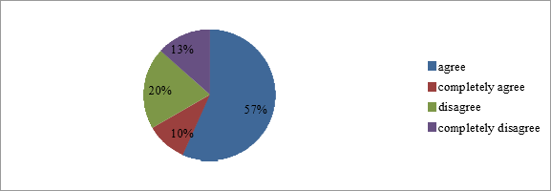

Figure 1 - Testing is one of the most important tools for testing students' knowledge and language skills

The vast majority of respondents (45.20%) disagreed with the opinion that the testing method is more effective than other control and evaluation methods (Figure 2). Similarly, 22.6% of respondents do not fully agree with this negative opinion. And while 8 people considered testing to be more effective than other methods, 2 people (6.5%) agreed with this opinion.

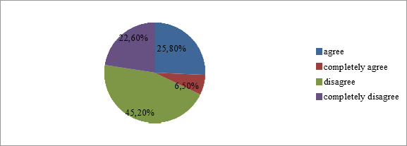

Figure 2 - I do not think that the test method is more effective than other methods of control and evaluation

One of the main disadvantages of testing is that it does not accurately reflect the progress of students in learning English. 7 respondents agreed with this opinion, while 12 respondents disagreed. Also, the number of respondents who fully agreed was 4 people, on the contrary, the number of respondents who did not fully agree with this statement was 8 people (Figure 3).

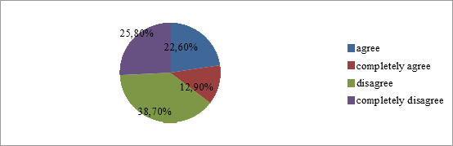

Figure 3 - I do not think that this type of knowledge assessment can measure the actual progress of students

According to 19 respondents, testing can be used not only for monitoring and approval, but also during training. Similarly, 6 respondents fully agreed with this opinion. However, 2 respondents believe that testing should be used only for monitoring and approval (Figure 4).

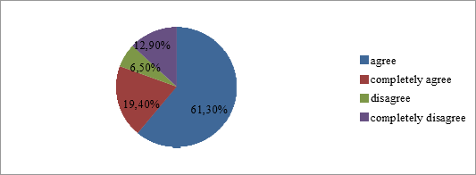

Figure 4 - In my opinion, testing can be used not only for control and verification, but also during training

According to 17 respondents, the purpose of the test is to help them learn English grammar and thus teach them to write and speak English correctly. The number of respondents who disagreed with this opinion was 5 people (Figure5).

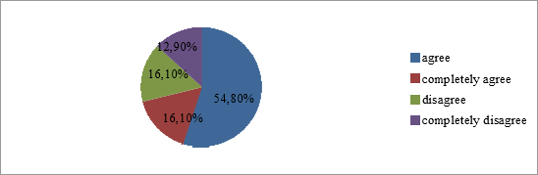

Figure 5 - The purpose of the test is to help students to master the grammar of the English language and thus teach them to speak and write English correctly

51.6% of respondents generally agree, and 22.6% fully agree that the use of different types of tests in teaching a foreign language to students increases their interest in learning a foreign language (Figure 6). At the same time, 12.9% of respondents disagree with this conclusion, saying that the use of different types of tests does not increase students' interest in learning a foreign language.

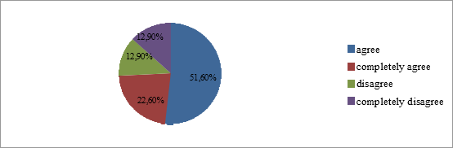

Figure 6 - The use of different types of tests in teaching a foreign language to students increases their interest in learning a foreign language

"I think that the test in English lessons is a very effective way to monitor the level of speaking, reading and writing". The number of respondents who disagreed with this opinion was 4 people (12.9%), and 16 people (51.6%) disagreed with this conclusion (Figure 7).

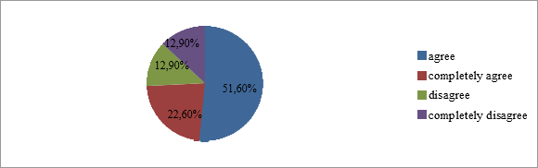

Figure 7 - I think that the test in English lessons is a very effective way to monitor the level of speaking, reading and writing

In my opinion, the most effective tests for teaching foreign languages in high school are listening tests, because listening to a foreign language is very important in order to learn to speak a foreign language. 61.3% of respondents agreed with the above opinion, while 6.5% disagreed with it (Figure 8).

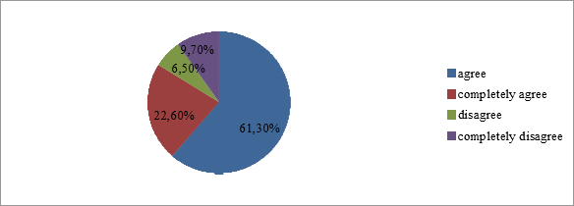

Figure 8 - In my opinion, the most effective tests for teaching foreign languages in high school are listening tests, because listening to a foreign language is very important in order to learn to speak a foreign language

The results of the article show that the use of testing in English lessons is one of the most effective methods.
Systematic use of scientifically based and correctly compiled test tasks will improve the quality of learning, the formation and development of students ' qualities of time-saving, quick thinking, concentration and rational decision-making, correct game design, and the ability to work independently. Of course, control through the test will have to be carried out in combination (in combination) with other traditional (oral, written, etc.) control works in accordance with the specifics of the specialty and discipline. Only then will the effectiveness of the testing method in teaching increase. The more we use different forms of testing in accordance with the specifics of the subject, specific chapter and topic and the current level of knowledge of students, the more significant its positive results will be, which will affect the quality of teaching and learning. Only then will the advantages and effective opportunities of testing be revealed, and the objectivity of control and evaluation will be ensured. As a result, the level of quality of training and education will definitely improve significantly [9].
In comparison with other test works, the advantage of the test is that it is objective, reliable, and has many variations. There must be several variants of the test. This increases the effectiveness of verification, as it is impossible to remember, remember, or copy the entire task. Test tasks are effective not only as a control, but also for teaching and practicing students [10] .
Conclusion
Summing up all of the above, we can conclude that tests are of high importance in mastering a foreign language, especially at the stage of consolidation and control of the studied material. The role of testing as an effective method of quality control of training of students is shown. The types of tests, functions were identified, as well as an analysis of the difficulties encountered in the development and use of tests. Moreover, we studied the methodological foundations of test development. Analysis of methodological literature made it possible to learn and appreciate the importance of testing. Research has shown that testing, one of the most important types of exercises is an effective way to develop various types of skills. Therefore, we come to the conclusion that the tests:
- contribute to faster memorization of both grammatical and lexical materials;
- help to form a general idea of the grammatical structure of the language;
- allow you to better form all types of speech activity - speaking, reading, writing, listening;
- make it possible to monitor the level of formation of general skills of students in a foreign language.
This study can be an effective guide for secondary school English teachers in assessing students' knowledge in the classroom.

LIST OF SOURCES
1 Богатырская В. А, Сергушина Е. С, Хамидуллова Д. Р. Особенности применения тестирования как метода педагогического контроля знаний студентов в образовательном процессе //Концепт. – 2019. – №. V1. – С. 7-12. URL: https://cyberleninka.ru/article/n/osobennosti-primeneniya-testirovaniya-kak-metoda-pedagogicheskogo-kontrolya-znaniy-studentov-v-obrazovatelnom-protsesse
2 Phuong V. V. THE IMPORTANT ROLE OF TESTING IN ENGLISH TEACHING AND LEARNING PROCESS IN VIETNAM // International Journal of Innovation Scientific Research and Review. - 2021. Vol. 03, Issue, 01, pp.688-694
3 Ibad F. Testing in English Language Teaching. - 2019. URL: https://www.researchgate.net/publication/332353298_Testing_in_English_Language_Teaching
4 Smith M. L., Edelsky C., Draper K, Rottenberg C, Cherland M. The role of testing in elementary schools. – 2019. URL: https://cresst.org/publications/cresst-publication-2695/
5 Ramadan M. Recognize The 8 Kinds Of Language Testing & The 6 Types Of Tests // English Language Teaching & Testing Guide. - 2020. URL: https://elttguide.com/8-kinds-of-testing-6-types-of-tests/
6 Тригуб Г. Я. Тестирование как метод обучения и контроля знаний в вузе // Концепт. – 2017. – №. S3. URL: https://cyberleninka.ru/article/n/testirovanie-kak-metod-obucheniya-i-kontrolya-znaniy-v-vuze/viewer
7 Миролюбова А. А. Вопросы контроля обученности учащихся иностранному языку : Метод. пособие / Рос. акад. образования. Ин-т общ. сред. образования. - Обнинск : Титул. - 2012. - 79 с. URL: https://search.rsl.ru/ru/record/01000906099
8 Ожерельева А. Т. Развитие методов тестирования // ПНиО. 2013. №6. URL: https://cyberleninka.ru/article/n/razvitie-metodov-testirovaniya
9 Сабенова Б.Қ. Оқушы білімін бағалауда тест тапсырмаларын қолдану: мақала. - 2015 URL: https://erketai.kz/informatika/okushi-bilimin-bagalauda-test-tapsirmalarin-koldanu/
10 Абдунабиева З.М. Тест әдісі, тесттің негізгі түрлері, мәліметтерді жинақтау және интерпретация: сабақ жоспары. - 2020. URL: https://kopilkaurokov.ru/prochee/prochee/test_disi_testtin_negizgi_turleri_m_limetterdi_zhinaktau_zh_ne_interpretatsiia

REFERENCE
1 Bogatyrskaya V. A, Sergushina E. S, Hamidullova D. R. (2019). Osobennosti primeneniya testirovaniya kak metoda pedagogicheskogo kontrolya znanij studentov v obrazovatel'nom processe [Features of the use of testing as a method of pedagogical control of students' knowledge in the educational process]. Koncept – Concept,1, 7-12. Retrieved from https://cyberleninka.ru/article/n/osobennosti-primeneniya-testirovaniya-kak-metoda-pedagogicheskogo-kontrolya-znaniy-studentov-v-obrazovatelnom-protsesse [in Russian].
2 Phuong V. V. (2021). Vazhnaya rol' testirovaniya v processe prepodavaniya i izucheniya anglijskogo yazyka vo V'etname [The important role of testing in English teaching and learning process in Vietnam]. International Journal of Innovation Scientific Research and Review, 03, 01, 688-694. [in English].
3 Ibad F. (2019). Testirovanie v prepodavanii anglijskogo yazyka [Testing in English Language Teaching]. Retrieved from https://www.researchgate.net/publication/332353298_Testing_in_English_Language_Teaching [in English].
4 Smith M. L., Edelsky C., Draper K, Rottenberg C, Cherland M. (2019). Rol' testirovaniya v nachal'nyh shkolah [The role of testing in elementary schools]. Retrieved https://cresst.org/publications/cresst-publication-2695/. [in English].
5 Ramadan M. Recognize (2020). 8 vidov yazykovogo testirovaniya i 6 tipov testov [The 8 Kinds Of Language Testing & The 6 Types Of Tests]. Retrieved from https://elttguide.com/8-kinds-of-testing-6-types-of-tests/. [in English].
6 Trigub G. YA. (2017). Testirovanie kak metod obucheniya i kontrolya znanij v vuze [Testing as a method of teaching and monitoring knowledge at a university]. Koncept – Concept, S3. Retrieved from https://cyberleninka.ru/article/n/testirovanie-kak-metod-obucheniya-i-kontrolya-znaniy-v-vuze/viewer [in Russian].
7 Mirolyubova A. A. (2012). Voprosy kontrolya obuchennosti uchashchihsya inostrannomu yazyku : Metod. Posobie [Issues of monitoring students' learning of a foreign language]. Obninsk: Titul. Retrieved from https://search.rsl.ru/ru/record/01000906099. [in Russian].
8 Ozherel'eva A. T. (2013). Razvitie metodov testirovaniya [Development of testing methods]. Retrieved from https://cyberleninka.ru/article/n/razvitie-metodov-testirovaniya [in Russian].
9 Sabenova B.Q. (2015). Oquşy bılımın bağalauda test tapsyrmalaryn qoldanu: maqala [Application of test tasks in the assessment of students' knowledge]. Retrieved from https://erketai.kz/informatika/okushi-bilimin-bagalauda-test-tapsirmalarin-koldanu/ [in Kazakh].
10 Abdunabieva Z.M. (2020). Test ädısı, testtıñ negızgı türlerı, mälımetterdı jinaqtau jäne interpretasia: sabaq jospary [Test method, main types of test, data collection and interpretation: lesson plan]. Retrieved from https://kopilkaurokov.ru/prochee/prochee/test_disi_testtin_negizgi_turleri_m_limetterdi_zhinaktau_zh_ne_interpretatsiia [ in Kazakh].

А. Қ. Мейрбеков¹ , Г. Б. Сәрсенбек¹ *, С.Х Апаева²
¹ Қожа Ахмет Ясауи атындағы Халықаралық қазақ-түрік университеті, Қазақстан
²Ж.Баласағын атындағы Қырғыз ұлттық университетінің, Қырғызстан

Ағылшын тілін оқытуда тестілеу әдісін қолданудың тиімділігі

Негізгі мәселе: бұл мақалада студенттердің шет тілі бойынша білімін бақылаудың бір түрі ретінде тестілеу әдісінің жан-жақты сипаттамасы берілген. Мақала студенттерге ағылшын тілін оқытуда білімді бағалаудың тиімді әдісі ретінде тестілеуді қолдану қажеттілігіне арналған. Тестілеу әдісі туралы отандық және шетелдік ғалымдардың пікірлері келтірілген. Шет тілін оқытуда қолданылатын тест түрлері және оларды қолдану мақсаты қарастырылған. Осы зерттеу жұмысының тақырыбы бойынша алынған сауалнама нәтижелері көрсетілген.
Мақсаты: шет тілін оқытуда студенттерді бағалау құралы ретінде тестілеу әдісін қолданудың тиімділігін анықтау.
Әдістері: бұл зерттеу жұмысында теориялық және эмпирикалық зерттеу әдістері қолданылған. Теориялық әдістерден анализдеу, сапалық, дедуктивті және т.б. әдістер қолданылған. Ал эмпирикалық әдістерден сандық, сауалнама, салыстыру әдістері қолданылған.
Нәтижелер және олардың маңыздылығы: жұмыстың практикалық маңыздылығы келесі жағдайларға байланысты:
Қазіргі кезеңде студенттерді оқытуға педагогикалық бақылау негізінен тестілеу түрінде жүзеге асырылады. Білімді бағалау әдісі ретінде тестілеу соңғы жылдары танымал бола бастады. Бұл шет тіліндегі сөйлеу әрекетінің әр түрлі түрлерін бағалаудың ең түсінікті, дұрыс, қолайлы, сапалы және объективті әдісі болып табылатын тест түріндегі тапсырмалар. Әр түрлі бақылау формаларынсыз, атап айтқанда студенттерді тестілеусіз студенттердің іс-әрекеттерін бағалау мүмкін емес.
Зерттеу нәтижелерін тиімді оқыту технологияларын дамытуда болашақ ағылшын тілі мұғалімдеріне нұсқаулық ретінде пайдалануға болады.
Түйін сөздер: ағылшын тілі, тестілеу, тиімділік, студенттер, әдіс, білім.

А. К. Мейрбеков¹ , Г. Б. Сарсенбек¹*, С.Х Апаева²
¹ Международный казахско-турецкий университет имени Ходжи Ахмеда Ясави, Казахстан
²Кыргызский национальный университет им.Ж Баласагына, Кыргызстан
Эффективность использования метода тестирования в обучении английскому языку

Основная проблема: В данной статье представлено всестороннее описание метода тестирования как одной из форм контроля знаний студентов по иностранному языку. Статья посвящена необходимости использования тестирования как эффективного способа оценки знаний при обучении студентов английскому языку. Приведены мнения отечественных и зарубежных ученых о методе тестирования. Рассмотрены виды тестов, используемых при обучении иностранному языку, и цель их применения. Показаны результаты анкетирования, полученные по теме данной исследовательской работы.
Цель: Определить эффективность использования метода тестирования как инструмента оценки студентов при обучении иностранному языку.
Методы: В данной исследовательской работе были использованы теоретические и эмпирические методы исследования. Из теоретических методов были использованы анализирование, качественные, дедуктивные и др. методы. А из эмпирических методов были использованы количественные, анкетирование, сравнительные методы.
Результаты и их значимость: Практическая значимость работы связана со следующими обстоятельствами:
На современном этапе педагогический контроль за обучением студентов осуществляется в основном в форме тестирования. Тестирование как метод оценки знаний набирает популярность в последние годы. Именно задания в тестовой форме являются наиболее понятным, правильным, подходящим качественным и объективным способом оценки различных видов речевой деятельности на иностранном языке. Невозможно оценить действия студентов без различных форм контроля, а именно тестирования студентов.
Результаты исследования могут быть использованы в качестве руководства для будущих учителей английского языка при разработке эффективных технологий обучения.
Ключевые слова: английский язык, тестирование, эффективность, студенты, метод, образование.

Information about authors:

Мейрбеков А.Қ. - PhD, Қожа Ахмет Ясауи атындағы Халықаралық қазақ-түрік университетінің доценті м.а. Түркістан қ., Қазақстан.
Мейрбеков А.К. - PhD, и.о. доцента Международного казахско-турецкого университета имени Ходжи Ахмеда Ясави, г. Туркестан, Казахстан.
Meyirbekov A.K. - PhD, Acting Associate Professor, Khoja Akhmet Yassawi International Kazakh-Turkish University, Turkistan c., Kazakhstan.
E-mail: akylbek.meyirbekov@ayu.edu.kz

Сәрсенбек Г.Б. - Қожа Ахмет Ясауи атындағы Халықаралық қазақ-түрік университетінің магистранты, Түркістан қ., Қазақстан.
Сарсенбек Г.Б. - Магистрант Международного казахско-турецкого университета имени Ходжи Ахмеда Ясави, г. Туркестан, Казахстан.
Sarsenbek G.B. - Master student of the Khoja Akhmet Yassawi International Kazakh-Turkish University, Turkistan c., Kazakhstan.
E-mail: gulmira.sarsenbek@ayu.edu.kz

Апаева С. Х. - филология ғылымдарының кандидаты, Ж.Баласағын атындағы Қырғыз ұлттық университетінің доценті, Бішкек қ., Қырғызстан.
Апаева С. Х. - кандидат филологических наук, доцент Кыргызского национального университета им.Ж Баласагына, г. Бишкек, Кыргызстан.
Apaeva S. Kh. - Candidate of Philological Sciences, Associate Professor of the Kyrgyz National University named after J. Balasagyn, Bishkek, Kyrgyzstan.
E-mail: apaeva.sofya@mail.ru

Дата поступления рукописи в редакцию:

