**UDC: 372.6420**

**IRSTI: 16.01.45**

**G.B. Sarsenbek 1*, A.K. Meyirbekov1**

1Khoja Akhmet Yassawi International Kazakh-Turkish University, Kazakhstan

*(e-mail: [gulmira.sarsenbek@ayu.edu.kz)](mailto:gulmira.sarsenbek@ayu.edu.kz)

**Tests as a means of controlling the knowledge of high school students in English lessons**

**Annotation**

*Main problem:* This article provided a comprehensive description of testing method as one of the forms of control of students' knowledge of a foreign language. The article dedicated to the need to use testing as an effective way to assess knowledge in teaching English to students. The views of domestic and foreign scientists on the method of testing are given. The types of tests used in teaching a foreign language and the purpose of their application are considered. The results of the questionnaire obtained on the topic of this research paper are shown.

*Purpose:* To determine the effectiveness of the use of testing method as a tool for assessing students in foreign language teaching.

*Methods:*In this research work were used theoretical and empirical research methods. From theoretical methods were used analysis, qualitative, deduction, etc. methods. And from empirical methods were used quantitative, questionnaire, comparison methods.

*Results and their significance:* Practical significance of the work is related to the following circumstances:

At the present stage, pedagogical control of students' learning is carried out mainly in the form of testing. Testing as a method of assessing knowledge has been gaining popularity in recent years. It is the tasks in the test form that are the most clear, correct, suitable qualitative and objective way of evaluating various types of speech activity in a foreign language. It is impossible to evaluate the actions of students without various forms of control, namely testing of students.

The results of research can be used as a guide for future teachers of English in the development of effective teaching technologies.

*Keywords:* English,testing, effectiveness, students, method, education.

**Introduction**

One of the most effective means of control in the teaching of AI is considered to be a test. Numerous publications in the journal "Foreign Languages at School" are devoted to the use of tests.

The main difference between the test and the traditional control work is that it always involves measurement. Therefore, the assessment made based on the results of testing is more objective and independent of the possible subjectivism of the teacher than the assessment for the performance of traditional control work, which is always subjective, because it is based on the impression of the teacher, not always free from his personal likes or dislikes in relation to this or that student.

The main distinguishing feature of the test is the objectivity guaranteed by measurement, whose function is to provide quantitative information.

It is possible to maximize the reliability of measurement and the validity of the use of the test if you follow the three main stages of its creation: 1) give clear and unambiguous theoretical - scientifically-based definitions of the skills to be measured; 2) accurately establish the conditions and operations to be followed when conducting the test and monitoring its implementation; 3) quantify the results of observations in order to make sure that the measuring scales used have all the necessary qualities.

There are various definitions of the concept of "test" - from almost any type of control task to a set of tasks of the "multiple choice" type. In the foreign practice of language testing, differences in the interpretation of the concept of test are presented as differences between the concepts of "control work" in general as the basis of an evaluative judgment and "control work", involving a specially organized measurement of the knowledge (skills, skills) of interest to us.

The quality of any measuring instrument, including a test, is determined primarily by the indicators of its reliability and validity.

The reliability indicator indicates how consistent the results of these measurements are.

A valid test will be considered to measure the level of development of those (and only those) skills, skills, knowledge, for which it was intended by the compilers to measure.

Validity will determine the validity of the interpretation of the test results. Obviously, the use of a certain test for purposes for which it was not intended, when compiled, will automatically make it invalid.

Testing in training is carried out to identify 1) the level of achievement in a certain type of activity; 2) abilities for a certain type of activity; 3) difficulties in mastering a particular type of activity and possible ways to overcome them.

Tests can be final or intermediate (thematic).

Final tests are designed to objectively confirm the level of learning achieved by students. The thematic test is designed to help improve the educational process itself.

According to the definition of S. K. Folomkina, the test refers to tasks that have a specific organization that allows all students to work simultaneously in the same conditions and record the execution of symbols.

Test tasks always have an unambiguous solution, the correctness of the answer is determined by the prepared key. The use of tests in control is advisable because they set the direction of students' mental activity, teach them to vary the process of processing perceived information.

Test control in the process of learning a foreign language

Systematic testing stimulates the activity and attention of students in the classroom, increases their responsibility when performing educational tasks.

**Materials and methods**

In this research work were used theoretical and empirical research methods. From theoretical methods were used analysis, qualitative, deduction, etc. methods. And from empirical methods were used quantitative, questionnaire, comparison methods.

The test results are analyzed by the teacher and serve for him, on the one hand, as an indicator of the level of knowledge of students, and on the other hand, as a self-assessment of the work of the teacher himself, which allows him to make the necessary adjustments in the learning process and thereby prevent the repetition of mistakes of schoolchildren. For the purpose of prevention, students write down possible typical mistakes in special notebooks, supplementing this with rules (in Russian) explaining a particular grammatical structure, and several, the most characteristic and clear examples of its use in speech.

Most tests have several options. In this case, the teacher prepares handouts for long-term use with assignments. In one case, the task is dictated or recorded on the blackboard. It is recommended to work with the test 10-15 minutes before the end of the lesson [1].

So, the test allows you to check all the students of the class / group at the same time; the test takes a little time, which makes it possible to conduct it in almost any lesson; when performing the test, all students are put in equal conditions — they work at the same time with the same volume and complexity of the material, which eliminates the impact on the assessment of their there is no such factor as luck / bad luck; the test makes it possible to include a large amount of material and control not only its assimilation, but also the presence of individual skills to use it.

The listed and some other characteristics of the tests, of course, indicate the expediency of their use in the educational process.

Tests that perform a controlling function include two main types: tests that check whether students have a certain level of communicative competence (proficiency tests), and tests that check students' mastery of specific language material and individual speech skills over a certain period of study (achievement tests). In secondary school, the first type of test can be correlated with the final control carried out at the end of the course of study, the second type — with the intermediate final control carried out at the end of a certain cycle of classes. These types of tests have been studied in detail in theoretical terms and are widely used in foreign practice of teaching foreign languages.

Of course, the test cannot yet replace such, for example, a form of final control as exams. However, it can be successfully used as one of the forms of intermediate final control, carried out, for example, at the end of a cycle of classes (achievement tests).

This form of verification, if it is of a regular nature, teaches students to be responsible for the entire material of the cycle, which contributes to the success of their training, since a test designed for 10-15 minutes of execution can cover all the material studied during the appropriate time and check all students. From this point of view, the test is a very effective and economical means of control. It should also be borne in mind that checking 30-40 tests by key will not take the teacher more than 5-7 minutes. As already noted, at present there is a very clear tendency to use tests in the teaching function, i.e. in the process of mastering language material, individual speech skills, various types of listening and reading by students. The assignment of this function to tests seems justified and promising for the following reasons.

First of all, the very nature of the test tasks and their organization inherently correspond to the purpose of the exercise. Choosing an answer from a number of proposed ones, combining language units by any attribute, determining the presence or absence of any feature in language units, restoring the whole from its parts — all these are types of work based on analytical operations aimed at identifying differential features of the trained unit, and the latter, as is known, they form the basis for memorizing language material.

Training tests make it possible to contrast a language unit for each of these features, which is difficult to provide with any other types of exercises. In other words, training tests make it possible to "process" the corresponding unit according to all its features without much time. Thus, the very characteristic of the test that casts doubt on the "purity" of control — the possibility of comparing differential signs of similar answer options - constitutes the educational value of the test as an exercise. Placing the studied unit in the position of being chosen, then rejected on one or another basis makes it possible not only to repeat it many times, but also to use both arbitrary and involuntary attention for memorizing it. The organization of the test allows you to gradually reduce the time of its execution. This, in fact, means that it is possible to work on speeding up analysis operations, their folding, i.e. to achieve automation of recognition processes. The latter is very important, since in the arsenal of the technique there are a small number of types of exercises that allow you to automate these processes.

With the development of individual skills (from among the established ones), which are associated with the semantic processing of information perceived by ear or in the process of reading, the nature and organization of test tasks provide for the training of each skill in an isolated form from other skills on excerpts / paragraphs of various construction.

Finally, learning tests allow to a certain extent to control the mental activity of the student while listening or reading the text.

As practice shows, the setting given by the teacher before listening to speech or reading a text is often insufficient to have a significant impact on the nature of the student's mental activity. The installation must necessarily be supported by an appropriate form of control of listening/reading comprehension, because - and this also shows practice — the student listens or reads as he is then tested. That is why the use of the test, which indicates what is important for understanding in a particular setting, teaches students to vary the process of processing perceived information depending on the goal, i.e. to use different types of listening and reading. The examples given, in my opinion, are enough to show that the range of application of tests in the training function is quite wide, and their educational value is beyond doubt. It goes without saying that in the learning process, these tests, in which the answer is actually suggested, should be followed by similar non-test exercises that provide for independent problem solving by students.

In other words, training tests represent an important intermediate stage in the work on mastering language material, developing speech skills, mastering various types of listening and reading. Two possible functions of tests in the educational process were considered — controlling and training.

Tests that implement a particular function are similar in appearance, but have different tasks, and therefore different requirements are imposed on their content and conduct. So, for example, the control test is characterized by a single repetition of the unit under test, contrasting it with other units only on one basis, placing it necessarily as the desired one, one-time execution of the test, etc.; for a training test, repeated repetition of the same unit, contrasting it with other units on different grounds, placing it in the position of being sought, then rejected, repeatedly performing the same test (to achieve the desired speed of recognition), etc. are typical. This indicates that the use of tests in teaching practice is justified, however, both in theoretical research and in the preparation of tests, their two functions should be clearly distinguished in order to use their real possibilities to improve the effectiveness of the educational process. It also seems necessary to have a special, focused study of the issues related to testing. Training tests need special study — determining the requirements for them, establishing their place in the general system of exercises for the development of a particular type of speech activity, determining the educational effectiveness of certain types of tests and other issues should attract the attention of both methodologists and practical teachers [2].

It should be noted that the principle of expediency of using various methods and forms of education should be used in the educational process of a higher educational institution. Access to computer programs is possible only in situations where they provide knowledge that is impossible or difficult enough to obtain with the help of other technologies. The quality of training of a future specialist should be checked according to the degree of readiness to solve problems on specific topics and sections of the program. And testing is one of the most effective tools for monitoring learning outcomes. But it should be borne in mind that testing is an ambiguous and complex process. Achieving a unified assessment of students' knowledge is difficult to achieve, since the level of training of students varies significantly. Therefore, it is premature to make testing the main element of pedagogical control. It is more effective to combine the classical method of oral response with various types of computer testing [3].

Testing increases the objectivity of knowledge assessment in comparison with an oral survey, since in this case the subjective factor is excluded. Objectivity is achieved by standardizing the verification of the quality indicators of tasks and tests. The complexity of assessing students' academic performance is generated by the inconsistency of approaches and methods of assessing knowledge, as well as the fact that the same methods are used by different teachers with varying degrees of accuracy and conscientiousness. A number of problems are associated with the assessment of students' cognitive progress. These are misunderstandings and discontent among students when grading, sometimes overstated requirements, the presence of unclear testing instructions, unclear wording of questions, sometimes misunderstood terminology by students, the influence of personal likes and dislikes on grading, irregular information of students about their academic performance, etc. The use of testing helps to eliminate misunderstandings and discontent among students. It is well known that some teachers have to work with full dedication to get a high grade. For other teachers, it is enough to make only a minimum of effort. In any case, achieving academic goals should be a difficult but feasible task for the student. Every teacher should strive to achieve the "golden mean". The use of testing allows you to make the process of evaluating students completely unified [3].

**Results and discussion**

The research was conducted through a questionnaire. A total of 30 respondents participated in the survey, of which 20% (6) were men and 80% (24) were women. 16 people aged 16-25, 7 people aged 26-35, 4 people aged 36-45 participated. Also, the number of respondents over 45 years was 3 people.

During the survey, students were given a test consisting of 8 questions. In accordance with the instructions, it was recommended to choose one of 4 answers ("agree", "completely agree", "disagree", "completely disagree") to the comments given in the test. Respondents' responses showed the following results (Table 1).

**Table 1-** Questionnaire results for research testing as an assessment tool

|  |  |  |  |  |  |  |  |  |
| --- | --- | --- | --- | --- | --- | --- | --- | --- |
|  | Testing is one of the most important tools for testing students' knowledge and language skills | I do not think that the test method is more effective than other methods of control and evaluation | I do not think that this type of knowledge assessment can measure the actual progress of students | In my opinion, testing can be used not only for control and verification, but also during training | The purpose of the test is to help students to master the grammar of the English language and thus teach them to speak and write English correctly | The use of different types of tests in teaching a foreign language to students increases their interest in learning a foreign language | I think that the test in English lessons is a very effective way to monitor the level of speaking, reading and writing | In my opinion, the most effective tests for teaching foreign languages in high school are listening tests, because listening to a foreign language is very important in order to learn to speak a foreign language |
| agree | 17 | 8 | 7 | 19 | 17 | 16 | 16 | 19 |
| completely agree | 3 | 2 | 4 | 6 | 5 | 7 | 7 | 7 |
| disagree | 6 | 14 | 12 | 2 | 5 | 4 | 4 | 2 |
| completely disagree | 4 | 7 | 8 | 4 | 4 | 4 | 4 | 3 |

Among respondents, 17 people (57%) considered testing as one of the most important tools for monitoring students' knowledge and language skills, and 6 students (20%) did not consider testing as a tool for assessing knowledge. And 3 respondents (10%) completely agreed with this opinion, 4 respondents (13%) completely disagreed with this opinion (Figure 1).

**Figure 1** - Testing is one of the most important tools for testing students' knowledge and language skills

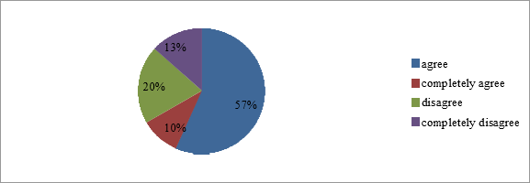

The vast majority of respondents (45.20%) disagreed with the opinion that the testing method is more effective than other control and evaluation methods (Figure 2). Similarly, 22.6% of respondents do not fully agree with this negative opinion. And while 8 people considered testing to be more effective than other methods, 2 people (6.5%) agreed with this opinion.

**Figure 2** - I do not think that the test method is more effective than other methods of control and evaluation

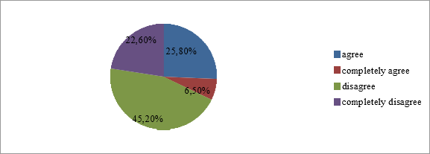

One of the main disadvantages of testing is that it does not accurately reflect the progress of students in learning English. 7 respondents agreed with this opinion, while 12 respondents disagreed. Also, the number of respondents who fully agreed was 4 people, on the contrary, the number of respondents who did not fully agree with this statement was 8 people (Figure 3).

**Figure 3** - I do not think that this type of knowledge assessment can measure the actual progress of students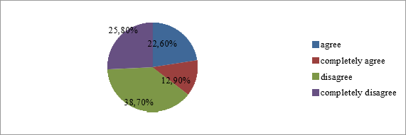

According to 19 respondents, testing can be used not only for monitoring and approval, but also during training. Similarly, 6 respondents fully agreed with this opinion. However, 2 respondents believe that testing should be used only for monitoring and approval (Figure 4).

**Figure 4** - In my opinion, testing can be used not only for control and verification, but also during training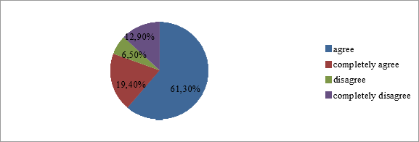

According to 17 respondents, the purpose of the test is to help them learn English grammar and thus teach them to write and speak English correctly. The number of respondents who disagreed with this opinion was 5 people (Figure5).

**Figure 5** - The purpose of the test is to help students to master the grammar of the English language and thus teach them to speak and write English correctly

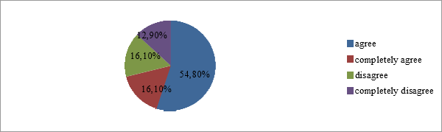

51.6% of respondents generally agree, and 22.6% fully agree that the use of different types of tests in teaching a foreign language to students increases their interest in learning a foreign language (Figure 6). At the same time, 12.9% of respondents disagree with this conclusion, saying that the use of different types of tests does not increase students' interest in learning a foreign language.

**Figure 6** - The use of different types of tests in teaching a foreign language to students increases their interest in learning a foreign language

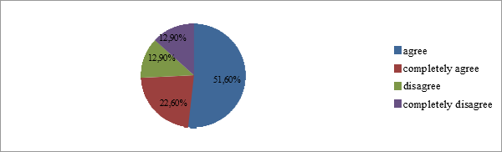

"I think that the test in English lessons is a very effective way to monitor the level of speaking, reading and writing". The number of respondents who disagreed with this opinion was 4 people (12.9%), and 16 people (51.6%) disagreed with this conclusion (Figure 7).

**Figure 7 -** I think that the test in English lessons is a very effective way to monitor the level of speaking, reading and writing

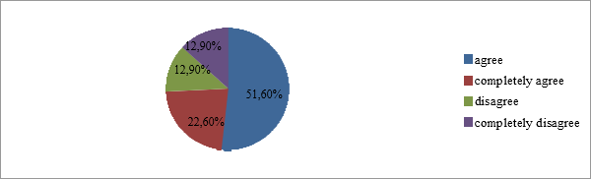

In my opinion, the most effective tests for teaching foreign languages in high school are listening tests, because listening to a foreign language is very important in order to learn to speak a foreign language. 61.3% of respondents agreed with the above opinion, while 6.5% disagreed with it (Figure 8).

**Figure 8 -** In my opinion, the most effective tests for teaching foreign languages in high school are listening tests, because listening to a foreign language is very important in order to learn to speak a foreign language

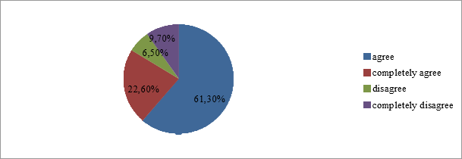

As we understand from the results of the study, tests as a means of controlling the knowledge of high school students in English lessons are very effective. At first, the test was considered as a special way of controlling the acquired knowledge, skills and abilities in different schools and directions. This concept has appeared relatively recently, but it is already quite firmly fixed in the form of a form of pedagogical activity. Individual results of theoretical research within the framework of test control are reflected in many educational and methodological complexes in English, falling at the disposal of teachers and significantly contributing to the perception, understanding and consolidation of the material.

**Conclusion**

Summing up all of the above, we can conclude that tests are of high importance when mastering a foreign language, especially at the stage of consolidation and control of the studied material. Nowadays, interest in testing as the most effective method of verification can be applied in educational institutions for the purpose of conducting training, intermediate and final control. In this paper, we have considered the pedagogical components of the tests, the expediency of their use. The conducted research has shown that testing is one of the important types of exercises, it is an effective way to form various types of skills. In the course of the work, the concept of the test and testing, as well as the main characteristics of the tests, were considered. We come to the conclusion that test control is an effective form of control, but only if the test is tailored to the specifics of work in a certain class and students are prepared to write not a traditional test paper, but testing. The use of testing as a form of control in the practice of teaching at school is associated with a certain range of issues that require serious scientific justification and approach.

***The work was carried out with the financial support of the Ministry of education and science of the Republic of Kazakhstan in the framework of the scientific project *AP08052329\****

**BIBLIOGRAPHY**

1. Kuvshinov V. I. Test control in the process of teaching a foreign language// Foreign languages at school - No. 2-1992.

2. Folomkina S. K. Testing in foreign language teaching// Foreign languages at school - No. 2-1986.

3. Попов Алексей Владимирович Тестирование как метод контроля качества знаний студентов // ТРУДЫ СПБГИК. 2013. №. URL: https://cyberleninka.ru/article/n/testirovanie-kak-metod-kontrolya-kachestva-znaniy-studentov

**REFERENCE**

1. Kuvshinov V. I. Test control in the process of teaching a foreign language// Foreign languages at school - No. 2-1992.

2. Folomkina S. K. Testing in foreign language teaching// Foreign languages at school - No. 2-1986.

3. Popov Aleksej Vladimirovich Testirovanie kak metod kontrolya kachestva znanij studentov // TRUDY SPBGIK. 2013. №. URL: https://cyberleninka.ru/article/n/testirovanie-kak-metod-kontrolya-kachestva-znaniy-studentov

**А. Қ. Мейрбеков1 , Г. Б. Сәрсенбек1 \***

1Қожа Ахмет Ясауи атындағы Халықаралық қазақ-түрік университеті, Қазақстан

**Тесттер ағылшын тілі сабақтарында жоғары сынып оқушыларының білімін бақылау құралы ретінде**

*Негізгі мәселе:* бұл мақалада студенттердің шет тілі бойынша білімін бақылаудың бір түрі ретінде тестілеу әдісінің жан-жақты сипаттамасы берілген. Мақала студенттерге ағылшын тілін оқытуда білімді бағалаудың тиімді әдісі ретінде тестілеуді қолдану қажеттілігіне арналған. Тестілеу әдісі туралы отандық және шетелдік ғалымдардың пікірлері келтірілген. Шет тілін оқытуда қолданылатын тест түрлері және оларды қолдану мақсаты қарастырылған. Осы зерттеу жұмысының тақырыбы бойынша алынған сауалнама нәтижелері көрсетілген.

*Мақсаты:* шет тілін оқытуда студенттерді бағалау құралы ретінде тестілеу әдісін қолданудың тиімділігін анықтау.

*Әдістері:* бұл зерттеу жұмысында теориялық және эмпирикалық зерттеу әдістері қолданылған. Теориялық әдістерден анализдеу, сапалық, дедуктивті және т.б. әдістер қолданылған. Ал эмпирикалық әдістерден сандық, сауалнама, салыстыру әдістері қолданылған.

*Нәтижелер және олардың маңыздылығы:* жұмыстың практикалық маңыздылығы келесі жағдайларға байланысты:

Қазіргі кезеңде студенттерді оқытуға педагогикалық бақылау негізінен тестілеу түрінде жүзеге асырылады. Білімді бағалау әдісі ретінде тестілеу соңғы жылдары танымал бола бастады. Бұл шет тіліндегі сөйлеу әрекетінің әр түрлі түрлерін бағалаудың ең түсінікті, дұрыс, қолайлы, сапалы және объективті әдісі болып табылатын тест түріндегі тапсырмалар. Әр түрлі бақылау формаларынсыз, атап айтқанда студенттерді тестілеусіз студенттердің іс-әрекеттерін бағалау мүмкін емес.

Зерттеу нәтижелерін тиімді оқыту технологияларын дамытуда болашақ ағылшын тілі мұғалімдеріне нұсқаулық ретінде пайдалануға болады.

Түйін сөздер: ағылшын тілі, тестілеу, тиімділік, студенттер, әдіс, білім.

**А. К. Мейрбеков1 , Г. Б. Сарсенбек1\***

1Международный казахско-турецкий университет имени Ходжи Ахмеда Ясави, Казахстан

**Тесты как средство контроля знаний старшеклассников на уроках английского языка**

*Основная проблема:* В данной статье представлено всестороннее описание метода тестирования как одной из форм контроля знаний студентов по иностранному языку. Статья посвящена необходимости использования тестирования как эффективного способа оценки знаний при обучении студентов английскому языку. Приведены мнения отечественных и зарубежных ученых о методе тестирования. Рассмотрены виды тестов, используемых при обучении иностранному языку, и цель их применения. Показаны результаты анкетирования, полученные по теме данной исследовательской работы.

*Цель:* Определить эффективность использования метода тестирования как инструмента оценки студентов при обучении иностранному языку.

*Методы:* В данной исследовательской работе были использованы теоретические и эмпирические методы исследования. Из теоретических методов были использованы анализирование, качественные, дедуктивные и др. методы. А из эмпирических методов были использованы количественные, анкетирование, сравнительные методы.

*Результаты и их значимость:* Практическая значимость работы связана со следующими обстоятельствами:

На современном этапе педагогический контроль за обучением студентов осуществляется в основном в форме тестирования. Тестирование как метод оценки знаний набирает популярность в последние годы. Именно задания в тестовой форме являются наиболее понятным, правильным, подходящим качественным и объективным способом оценки различных видов речевой деятельности на иностранном языке. Невозможно оценить действия студентов без различных форм контроля, а именно тестирования студентов.

Результаты исследования могут быть использованы в качестве руководства для будущих учителей английского языка при разработке эффективных технологий обучения.

Ключевые слова: английский язык, тестирование, эффективность, студенты, метод, образование.

**Information about authors:**

**Сәрсенбек Г.Б. -** Қожа Ахмет Ясауи атындағы Халықаралық қазақ-түрік университетінің магистранты, Түркістан қ., Қазақстан.

**Сарсенбек Г.Б.** - Магистрант Международного казахско-турецкого университета имени Ходжи Ахмеда Ясави, г. Туркестан, Казахстан.

**Sarsenbek G.B.** - Master student of the Khoja Akhmet Yassawi International Kazakh-Turkish University, Turkistan c., Kazakhstan.

E-mail: [gulmira.sarsenbek@ayu.edu.kz](mailto:gulmira.sarsenbek@ayu.edu.kz)

**Мейрбеков А.Қ. -** PhD, Қожа Ахмет Ясауи атындағы Халықаралық қазақ-түрік университетінің доценті м.а. Түркістан қ., Қазақстан.

[**Мейрбеков А.К.** -](https://orcid.org.0000-0002-7293-6383/) PhD, и.о. доцента Международного казахско-турецкого университета имени Ходжи Ахмеда Ясави, г. Туркестан, Казахстан.

**Meyirbekov** **A.K. -** PhD, Acting Associate Professor, Khoja Akhmet Yassawi International Kazakh-Turkish University, Turkistan c., Kazakhstan.

E-mail: [akylbek.meyirbekov@ayu.edu.kz](mailto:akylbek.meyirbekov@ayu.edu.kz)