UDC 004.942
МРНТИ 50.51.19

I.I. Lyashenko ^{1*}
¹ Innovative Eurasian University, Kazakhstan
*(e-mail: irinaL72@yandex.ru)

About the use of CASE-technologies in the process of designing information systems

Annotation
The main problem: Today electronic information is one of the important resources in the management system. Electronic information resources are not only means, but also control flows. For example, any instruction or instruction in the management system is actually a guide to action. At the same time, for example, data on the movement of an object (employees, goods, money, etc.) are information resources, the storage and accounting of which is the basis of the organizational process. Large flows of information require their structuring, and operations on them become time-consuming. One of the ways to solve this problem is the development and implementation of an information system.
Objective: To analyze and design an information system using specialized tools designed to optimize the implementation of the above stages of software system development, using the example of a real business process.
Methods: The article discusses the methodologies of CASE tools designed to automate software development processes, namely, the first two stages of the life cycle: analysis and design of a software product. The analysis and design of the business process functionality is carried out using the IDEF0 functional modeling methodology. The design of the database structure of the information system was carried out using the methodology of semantic (information) modeling IDEF1X. Description of the scenario of the designed software for a real business process is carried out using the dynamic modeling methodology IDEF3.
Results and their significance: The article substantiates the relevance of the use of modern CASE-technologies in the process of analyzing and designing a future information system, as well as for the purpose of possible optimization on the example of a real business process "Inventory accounting". As a result, a comprehensive business process model was built using tools based on CASE-methodologies. The resulting model, as well as the description of its construction, is a clear example of the use of CASE technologies for software developers, as well as system analysts and IT specialists.

Keywords: information system, ICAM methodology, CASE, analysis, design.

Introduction
The information system allows not only to structure large flows of information, but also to optimize the execution of basic operations on them: input, editing, search, deletion. At the heart of any information system is a database, which should optimally structure the data, and the functionality should be solved by a convenient and rationally designed interface. Thus, it can be assumed that a qualitatively designed information system will solve most of the optimization problems of organizational and managerial processes that use information as one of the main resources of technological or business processes.
It should be noted that simple information systems aimed at automating a small number of operations on data, the volume of which can be represented by two or three tables in the database, does not require much labor in their development. That is, their development fits into a standard set of patterns, including typical data processing functions: input, editing, search, deletion in the database. Such examples of simple information systems can be automated workplaces of employees. In such cases, it is quite enough to develop a desktop application with a local database location. This version of software development does not require a detailed preliminary study of the information system project. It is enough to use ready-made patterns.
Materials and methods
However, considering more serious software developments in which the functionality, and most often, the amount of data to be processed and stored, is quite voluminous, the preliminary stages of information system development – analysis and design - will be mandatory. In particular, for example, system analysis will avoid data redundancy, which will significantly save the amount of memory occupied by a database containing a large number of records. Designing a management system, for example, in the form of a functional model, will reveal the level of automation of the future information system, highlighting which of the stages of the business process can be implemented in software development. Thus, the development of the future information system project will allow solving one of the main tasks of software engineering – the rationalization of the software development process. Indeed, making adjustments to the model at the stage of the information system project requires significantly less developer time than, for example, in ready-made program code, which may contain several thousand lines of code. Any model has more visibility than a text description, especially if the project is commercial and the customer takes an active part in its development. In this case, it is much easier for the developer and the customer to interact, especially if the model is a graphical diagram, diagram, etc.
There are a huge number of tools for developing graphic objects. From this class, it is necessary to highlight the tools that contain not only a powerful set of graphical tools, but also have functionality that allows you to automate some of the operations. Such tools belong to the class of CASE-tools.
The concept of CASE (Computer Aided Software Engineering) implies tools that support the processes of creating and maintaining automated systems, including database design, code generation, testing and other processes [1]. CASE-tools, in turn, require formalization of information system design methods. CASE-methodologies allow us to describe the model of a future software tool from various points of view. Thus, one of the most popular families of methodologies is still the IDEF family (ICAM Definition – definition of the main terms of the ICAM program), developed within the framework of the ICAM program (Integrated Computer Aid of Manufacture – integrated computer assistance to production) [2]. Among the many developed tools that support the IDEF family of methodologies, we can single out the AllFusion Process Modeler software product.
AllFusion Process Modeler (BPwin) is one of the popular tools for visual modeling of business processes that does not require writing program code. The tool allows you to optimize the work of designing a software tool, which allows you to significantly reduce costs already at the first stages of development, eliminate unnecessary operations, increase the flexibility and efficiency of the future information system. [2]
AllFusion Process Modeler supports three standard notations:
- IDEF0 (Functional Modeling methodology);
- DFD (Data Flow Modeling Methodology);
- IDEF3 (modeling of work flows - scenarios).
Of particular note is the possibility of integrating the tool with the ERwin Data Modeler program, which allows you to build a future database project in the IDEF1X methodology and generate it in various database systems, the most popular of which are MySQL, SQL Server, Access.
Thus, IDEF methodologies allow for a comprehensive approach to solving the problem of designing an information system from various sides: by functionality (IDEF0), by database structure (IDEF1X), by work flow scenario (IDEF3).
Results
The process of designing an information system at the stage of domain analysis using CASE tools is presented by the example of building a model of the information subsystem "Inventory accounting". The model includes three diagrams: IDEF0, IDEF1X, IDEF3.
The functional modeling diagram IDEF0 describes a sequence of actions (functional blocks) connected by information or material flows. The information subsystem "Inventory accounting" includes several business processes, one of which is the process of issuing tools from the warehouse for use by employees of the organization. The following is an example of building a model of the specified business process.
To solve the problem, it is necessary to answer questions, the answers to which will determine the number and sequence of functional blocks, as well as the main flows: input and output data, mechanisms and control flows. An indicative list of questions and answers are given in table 1.

Table 1 – Descriptive model IDEF0
Question | Answer
What steps should be performed to get the tool in stock | - identify the employee  - select the necessary tool  - apply for a tool  - sign a document to receive the tool for use  - get a tool (receipt invoice)
Who is involved in the process of issuing / receiving the tool in the warehouse | - warehouse manager  - employee
Which input streams should be set to initialize the process | - list of employees  - tools catalog (description)
What result should be obtained after the completion of the process | - instrument on request / invoice for receipt of the instrument

The graphical interpretation of the descriptive model IDEF0 will have two levels. The first, upper level shows a contextual diagram describing the business process in the first approximation. Figure 1 shows a single functional block that includes a business process, as well as all information and material flows.
The input information flows are: a list of tools and employee data. The output stream is the expected result: the material flow "Tool" or the information flow "Invoice for the receipt of the tool". At the same time, the document can also be a material flow of a real business process, or it can also act as an information flow in the projected information system.
The mechanisms of the process include: the warehouse employee and the recipient of the tool.
The control flows in this case will be instructions on the rules for issuing and returning tools, as well as the warehouse work schedule. These flows define the rules, conditions, and constraints of the business process.

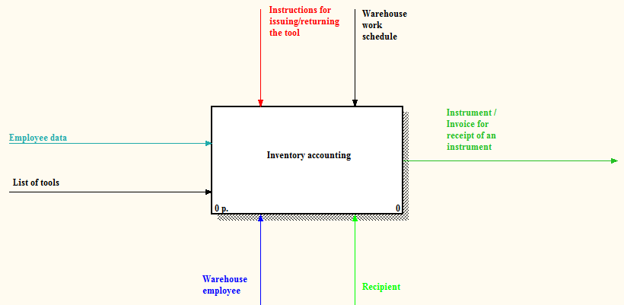

Figure 1 – IDEF0 context diagram (top level)

At the lower level of the diagram, the business process is refined through a description of the sequence of functional blocks, which are also connected by information flows. Table 2 describes each functional block and the connecting information flows.

Table 2 – Description of the lower level of IDEF0
Function block | Input stream | Output stream | Mechanism | Management | Note
Identify the employee | Employee data | Successful identification | - Warehouse employee  - Recipient | - | -
Select a tool | - Employee data  - List of tools | Data about the selected tool | - Warehouse employee  - Recipient | - | -
Send / fill out an application for a tool | Data about the selected tool | Completed application for the instrument | - Warehouse employee  - Recipient | Instructions for issuing / returning the tool | -
Sign a document to receive the tool | Completed application for the instrument | A signed document on receipt of the instrument | - Warehouse employee  - Recipient | Instructions for issuing / returning the tool | -
Get a tool / invoice for receiving a tool | A signed document on receipt of the instrument | Instrument / Invoice for receipt of an instrument | - Warehouse employee  - Recipient | Warehouse work schedule | If the tool does not match the one specified in the application, or the tool is in a non-working state, a return to the "Select tool" function block is performed

Figure 2 shows the lower level of the functional business process modeling diagram in the IDEF0 methodology.

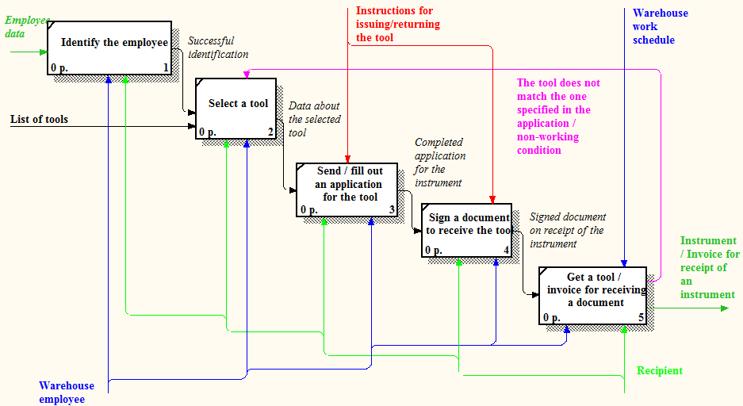

Figure 2 – Diagram of functional business process modeling in the IDEF0 methodology (lower level)

A detailed description of the process in the functional modeling notation allows the developer of the future information system to determine possible ways to optimize the process, as well as to track the movement of information flows. So, for example, to initialize the functional block "Identify employee", the input stream must load the data of all employees of the organization (in the diagram "Employee Data"). Only in case of successful identification can the second block "Select tool" be activated. For this action, the system will also need to download a list (catalog) of all the tools available in stock. The result of this step is the name of the desired tool. The third step involves filling out an application by an employee to receive a tool from the warehouse for use. Data about the selected tool is a mandatory information flow that initializes the current functional block. In addition, filling out an application for a tool is regulated by the instructions for issuing / receiving the tool in the warehouse. Obtaining a tool necessarily requires signing a document regulating guarantees for the safety of the tool in the process of its use. This action is performed at the fourth step of the process and is initiated by the completed application at the previous step, as well as the instructions for issuing / receiving the tool in the warehouse. The result of this step is a document signed by all parties (in this case, the warehouse employee and the recipient) on material liability. This document initiates the last functional block of the business process: the issuance of a tool or an invoice for its receipt, if we consider this process from the point of view of a future information system. At the same time, a control flow is also required that determines the conditions for performing the last step – the "Warehouse work schedule". The last functional block can end with one of two possible results: a tool (a document for its receipt), or a return to the choice of another tool, if the tool does not meet the requirements specified in the application or is in a faulty condition.
The analysis of the business process model showed that when developing an information system, the consequence of the unsuccessfully completed first block should be taken into account (this option is not considered in the model), as well as the possibility of using templates when filling out documents at the third and fourth stages.
At the same time, already at the first stage of designing an information system in order to optimize the business process under consideration, it is possible to give the first recommendations on structuring information flows that form the basis of the information system database. So, it is clearly seen that at least two tables are required: employee data and a catalog of tools.
To develop a model of the future database of the projected information system, the methodology of semantic (informational) modeling of the IDEF1X ICAM family was chosen. The ERwin Data Modeler program is selected as a tool.
Figure 3 shows a logical database model in the methodology of ER diagrams.

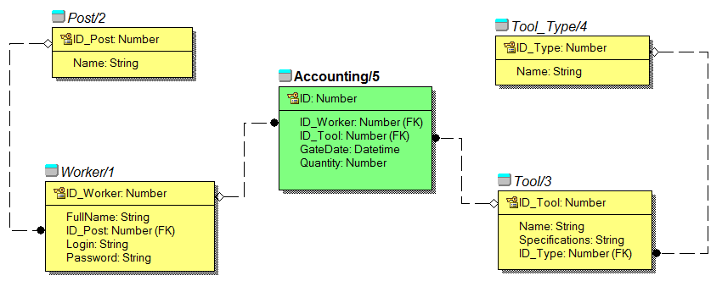

Figure 3 – ER diagram in the IDEF1X methodology notation

The database model consists of five tables. Four of them are actually reference books, the data from which are used to store data accounting for the "movement" of tools in the organization. Such directories include the entities: "Employee", "Tool", as well as clarifying data from these directories – the entities "Position" and "Type of tool". In the "Position" - "Employee" chain, the parent entity is the "Position" table. Thus, in case of a change, for example, the name of the type of position, all changes will automatically be reflected in the "child" entity – "Employee". A similar variant of the relationship between the entities "Tool" and "Tool type". Here the "parent" entity is the "Tool Type" table. If changes are made to the list of tool types, then the relationship between these tables guarantees automatic adjustments in the "child" entity – "Tool".
It should be noted that the entities "Employee" and "Tool" are also "parent" for the entity "Accounting". The entity "Accounting" was created to store data about the "movement" of instruments. The connection of each record of the "Accounting" table with the "Employee" and "Tool" tables is carried out through the identifier fields of the corresponding entities. This makes it possible to reduce data redundancy, that is, it is no longer necessary to store complete employee data or all the characteristics of the tool. It is enough to specify their unique identifiers in the table, and if necessary, these data can be unambiguously obtained by executing an SQL query by their unique number in the corresponding directory.
The analysis of the IDEF1X diagram shows that the future database in the proposed implementation has a fairly logical and rational structure, so its modernization is not required at this stage of design. At the same time, it should be noted that the functional model IDEF0 demonstrates functionality, but rather poorly shows the dynamics of the described business process, especially from the point of view of the software development of a future information system designed to optimize work with data.
As an alternative version of the model that complements and clarifies the dynamics of the business process, taking into account various situations and scenarios, a diagram was compiled in the dynamic modeling notation IDEF3. The AllFusion Process Modeler tool was used to build it. So, in particular, when analyzing the IDEF0 diagram, there was a problem of choosing an action if the employee identification failed. In a real business process, this could mean the absence of an employee's pass identifying him as a valid employee of the organization. In the information system, this situation may mean an incorrectly entered username and/or password. In addition, it is also possible that the paperwork of financial responsibility for the issuance of the tool can take place in parallel with the issuance of the tool itself (if the number of employees working in the warehouse is several people). So the process of issuing the tool will take less time than in the case described in the diagram IDEF0, when these processes are sequential. In addition, the parallel execution of these two stages is logical, since it increases the level of responsibility of both sides of the business process.
Thus, new operations were added to the business process scenario. The general list of operations can be represented by the following set:
- identify the employee;
- select a tool (from the list);
- check the availability of the tool in stock;
- apply for a tool;
- Sign a document to receive the tool;
- issue a tool / invoice for getting a tool in stock.
Figure 4 shows a scenario diagram describing a business process in IDEF3 dynamic modeling notation.

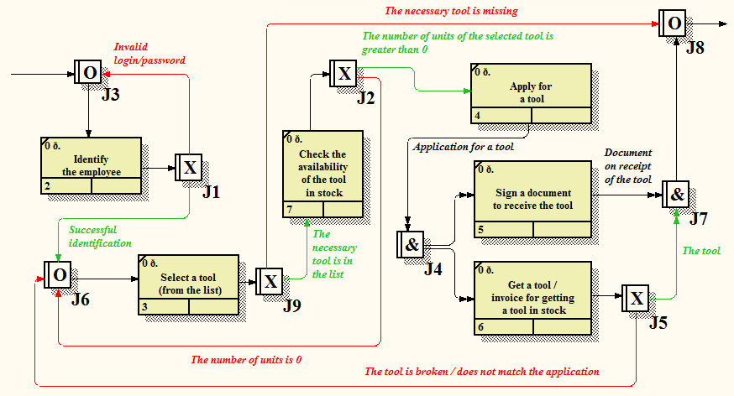

Figure 4 – Scenario diagram in IDEF1X notation

Each operation has an ordinal number in the lower left corner of the graphical entity.
A distinctive feature of the IDEF3 diagram is the presence of merge and branch blocks, which allow specifying how the previous operations should be completed, and in which case the operations following this block should start (be initiated). Thus, blocks with the names J3 and J6 denote "Asynchronous OR" and are used to merge several data streams. For example, J3 means that operation No.2 "Identify Employee" can begin if at least one (or several) previous operations have already been completed. For this operation, following the arcs, there are operations No. 1 (the upper level of the diagram, indicating the beginning of the business process) and operation No.2 itself, in case the identification failed (an arc with the name "Invalid login / password"). Since any of these operations can be completed separately, it is not necessary to complete them simultaneously to identify an employee, it is enough to complete at least one of them.
Operation No.3 "Select a tool (from the list)" is initiated if at least one of the operations is completed:
- No. 2 "Identify employee" (in case of successful identification);
- No. 7 "Check the availability of tools in stock" (if the necessary tool is not available in stock – the arc "The number of pieces is 0");
- No. 6 "Issue a tool / Invoice for the issuance of a tool in the warehouse" (if the tool is not in good condition or does not correspond to the specified name in the application).
Similarly to the previous example, it is also not necessary to complete all three operations to initiate a tool selection operation, it is enough to complete at least one of the previous operations.
In cases where an operation can end with only one result out of two, the "Exclusive OR" branch block is used. These blocks include: J1, J2, J5, J7, J9. In the diagram, the successful completion of the operation associated with each of the listed blocks is marked with a green arc, and the unsuccessful completion is red. Color differentiation is not required to build a model, but it gives a more visual result for the developer and the customer.
So, for example, block J9 shows the script to the developer how the business process should be continued after the completion of the operation "Select a tool (from the list)". If the required tool is found in the list, then the following operation No. 7 "Checking the availability of the tool in stock" is initiated. But if the result is negative, i.e. the necessary tool is not found, then the entire business process is terminated, and all other operations are ignored.
Similarly, block J2 shows the scenario of how the business process should be continued after the completion of operation No. 7 "Check the availability of the tool in stock". If the selected tool is not available, it is suggested to return to operation No. 3 "Select a tool (from the list)", showing the possibility of an alternative tool selection. If operation No. 7 succeeds, then the next operation of the business process No. 4 "Fill in the application" is initiated.
In cases where the completion or initiation of operations must be performed in parallel, the "Asynchronous AND" block is used. An example of such a script fragment is block J4 and J7. So, for example, block J4 shows that operation No. 4 "Fill out a document for receiving a tool" and operation No. 5 "Issue a tool / invoice for receiving a tool" can take place in parallel. And block J7 shows that the business process is considered completed only if both previous operations are completed, but not necessarily at the same time.
It should also be noted that the IDEF3 notation can also refine data flows. For example, most arcs indicate the completion or beginning of an operation. But it is possible to clarify these processes by specifying, for example, that the completion or start of an operation can also be accompanied by material flows. So, for example, operation No. 4 should end with the additional issuance of the document "Application for the issuance of a tool", which is shown in the diagram by an arc with a double tip. Similarly, operation No. 5 "Fill out a document for obtaining a tool" should end with the issuance of a document on financial responsibility for the use of the tool.
Thus, the analysis of the IDEF3 scenario diagram describing the business process of issuing a tool in a warehouse allows us to conclude that it is necessary to implement various options in ambiguous situations at each stage, which will allow us to develop an information system more dynamic and user-friendly in functionality.
Discussion
The given example of building a business process model using tools and CASE technologies showed the advantages of automating the design process over the traditional approach of software development. Indeed, already at the design stage, the use of a description of the process from various points of view will clearly demonstrate not only the structure of the future information system, but also its functionality. At the same time, graphical notation allows you to make this process quite visual and understandable even for a person who is not an IT specialist, which, for example, may be a customer. It should also be noted the rationality of using CASE-tools by information system developers, because already at the design stage it is possible to make any adjustments coming from the customer quickly and at no great cost, or when identifying "weak points" of the business process itself, to optimize it.
Conclusion
In accordance with the goal of demonstrating the relevance of CASE-methodologies in the process of designing software systems, the task was set: to show by example the process of designing a real business process using ICAM family methodologies, as well as tools for visual modeling of business processes AllFusion Process Modeler (BPwin), which do not require writing program code. As a result of the analysis, three diagrams describing the business process from three points of view were obtained: a functional model, an information model and a dynamic model. At the same time, already at the stage of dynamic and information modeling, ways to optimize the business process by reducing labor costs were proposed, which proves the effectiveness of using CASE technologies in system analysis.

THE LIST OF SOURCES

- Токмаков, Г. П. CASE-технологии проектирования информационных систем: учебное пособие. – Ульяновск : УлГТУ, 2018. − 224 с.
- Замятина О. М. Моделирование систем: Учебное пособие. – Томск: ТПУ, 2009. – 204 с.

REFERENCES

- Tokmakov G.P. (2018) CASE-tekhnologii proektirovaniya informacionnyh sistem: uchebnoe posobie [CASE-technologies for designing information systems: a textbook]. Ul'yanovsk : UlGTU [in Russian].
- Zamyatina O.M.(2009) Modelirovanie sistem: Uchebnoe posobie [Modeling of systems: Study guideTomsk: TPU [in Russian]

И.И. Ляшенко¹
¹ Инновациялық Еуразия университеті, Қазақстан

Ақпараттық жүйелерді жобалау процесінде Case-технологияларды пайдалану туралы

Негізгі проблема: бүгінгі таңда электронды ақпарат Басқару жүйесіндегі маңызды ресурстардың бірі болып табылады. Ақпараттық электрондық ресурстар тек құрал ғана емес, сонымен қатар ағынды басқару болып табылады. Мысалы, басқару жүйесіндегі кез-келген нұсқаулық немесе бұйрық іс жүзінде іс-әрекетке арналған нұсқаулық болып табылады. Бұл ретте, мысалы, қандай да бір объектінің қозғалысы туралы деректер (қызметкерлер, тауарлар, ақша қаражаты және т.б.) ақпараттық ресурстар болып табылады, оларды сақтау және есепке алу ұйымдастыру процесінің негізі болып табылады. Үлкен ақпарат ағындары оларды құрылымдауды қажет етеді, ал олардағы операциялар уақытты қажет етеді. Бұл мәселені шешудің бір жолы-ақпараттық жүйені әзірлеу және енгізу.
Мақсаты: нақты бизнес-процесс мысалында бағдарламалық жүйелерді дамытудың жоғарыда аталған кезеңдерінің орындалуын оңтайландыруға арналған мамандандырылған құралдарды қолдана отырып, ақпараттық жүйені талдау және жобалау.
Әдістері: мақалада бағдарламалық жасақтаманы әзірлеу процестерін автоматтандыруға арналған CASE құралдарының әдіснамасы, атап айтқанда өмірлік циклдің алғашқы екі кезеңі: бағдарламалық өнімді талдау және жобалау қарастырылады. Бизнес-процестің функционалдығын талдау және жобалау IDEF0 функционалды модельдеу әдіснамасын қолдану арқылы жүзеге асырылады. Ақпараттық жүйенің мәліметтер базасының құрылымын жобалау IDEF1X семантикалық (ақпараттық) модельдеу әдістемесін қолдану арқылы жүзеге асырылады. Нақты бизнес-процестің жобаланған бағдарламалық жасақтамасының сценарийін сипаттау IDEF3 динамикалық модельдеу әдіснамасын қолдану арқылы жүзеге асырылады.
Нәтижелер және олардың маңыздылығы: мақалада қазіргі заманғы CASE технологияларын Болашақ ақпараттық жүйені талдау және жобалау процесінде, сондай-ақ "тауарлық-материалдық құндылықтарды есепке алу"нақты бизнес-процесінің мысалында мүмкін болатын оңтайландыру мақсатында қолданудың өзектілігі негізделген. Нәтижесінде CASE-әдіснамаларға негізделген аспаптық құралдарды қолдана отырып, бизнес-процестің кешенді моделі жасалды. Алынған модель, сондай-ақ оның құрылысының сипаттамасы бағдарламалық өнімдерді әзірлеушілерге, сондай-ақ жүйелік талдаушылар мен IT-мамандарға CASE технологияларын қолданудың жақсы мысалы болып табылады.
Түйінді сөздер: ақпараттық жүйе, ICAM әдістемесі, CASE, талдау, жобалау.

И.И. Ляшенко^{1*}
¹Инновационный Евразийский университет, Казахстан

Об использовании Case-технологий в процессе проектирования информационных систем

На сегодняшний день электронная информация является одним из важных ресурсов в системе управления. Информационные электронные ресурсы являются не только средствами, но и управляющими потоками. Так, например, любое указание или распоряжение в системе управления фактически является руководством к действию. При этом, например, данные о движении того или иного объекта (сотрудники, товары, денежные средства и т.п.) являются информационными ресурсами, хранение и учет которых является основой организационного процесса. Большие потоки информации требуют их структуризации, а операции над ними становятся трудоемкими. Одним из способов решения этой проблемы является разработка и внедрение информационной системы.
Цель: Провести анализ и проектирование информационной системы с помощью специализированных инструментальных средств, предназначенных для оптимизации выполнения вышеуказанных этапов разработки программных систем, на примере реального бизнес-процесса.
Методы: В статье рассматриваются методологии CASE-средств, предназначенных для автоматизации процессов разработки программного обеспечения, а именно, первых двух этапов жизненного цикла: анализ и проектирование программного продукта. Анализ и проектирование функционала бизнес-процесса выполнен с помощью методологии функционального моделирования IDEF0. Проектирование структуры базы данных информационной системы выполнено с применением методологии семантического (информационного) моделирования IDEF1X. Описание сценария работы проектируемого программного обеспечения для реального бизнес-процесса выполнено с помощью методологии динамического моделирования IDEF3.
Результаты и их значимость: В статье дано обоснование актуальности применения современных CASE-технологий в процессе анализа и проектирования будущей информационной системы, а также с целью возможной оптимизации на примере реального бизнес-процесса «Учет товарно-материальных ценностей». В результате построена комплексная модель бизнес-процесса с применением инструментальных средств, базирующихся на CASE-методологиях. Полученная модель, а также описание ее построения является наглядным примером применения CASE-технологий для разработчиков программных продуктов, а также системных аналитиков и IT-специалистов.

Ключевые слова: информационная система, методология ICAM, CASE, анализ, проектирование.

Сведения об авторах:
Ляшенко И.И. - информатика магистрі, инженерлік-технологиялық факультетінің аға оқытушысы, Инновациялық Еуразия университеті, Павлодар қ., Қазақстан Республикасы. Ляшенко И.И. – магистр информатики, старший преподаватель Инженерно-технологического факультета, Инновационный Евразийский университет, г. Павлодар, Республика Казахстан. Lyashenko I.I. – Master of Computer Science, Senior Lecturer of the Faculty of Engineering and Technology, Innovative Eurasian University, Pavlodar, Republic of Kazakhstan. E-mail: irinaL72@yandex.ru.

Дата поступления рукописи в редакцию:

