**The uniqueness of a person's character on a psychological level**

*The main secret of success is that without our efforts, it becomes almost impossible to Wake up, shake, call to life our hidden reserves, our potential capabilities, which are the key to achieving the goal. And if we do not feel like a fish in the water in all spheres of activity, it is mainly because of our own self-doubt, because of the presence of our own created barriers that hinder our development.*

Keywords

Uniqueness, choice, individuality, freedom, psychology

*“All growth depends upon activity.*

*There is no development physically or intellectually without effort, and effort means work.”*

*Calvin Coolidge*

When life gives you a choice you’re faced with a choice in life, always choose the one that will promote your personal growth instead of opting taking the easier easy way.

Author Charlie Harary explains in Unlocking Greatness: “It’s your choice how to respond to challenges, how to live in the moment, and whether you will fight for excellence in everything you do.”

One You should apply the same discipline and dedication in their to your personal growth; Being Be meticulous in choosing growth over the easier easy path.

Many people experience problems in their lives because they choose the easier easy path. Everyone is looking for shortcuts, whether it be in: business, health, finance or relationships. The craving for success without committing oneself to the task is an attractive undertaking many go in search of.

As we you know, what comes quickly may not be long-lasting.

For example, if you want to be in an intimate relationship, you may need to put the other person’s interests before yours. You will need to be a good listener and give of your time to nurture the relationship.

We have become a throwaway society with less than optimal values and character. It’s rare to meet a person with strong values because most people are lured by the notion of: “What’s in it for me?”

What’s in it for you may not be what’s in it for others. Personal growth will require you to put other people before you, so it matters in the long run.

То, что есть в нем для вас, может не быть тем, что есть в нем для других. Личностный рост потребует от вас ставить других людей выше себя, так что это имеет значение в долгосрочной перспективе.

Decide what’s important to you and follow the principles as best you can. Pursue character and integrity as your highest moral code if that is who you intend to be.

“Greatness is a choice. You have to choose to unlock the greatness within.

Choosing the path of good moral character can be a lonely road because not all people walk the path, so you will be required to walk it alone.

Do so anyway.

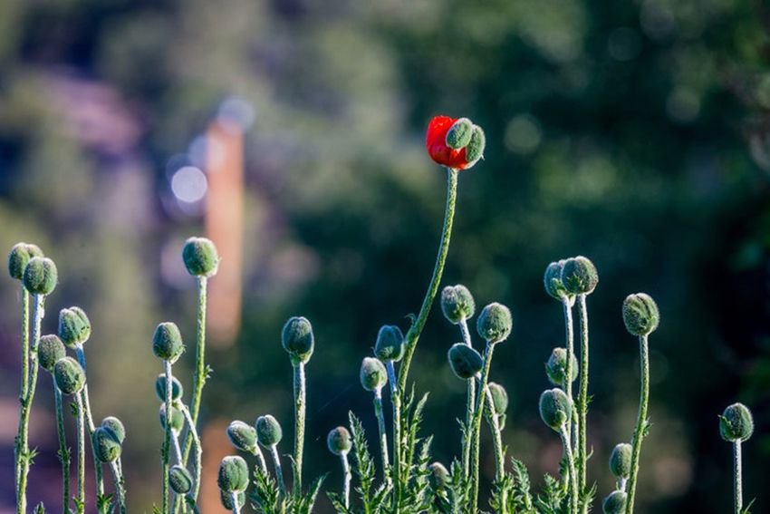

The one key principle is the relationship you have with yourself which cannot be taken from you, so guard it fiercely so you evolve into someone you are proud to be.

A person's life consists of a series of choices. Each choice determines a change in the vector of the life path. Making a choice, a person determines their future path. Some decisions can affect this path almost instantly; some choices will affect the person over time; some decisions affect the path more strongly, some almost imperceptibly. However, together they all form what we are used to calling fate.

Whether our life path is predetermined or whether the person himself is the Creator of his life can be debated for a long time. Although, both of these views, in my opinion, are correct. It all depends on how you look at it. For someone who makes a choice unconsciously, automatically, life really has a somewhat predetermined character. After all, as usual, a person chooses the path that he is used to walking. In this case, the choice simply goes unnoticed.

By directing a person along a familiar route, the brain can afford to shut down, not work, and not waste extra energy on processing new information. Therefore, the familiar route is preferable for the mind. Someone who is used to reacting to aggression with aggression, in another similar situation, the first thing you will feel, of course, is the impulse to react habitually. To give in to this impulse is to give up the opportunity to choose again, and once again go down the beaten path. In this regard, it was once said: it is stupid to hope for different results by performing the same actions.

In the psyche of an adult, patterns of behavior have already been formed, according to which he builds his life. Therefore, the life of someone who does not pass through the filters of consciousness their thoughts, words and actions is like a constant replay of the same algorithms for the development of events.

Here is one of the hypothetical situations. Let's say that someone seemed stupid to you, and you are used to treating stupid people with condescension. The person you think is stupid feels your arrogance, and this makes them uncomfortable. It turns on the appropriate defensive program of aggression. Those who treat him with arrogance, he is used to compromising open conflict in order to undermine the authority of his opponent. Thus, he is trying to restore justice. In response to his actions, your program may turn on. For example, one day you may react to another attack and ignite a scandal or even a fight.

The above chain could have been stopped at any stage. It would be enough for one of the participants to ask himself the question: "what am I doing and for what?". It is not necessary to label a person as a fool, because for someone else you may be a fool. Is it worth reacting to someone's arrogance, or can you just ignore it? Whether it is necessary to respond with aggression to aggression, if in most cases the relationship can be improved by showing their good intentions. Naturally, you can't do without internal work to change your attitude to the situation.

In fact, it is not even so important which path you choose next. The important thing is how much this choice will be conscious and how much it will be with an understanding of the consequences for the soul and body. After all, sometimes it is true, it is worth giving up the fight for justice, when it does not make sense for you. Is it worth fighting a gang of robbers if the physical advantage is clearly not on your side? Is it worth it to restrain your desire to fight, if this fight for you is a matter of honor and conscience?

This is the meaning of the statement "life is a choice". And there can be no algorithm by which this choice should be made. The right choice is one that is made consciously. But the one who becomes a slave to their habits and behavioral patterns, refuses to be able to choose. Which, to some extent, is also a choice.

A person's life is a series of decisions that they make. Each of our decisions is a choice from a number of options. Every day, each person makes a choice not once, but several times, from simple household to those that affect the rest of his life. Sometimes it's easy to choose, like when you choose between what you like and what you don't. Sometimes it is more difficult to do this because your choice collides with the interests of other people.

Of course, when we choose specific things, we analyze the pros and cons of different options. But even in this

we can't be sure that everything will be exactly as we thought it would be. And we don't know for sure what it would have been like if we had made a different choice. Because life is unpredictable, and apparently it can't be planned in advance. The profession chosen once may not be in demand in a few years or just not like it, moreover, the relationship with your husband or wife may not go well, but who knows about that in advance? The only Life choice we can make is to choose our own principles for making important decisions.

Apparently, the Life choice of a person means his attitude

to life itself and other people, the means that a person chooses to achieve their goals. Who chooses life on the tips of the soul and the truth, and someone-for arrogance and profit. The first goes his own way, overcomes difficulties, reveals talents and finds happiness, and the second thinks only about how to be better than others – more money, occupy a better position, marry the most beautiful woman possible, drive a posh car. Such people do not get real pleasure from life, but only envy from others.

Someone can afford to get a profit by deceiving someone, profiting from someone's misfortune, and for the second this is the norm. Someone can sacrifice their own Life for the Sake of another person, and someone can kill for an insult or money.

All I can say is that everyone makes their own choices. You can't really make someone be honest, kind, hardworking. You can imprison a thief or beg money for the benefit of a miser, but this will not make them better or happier. Therefore, it is better to think for yourself and build your life, which in principle is the main goal for everyone.

Tags: Essay the life path of a person, how to choose the right path in life, Essay on the topic: choosing a life path, the main choice in life.

While Plato believed that there was a definite purpose in creating man, Socrates suggested that everyone should know themselves. This is a good piece of advice, which requires first of all recognition of the fact that the process of learning requires an understanding of one's own uniqueness. The uniqueness of a person can be considered as a great gift of Nature.

In fact, it is impossible to find a second, exactly the same person on earth, at least, such a chance is microscopically small. Scientists have long proven the individuality of fingerprints, the shape of lips, ears. What to say about the composition of blood, no less unique than everything else in the human form. We can safely say that any of us is an amazing, completely unique crown of nature's creation, designed and created to achieve truly incredible results. In addition, unlike all other living organisms on the planet, man has a mind, a truly ideal tool for carrying out absolutely any tasks set before him.

The problem, however, is that most people do not realize that they belong to the highest creation of nature, and they are not at all proud of their existence. But the human resources that we use to achieve the desired goal can be truly unlimited, and the possibility of achieving much more success than exists at the moment is quite real, if you only set your priorities correctly. The potential available to us is always with us, we just need to learn how to use it to its full extent. The task may not be easy, but it is achievable.

Do you doubt it? Although such doubts are understandable, they are nevertheless futile: for example, think of yourself at school. In your childhood, when you were learning a new rule or theorem, did you not think that the new knowledge was incomprehensible to you and therefore unattainable? And how many times have you made mistakes on your own account, after time has passed and after applying certain efforts, you begin to understand everything that the teacher wanted to convey to you?

The main secret of success is that without our efforts, it becomes almost impossible to Wake up, shake, call to life our hidden reserves, our potential capabilities, which are the key to achieving the goal. And if we do not feel like a fish in the water in all spheres of activity, it is mainly because of our own self-doubt, because of the presence of our own created barriers that hinder our development.

Life is like a big sport: the "second wind" does not open up where there is no full calculation at the initial stage, and therefore, there is no push to open additional reserves and hidden opportunities. In fact, this is one of the main barriers: many of us calm down too quickly, content with the result we already have, even if it is not as good as we dreamed. And favorable opportunities, of which there are a huge number in our life, pass by. Do not relax and do not give up – this is the main rule for a decent life. Not to be a winner to the one who assures himself that there is nothing more to hope for and nothing to wait for. The power of the spirit, insight, imagination – all these qualities are not love shy and insecure people…