**УДК 378**

**МРНТИ 11.04.22**

**B.D. Kairbekova1, S.H.Apayeva2, М.Т. Kairbekova3, А.Zh. Kairambayeva4**

Innovative University of Eurasia, Kazakhstan1

Kyrgyz National University named after J. Balasagyn, Kyrgyzstan2

Higher College of Toraighyrov University, Kazakhstan3

Innovative University of Eurasia, Kazakhstan4

(e-mail: [kairbekova.bagzhanat@mail.ru](mailto:ipkm@mail.ru))

**Basic Moral and Conceptual Guidelines for Educational and Pedagogical Activities**

**Abstract**

*The main problem:* Humane pedagogical thinking seeks to embrace the immensity, and this is the strength of educational systems and processes born in its bowels.

To actualize the value of self-disclosure of students’ innovative abilities with the accompanying, providing role of a teacher, it is necessary to recognize a one’s intellectual reflective mechanism as the main subject of education. Developed reflexive abilities are a logical condition for a person to independently overcome all sorts of difficulties in life and activity. During the entire process of educational and pedagogical interaction with students, a teacher must monitor the formation of these abilities and, if necessary, take corrective actions. The culture of a modern teacher is determined by the knowledge and skills of using objective methods and paradigms of thinking, communication and interaction. Demonstrating this culture, a teacher creates the environment for mutual development and indirectly contributes to self-disclosure of students’ potential, acts as a kind of trigger that starts the process of one’s self-development throughout their life.

*Purpose:* understanding and formalization of the “golden principles” of socio-natural thinking and activity of a human as a biological organism.

*Methods:* the method of ascending from the abstract to the concrete, the method of transforming specific images of objects based on their abstract essence, the speculative language of schematic representation of a thought.

*Results, their significance:* considering a high dynamics of technological changes in the world of activity, we accept the reflective ability for self-education as the main means to independently discover certain professional abilities necessary in life. This means that, first of all, students must learn how to learn, i.e. learn to think independently, critically perceive and transform the received information into knowledge, pose their own questions, offer a range of answers, logically formulate and coordinate different points of view, build knowledge together with others. Innovative methods and models of pedagogical activity encourage students’ innovative abilities which cause innovative and technological development of a country.

*Key words:* педагог, teacher, educational function, thinking, nature-like paradigm, principles of mutual development, mental activity, implementation activity, ascent from the abstract to the concrete.

First of all, a modern teacher must have a civil position and in all situations perform his basic educational function. Realizing the responsibility for ensuring functional integrity and the development of the country, he must demonstrate an appropriate culture of thinking and behavior. A teacher must have clear worldview guidelines, ordered value bases; build his/her activity in the logic of objective methods of revealing students’ personal, social and professional potential. In this regard, the definition of non-random methodological guidelines of pedagogical activity for the early growth of children’s intellectual abilities is of paramount importance [1].

A human being is a irrational-rational being with a spiritual, intellectual and activity potential. Every child, every person is a separate, unique, nature-like world. The rudiments of revealing these possibilities and conscious self-development are laid at a young age, when the formation of a brain and basic cognitive functions of thinking take place. It is obvious that from the very childhood children must master the language of nature, master the so-called nature-like paradigm of thinking, formed within the framework of a functional picture of the whole world.

The main function of a human is the development of the principles of mutual development, including the reflective principles of self-preservation, self-organization, self-change, self-realization and the creation on their basis of the socio-natural world of life and activity, i.e. a comfortable artificial environment that fits into the natural world according to its laws. All biological organisms live by these principles. To understand and use them in thinking as well as in activity means to correspond to the concept of a human being.

The main distinguishing feature of a human being from other biological organisms is the intellectual potential – the ability of a brain to think in a non-random way and create a nature-like artificial world. However, if the physiological processes of a body are programmed and initially exist in the mode of autonomous self-organization, the thinking process is launched, functions and develops thanks to social communications. In this regard, the statement ‘one is not born a human, but become one’ is true. If taking into account that a modern average human uses only 3-5% of the brain’s potential in his/her life, the development of mental and intellectual abilities can continue throughout their life.

Within the framework of the Earth’s biosphere, mankind has created an artificial world of activity and the environment called technosphere. However, due to the imperfection of the total intelligence, the created technosphere has a devastating effect both on the natural environment and on the humans themselves. This indicates that the so-called ‘Homo sapiens’ and the entire earth civilization on the whole are in their infancy, the infantile consumer ‘age’. Selfish aspirations of a human, based on the desire for immense satisfaction of physiological needs, are often closed within one, two, three life cycles and neutralize the idea of the possibility and necessity of fitting into the cosmic laws of being, long-term processes of reproduction and mutual development. Despite the numerous appeals of scientists, artists, social activists to limit the barbaric plunder of natural resources, to stop ‘cutting off the branch we are sitting on’ a steady trend of self-destruction of mankind has developed [2]. The main role here is played by the stereotypes of consciousness, formed mainly in the organizations of the education system.

The world of activity divided into two spheres – educational and professional, involves the creation of a variety of items to meet the ever-growing needs of a human in life. In educational activity human’s abilities for professional activity are revealed, and in the professional activity they are realized. On the other hand, both in education and in professional practice, mental (‘internal’, causal) and implementing (‘external’, consecutive) activities are distinguished. Certainly, taking into account the cause-and-effect relationship and from the position of the final result, mental activity is of decisive importance.

Thinking, which determines the knowledge of the world, is directly related to the concept of education. The concept of education as a verbal noun contains the answer – the construction of lifestyles and activities as well as formation-construction of forms, regulation-construction of norms, design-construction of projects, etc. Taking into consideration that thinking of a person, a student involves a non-random operation of images (construction, restoration, transformation), it definitely should be recognized as the main subject of education [3].

So far, this thesis has not been accepted in the pedagogical and managerial environment. Thinking process and features are not understood completely; its role in the development of both a person and a country as a whole is not realized. Nevertheless, without monitoring, evaluating or correcting their own thinking, most educators continue to declare that ‘a student is not a vessel to be filled, but a torch to be lit’. It turns out a paradox ‘torch’ is not associated with thinking – an internal factor in students’ self-change and self-development.

It is not surprising that the majority of school and even university graduates, despite their teachers’ calls to ‘know thyself’, are not aware of how to do it, i.e. how to think in order to know yourself. Consequently, with all their desire, they like the teachers who raised them, cannot be responsible for the nature of their thinking and the decisions they make. According to Kozma Prutkov, ‘some people are like sausages – they carry in themselves the stuff they are filled with’. Ignoring the culture of thinking in education predetermines the bias towards the creation of a consumer society and a destructive vector of the activity towards the natural environment.

Thinking is a function of a brain, which is an organ of human’s ‘local self-government’ a kind of biological ‘computer’. However, at birth a brain is not loaded with software products. Loading occurs gradually and most intensively and productively in education. In this regard, the main task of educational institutions, and first of all, preschool education is to assist children from their childhood in mastering the basic program in self0education, i.e. in mastering the foundations of culture, the rules of thinking self-construction of knowledge.

The basic, key concepts of thinking culture include the concept of reflection, which combines a human’s ability to self-observation, introspection, self-criticism, self-problematization, self-regulation, self-organization, self-education, self-sufficiency, self-improvement and, ultimately, mutual development [4]. Considering the high dynamics of technological changes in the world of activity, we accept the reflective ability for self-education as the main means of self-discovery of certain professional abilities necessary in life. This means that, first of all, students must learn how to learn, learn to think independently critically perceive and transform the received information into knowledge, pose their own questions, offer a variety of answers, logically formulate and coordinate different points of view build knowledge together with others.

It should be emphasized that knowledge refers to the products of one’s own thinking. All the knowledge created by other people, kept in dictionaries, reference books, textbooks, encyclopedias, etc., should be considered as cultural information as a source of knowledge (images, schemes). On the other hand, thanks to thinking, each person is able to contribute to the world culture by updating or building new knowledge, thereby strengthening the intellectual heritage created by previous generations this is the very concrete essence of a society evolution as a whole.

Undoubtedly, the main role in the disclosure of the spiritual potential and intellectual abilities of a person over the initial period is played by those working in preschool education. Treating every child or student as the main potential source of development of a country or a society, teachers (educators) become the main progressors, movers of humanitarian progress, the transition of a society from the past to the future.

Progressors could be presented not only by innovative teachers, but also spiritually and intellectually growing creative individuals who have inner freedom, systematically engage in self-education and demonstrate by their example a prototype of new human opportunities. Such people create a special education environment in which a person develops the feeling of confidence, self-respect, self-esteem, motivation for action, reflection, self-knowledge understanding of a holistic picture of the world, disclosure and realization of their unique abilities.

Preschool education is associated with the growing of the basic intellectual, cognitive abilities in children ensuring their socialization and independence in further school education. This period is characterized by the following types of child difficulties:

1. in independent satisfaction of physiological needs;
2. in communication and interaction with other children;
3. in the performance of practical tasks, assignments;
4. in reflection, self-organization, and renormalization.

These types of difficulties should be considered while planning pedagogical activities and compilation of ‘intellectual maps’ of children.

At the same time, acquisition by a child of the culture of rational thinking should be based on the advanced education of the moral culture of feelings. The initial idea of the world is formed at an early age in a natural way at the level of sensory sensations. From birth a child perceives the world as an undivided integrity attracting by its secrets and causing interest in knowledge. When parents take care of their baby, endow him/her with their warmth and affection, the child is carefree, smiling and happily expecting miracles. A priory, he/she sees the world to be harmonious. In this regard, progressively oriented educators and teachers are guided by the value of the child’s independent disclosure of his/her intellectual potential based on respect for the environment and natural world.

The question arises – how to ensure the cognition of different sides and laws of the world without losing the harmony and holistic picture of the world perceived by children sensually? There are also specific questions – how to interest a child in him/herself, in his/her own thinking, in the culture of communication, in the social environment? Obviously, it is necessary to acquaint a child with the ‘golden principles’ of the harmony of the earth’s flora and fauna (Figures 6-8) [3].

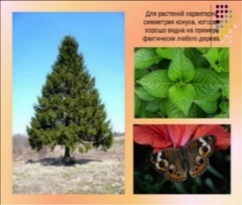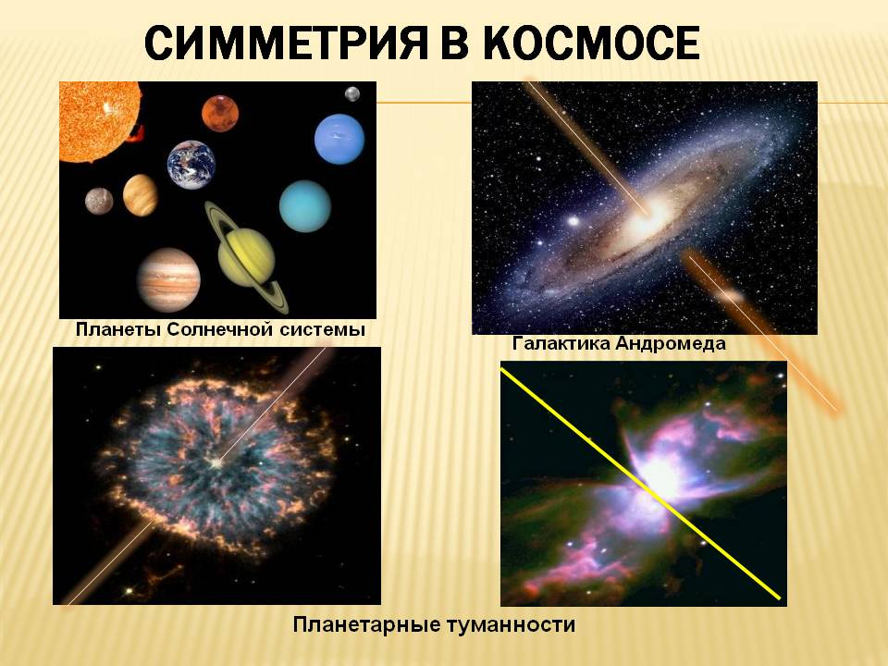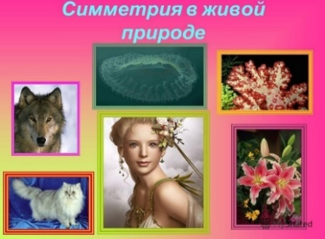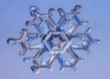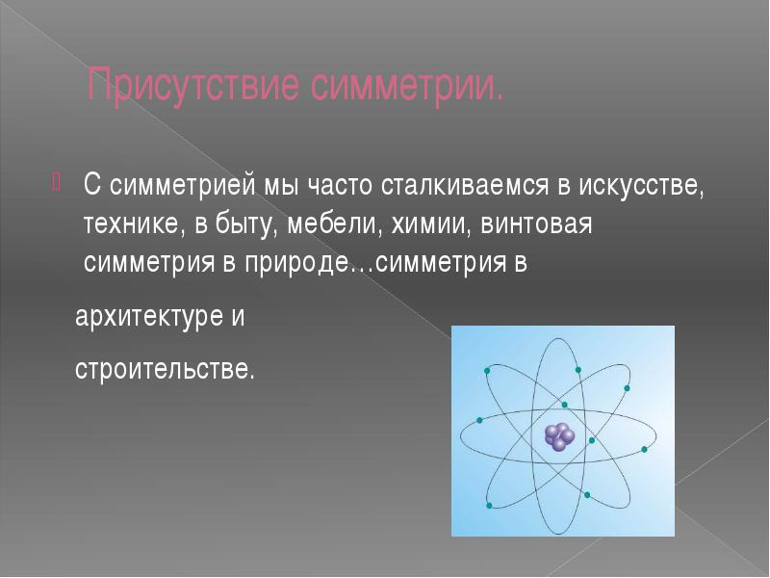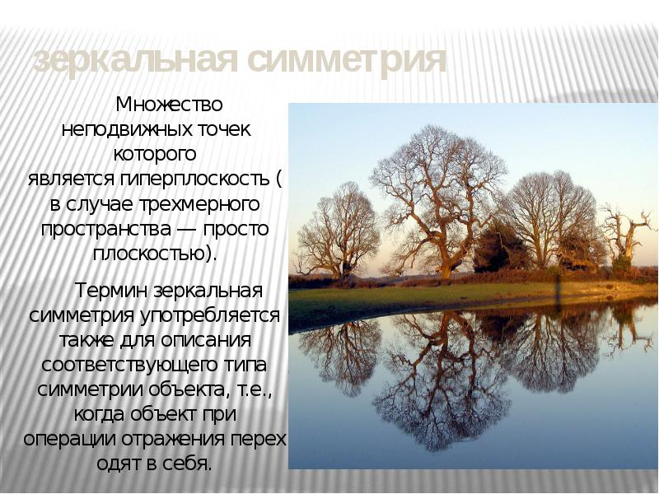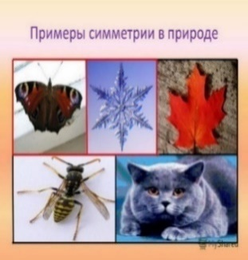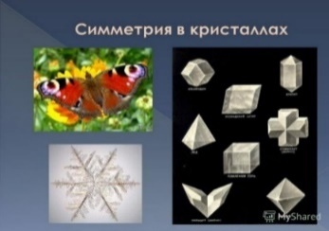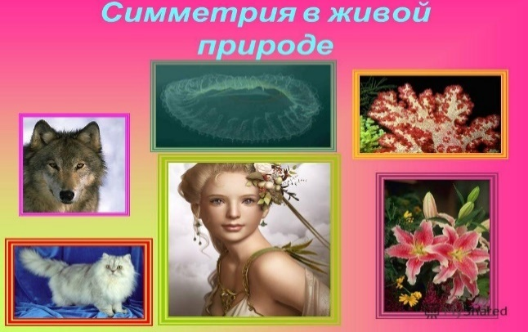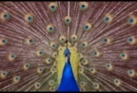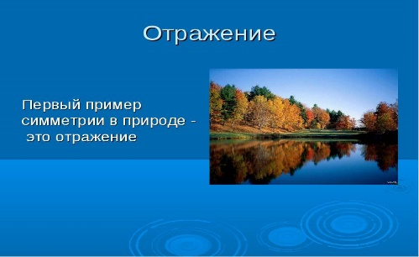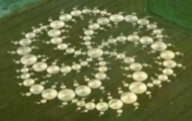

Figure 6 – The first principle of harmony of animate and inanimate nature: ‘golden mean, symmetry’

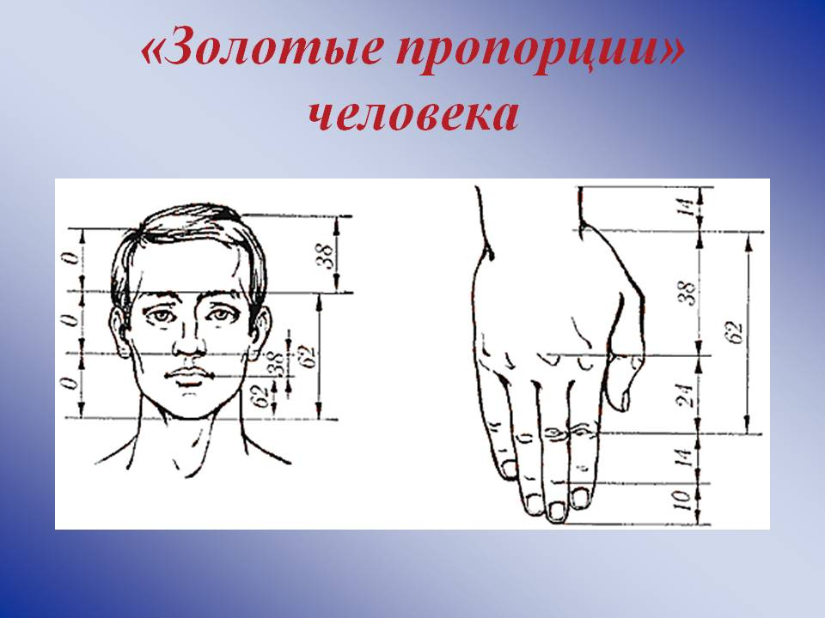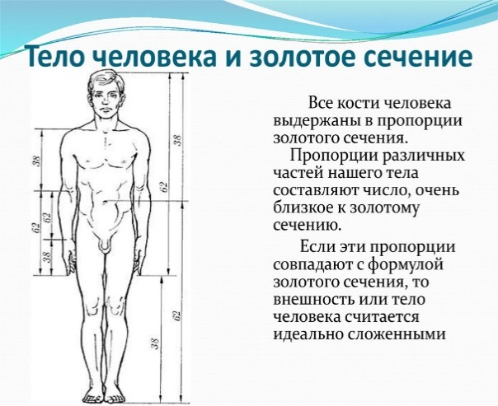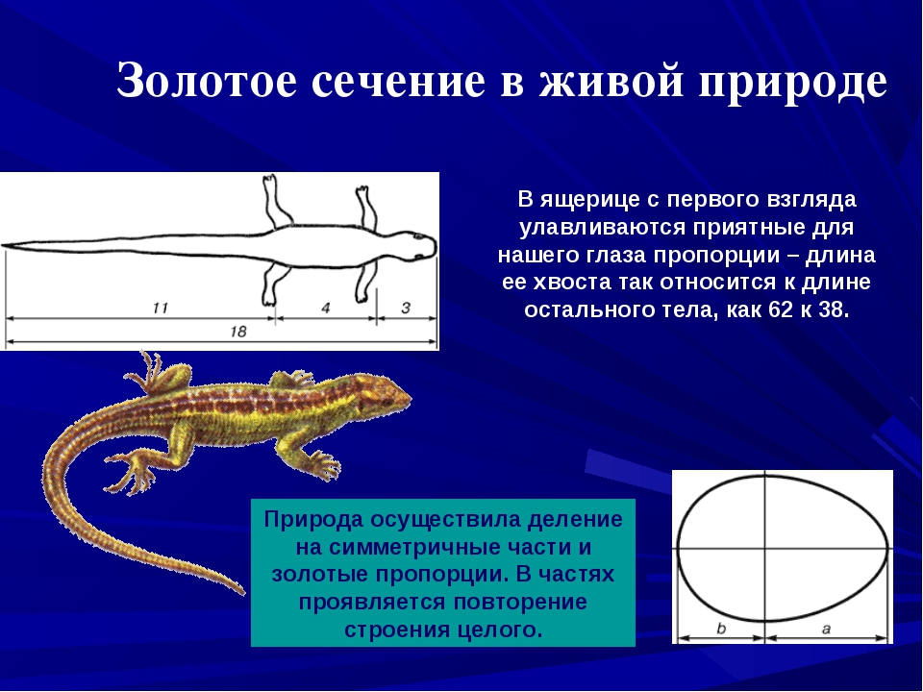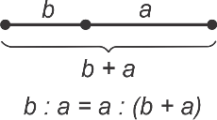

Figure 7 – The second principle of harmony of animate and inanimate nature: ‘golden sections, proportions’

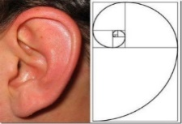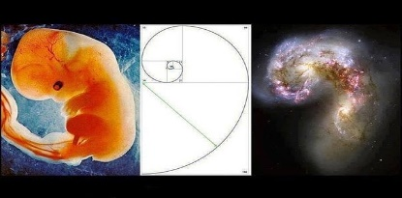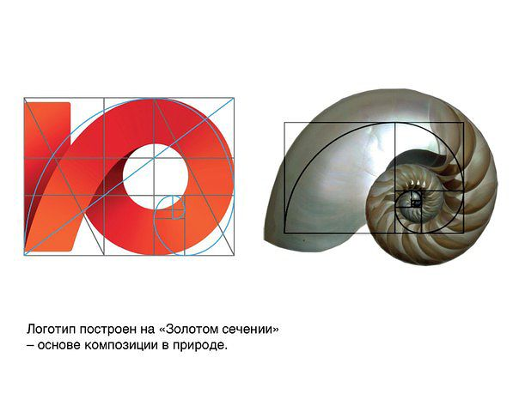

Figure 8 – The second principle of harmony of animate and inanimate nature: ‘golden spirals’

Observing different objects, a child learns their signs and properties. Understanding and generalizing such properties of natural objects as visibility, structure, pairing, tripartiteness, constructiveness, proportionality, similarity, balance, movability, continuity, causality, non-randomness, and others, leads to the realization of the ‘golden signs’ of the harmony in the natural world – ‘golden mean’ and symmetry, ‘golden sections and proportions’, ‘golden spirals.’ Understanding the signs of harmony and beauty of the natural world is essential in the development of the socio-natural thinking of a modern person who has difficulty in organizing harmless activities and creating a comfortable artificial habitat (Figure 9).

Золотые принципы социоприродного мышления и деятельности – Golden principles of socio-natural thinking and activities

Objectivity, functionality, integrity, consistency, environmental friendliness, morality, organismality, unity, interdependence, mutual development

Золотые признаки гармонии природы - Golden features of nature harmony

Золотая середина, симметрия – golden mean, symmetry

Золотые сечения, пропорции – golden sections, proportions

Золотые спирали – golden spirals

Свойства природных объектов - Features of natural objects

Зримость – visibility

Структурность – structurality

Парность - pairing

Троякость – tripartiteness

Конструктивность – constructiveness

Соразмерность – proportionality

Подобие – similarity

Сбалансированность – balance

Движимость – movability

Непрерывность – continuity

Казуальность – causality

Неслучайность – non-randomness

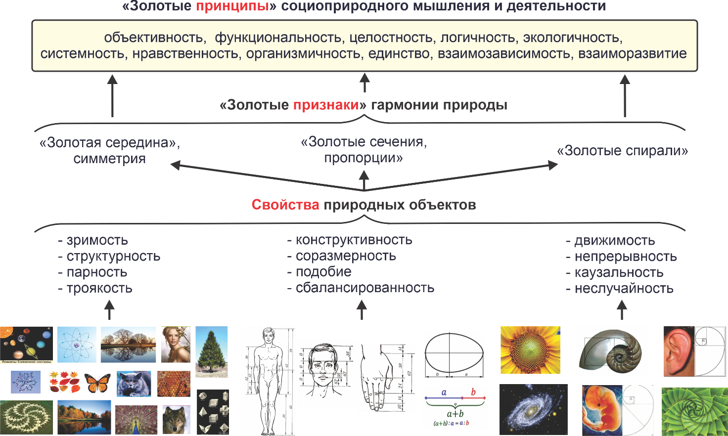

Figure 9 – ‘Golden principles’ socio-natural thinking and activities

The analysis of the ‘golden signs’ leads to the establishments of logical connection between them, manifestation of the integrating function of the ‘golden spirals’, combining both symmetry and the ‘golden sections’, and the most important signs of life – movement and development. There comes the understanding of the essence of the harmony in the natural world as a unity of ‘golden signs’, followed by hiding behind them ‘golden principles’ of functional self-organization, self and mutual development of all objects. This gives reason to realize and formalize the corresponding ‘golden principles’ of socio-natural thinking and activities by a human as a biological organism: objectivity, functionality, integrity, consistency, environmental friendliness, unity, morality, organismality, interdependence, mutual development. Being an organic link in the natural world, a human being is obliged to master and be guided by these principles in educational and professional activities.

**THE LIST OF SOURCES**

1. Цой В.И. Навигационные ориентиры инновационного евразийского мышления и взаимодействия / В.И. Цой, К.Т. Кусаинов, А.М. Федорук. – Караганда, 2020 – 192 с.
2. Цой В.И. Инструментальное обеспечение управленческого мышления. Часть 1. Инструменты / В.И. Цой; Академия системной аналитики и моделирования. – Астана, 2016. – 59 с.
3. Цой В.И. Педагогические технологии раскрытия инновационного потенциала: Часть I. Концептуальные ориентиры: Учебное пособие / В.И. Цой. – Караганда: КарГТУ, 2007. - 152 с.: ил.
4. Цой В.И. Мировоззренческие ориентиры управленческого мышления и деятельности: учебное пособие / В.И. Цой. – Караганда: КарГТУ, 2005. – 181 с.

**REFERENCES**

1. Tsoі, V.I., Kusainov, K.T., & Fedoruk, A.M. (2020). Navigacionnye orientiry innovacionnogo evraziyskogo myshlenia i vzaimodeiystvia [Navigational guidelines of innovative Eurasian thinking and interaction]. Karaganda: KarSTU [in Russian].

2. Tsoi V.I. (2016). Instrumental'noe obespechenie upravlencheskogo myshleniia. Instrumenty / V.I. Tsoi. Astana.

3. Tsoi V.I. (2007). Pedagogicheskie tehnologii raskrytija innovacionnogo potenciala: Chast' I. Konceptual'nye orientiry [Pedagogical technologies for the disclosure of innovative potential: Part I. Conceptual guidelines] Karaganda: KarSTU [in Russian].

4. Tsoi, V.I. (2005). Mirovozzrencheskie orientiry upravlencheskogo myhlenia i deiatelnosti [Ideological guidelines of managerial thinking and activity] Karaganda: KarSTU [in Russian].

**Б.Д. Каирбекова1, С.Х. Апаева2, М.Т. Kаирбекова3, А.Ж. Кайрамбаева4**

Инновационный Евразийский университет, Казахстан1

Кыргызский национальный университет им. Ж.Баласагына, Кыргызстан2

Высший колледж Торайгыров университета, Казахстан3

Инновационный Евразийский университет, Казахстан4

(e-mail: [kairbekova.bagzhanat@mail.ru](mailto:ipkm@mail.ru))

**Основные нравственные и концептуальные ориентиры образовательной и педагогической деятельности**

**Аннотация**

*Основная проблема:* Гуманное педагогическое мышление стремится охватить необъятное, и в этом сила образовательных систем и процессов, рожденных в его недрах.

Чтобы актуализировать ценность самораскрытия инновационных способностей учащихся при сопутствующей, обеспечивающей роли преподавателя, необходимо признать свой интеллектуальный рефлексивный механизм главным предметом образования. Развитые рефлексивные способности являются логичным условием для того, чтобы человек самостоятельно преодолевал всевозможные трудности в жизни и деятельности. В течение всего процесса учебно-педагогического взаимодействия с учащимися учитель должен следить за формированием этих способностей и, при необходимости, предпринимать корректирующие действия. Культура современного учителя определяется знаниями и умениями использования объективных методов и парадигм мышления, общения и взаимодействия. Демонстрируя эту культуру, учитель создает среду для взаимного развития и косвенно способствует самораскрытию потенциала учащихся, выступает своеобразным спусковым крючком, запускающим процесс их саморазвития на протяжении всей жизни.

*Цель:* понимание и формализация «золотых принципов» социально-естественного мышления и деятельности человека как биологического организма.

*Методы:* метод восхождения от абстрактного к конкретному, метод преобразования конкретных образов объектов на основе их абстрактной сущности, спекулятивный язык схематического представления мысли.

*Результаты, их значимость:* учитывая высокую динамику технологических изменений в мире деятельности, мы принимаем рефлексивную способность к самообразованию как основное средство самостоятельного раскрытия определенных профессиональных способностей, необходимых в жизни. Это означает, что, прежде всего, учащиеся должны научиться тому, как учиться, то есть научиться самостоятельно мыслить, критически воспринимать и преобразовывать полученную информацию в знания, задавать собственные вопросы, предлагать ряд ответов, логически формулировать и согласовывать различные точки зрения, накапливать знания вместе с другими. Инновационные методы и модели педагогической деятельности поощряют инновационные способности студентов, которые способствуют инновационному и технологическому развитию страны.

*Ключевые слова:* педагог, учитель, воспитательная функция, мышление, природоподобная парадигма, принципы взаимного развития, мыслительная деятельность, реализационная деятельность, восхождение от абстрактного к конкретному.

**Б.Д. Каирбекова1, С.Х. Апаева2, М.Т. Kаирбекова3, А.Ж. Кайрамбаева4**

Инновациялық Еуразия университеті, Қазақстан1

Қырғыз ұлттық университеті. Ж. Баласағына, Қырғызстан2

Жоғары колледж Торайғыров университеті, Қазақстан3

Инновациялық Еуразия университеті, Қазақстан4

(e-mail: [kairbekova.bagzhanat@mail.ru](mailto:ipkm@mail.ru))

**Білім беру және педагогикалық қызметтің негізгі адамгершілік және тұжырымдамалық бағдарлары**

**Аннотация**

Негізгі проблема: гуманитарлық педагогикалық ойлау орасан зор нәрсені қамтуға тырысады және бұл оның жер қойнауында туылған білім беру жүйелері мен процестерінің күші.

Оқытушының ілеспе, қамтамасыз етуші рөлімен оқушылардың инновациялық қабілеттерін өзін-өзі ашудың құндылығын өзектендіру үшін өзінің интеллектуалды рефлексивті механизмін білім берудің негізгі пәні ретінде тану қажет. Дамыған рефлексиялық қабілеттер адамның өмірдегі және қызметтегі барлық қиындықтарды өз бетінше жеңуінің логикалық шарты болып табылады. Оқушылармен оқу-педагогикалық өзара іс-қимылдың бүкіл процесінде мұғалім осы қабілеттердің қалыптасуын қадағалап, қажет болған жағдайда түзету шараларын қабылдауы керек. Қазіргі мұғалімнің мәдениеті объективті әдістер мен ойлау, қарым-қатынас және өзара әрекеттесу парадигмаларын қолдану білімі мен дағдыларымен анықталады. Осы мәдениетті көрсете отырып, мұғалім өзара дамуға жағдай жасайды және жанама түрде оқушылардың әлеуетін ашуға ықпал етеді, олардың өмір бойы өзін-өзі дамыту процесін бастайтын өзіндік триггер ретінде әрекет етеді.

*Мақсаты:* адамның биологиялық организм ретіндегі әлеуметтік-табиғи ойлауы мен іс-әрекетінің «алтын принциптерін» түсіну және ресімдеу.

*Әдістер:* абстрактіліден нақтыға көтерілу әдісі, объектілердің нақты бейнелерін олардың абстрактілі мәніне қарай түрлендіру әдісі, ойды схемалық бейнелеудің алыпсатарлық тілі.

*Нәтижелер, олардың маңыздылығы*: қызмет әлеміндегі технологиялық өзгерістердің жоғары динамикасын ескере отырып, біз рефлексивті өзін-өзі тәрбиелеу қабілетін өмірде қажетті белгілі бір кәсіби қабілеттерді өздігінен ашудың негізгі құралы ретінде қабылдаймыз. Бұл дегеніміз, ең алдымен, студенттер қалай үйренуді үйренуі керек, яғни өз бетінше ойлауды, сыни тұрғыдан қабылдауды және алынған ақпаратты білімге айналдыруды, өз сұрақтарын қоюды, бірқатар жауаптар ұсынуды, әртүрлі көзқарастарды логикалық түрде тұжырымдауды және үйлестіруді, басқалармен бірге білім жинауды үйренуі керек. Педагогикалық қызметтің инновациялық әдістері мен модельдері елдің инновациялық және технологиялық дамуына ықпал ететін студенттердің инновациялық қабілеттерін ынталандырады.

*Түйін сөздер:* мұғалім, мұғалім, тәрбиелік функция, ойлау, табиғатқа ұқсас парадигма, өзара даму принциптері, ақыл-ой қызметі, іске асыру қызметі, абстрактіліден нақтыға көтерілу.