The impact of the beauty standards on academic performance
Intro:
Within the contemporary society so decisively influenced by the press and social networking, these beauty standards dominate a human being's world in so many critical fields. Most of such standards are part of public sentiment that have crucial effects on self-esteem, confidence, and human behavior.
This research work embarks on an inquiry into the influence of beauty standards on academic achievement, a vital component in personal growth and future success, because one is increasingly aware that a student's self-image and confidence can alter their capability for concentration and accomplishment in educational settings. Students who do not align with societal beauty ideals, become victims of self-doubts, social alienation, and generally lower involvement in academic life. Subsequently, female students in school are more likely to face some eating disorders like anorexia nervosa, bulimia nervosa or binge eating. Those illnesses affect approximately on 5.7% of adolescent girls, almost 2 in a class of 30. Someone with bulimia nervosa is approximated to suffer from double probability of early mortality compared to those without the condition, while one suffers from anorexia nervosa is expected to be about six times more likely to have early death.
It will also focus on the policies and programs regarding schools that work best to mitigate the effects of such beauty standards on students' confidence in speaking up in class. One such program is KiVa, which, while associated with reducing bullying, does have a part in aiding issues about appearance-based discrimination in schools and inclusivity that could be of immense help in reducing some of the pressures of the societal beauty norms. This research will evaluate the effectiveness of KiVa in Kazakhstan’s educational context, focusing on schools in both urban and rural areas, such as schools in Ridder, Shemonaikha, Zaisan, Tarbagatay, and Akzhar.
School uniforms will also be considered as a potential tool for reducing the influence of beauty standards. By standardizing student appearances, uniforms may help create a more equal and focused learning environment. These factors may further contribute to academic inequality.
Much of the prior research focuses on self-esteem as a cause of disparities in academic outcomes. There would therefore appear to be a gap in existing research into the role played by beauty standards. Educators, counselors, and psychologists said that it was an issue worth investigating to understand exactly what types of pressures exist and how those pressures could be diminished. The study examined programs such as KiVa and the role of school policies in order to come up with some strategies on how to nurture self-acceptance and reduce some of the damages from current beauty standards in society current study, therefore intended to assist students in reaching their full human potential where helping students achieve an academic environment that is equitably free from physical appearance discrimination is attained.

Aims:

The research aims to analyze how social construction of beauty norms affects the self-esteem of the students in particular in relation to their participation and engagement in the class. It goes further to explore the amount of resources, time and money in particular, that students from Kazakhstan allocate to beauty and the hair and makeup, and how these commitments affect their concentration on studies. In addition, the study will investigate which school policies allow wearing a uniform and which include restrictions on beauty such as KIVA anti-bullying programs that reduce the stress surrounding social beauty norms. In order to achieve the goal, the following research questions are going to be:

● How much money do Kazakhstani students spend on beauty treatments?

● How long do they spend on this procedures?

● What consequences that may lead?

● What role does school policy and the environment, such as uniform rule, inclusivity programs like KIVA, play in countering the harmful effects of beauty standards on academic achievement?

● Are students who meet societal beauty standards treated differently by teachers and peers than those who do not?

● How do societal beauty standards influence students’ confidence and willingness to participate in classroom activities?

● To what degree do beauty norms affect students’ academic performance and level of engagement in their studies?

We hypothesise that one of the lines of inquiry is how self-esteem related to adherence to beauty standards interacts with academic confidence. The research investigates how peers and appearance-related pressures relate to student participation in class. It also tries to determine whether certain groups of students, particularly female students or students from poorer backgrounds, experience such beauty-related pressures differently. In order to solve the issues that may come from our research, we suggest to ask students for help from school psychologists; create a supporting school environment by training teachers (KIVA) or implement policies against bullying or discrimination. Finally, strategies will be identified for educators and policymakers on how to mitigate the negative consequences of rigid beauty ideals in school cultures, thereby reinforcing positive and inclusive ideals that reward all students.

Context

In 21st century the beauty standards play crucial role in life of majority people around the world. Each person has its own individual perception of beauty, but social media still trying to bind one common concept for all of the people as a modern standard. It is specifically reflected on students and their academic performance in school. Looking at it now, newly established standards that almost rooted deeply in student`s minds disrupt them from paying enough attention to their studies.

Across the ages, standards of hair styles were changed and normalized in society. So, people have exact norms of hair colour and length that have impact in schools too. Weitz (2008) found that women who drew attention to their minority status with their hair were perceived by others to have lower credibility in the workplace. Teachers and students, specially, women pay more attention and spend more time to their appearance at school to not be judged. Thus, young women try to be perfectly proportionalized in body shape and spend big amount of money. Worldwide, the weight loss industry is worth $586 billion and has a 98% failure rate (Rossini, 2015). Moreover, spending time in gyms and beauty salons students forget about studies. Not only does standards effect on people’s finance but also impact on student’s academic performance.

The widespread influence of beauty standards has led to a growing reliance to cosmetics, especially among young female students, because they wish to conform to social expectations of attractiveness and feel insecure about their appearance. All of this, often leads to a reduced focus on education and emotional well-being, significantly impacting on peer relationship too. For instance, professors Brown & Jasper (1993) found that worries about appearance can create mental distractions, reducing ability to participate actively in lessons, lectures or complete assignments effectively. Female students who feel pressured to meet newly fixed beauty standards often dedicate more time and energy to their appearance being good through make-up, rather than concentrating on their academic achievements. According to Darling-Wolf (2009) this attention to cosmetics can negatively effect on their self-esteem by promoting more and more unfavorable thoughts about being “ugly”, so young female students cannot go out without make-up on.

Beauty standards can influence students’ academic performance in various ways. According to the latest research of professors, students who view themselves as unattractive may experience low self-esteem, hence there are huge reduction in their confidence in academic settings, leading to a decline in participation, classroom engagement and overall performance (Daniel S. Hamermesh & Amy Parker. 2005). Moreover, when students prioritize beauty, it may affect on their relationships with peers and teachers. In the first place, students often compare themselves to peers in beauty and academic performances, so they feel envy or jealousy and become more insecure (which can affect on marks too). Therefore, people who are recognised by society as attractive person may feel a lot of pressure to match their appearance and study hard. On the other hand, teachers think that female students that are into fashion and looks are always not smart and do not care about education, so they intentionally be biased and fail some students.

From economic perspectives, students waste a lot of time and money for fashion and attitude under the influence of beauty norms, to be more precise people spend financial sources for gym, cosmetics and hair products. Along with it, beauty standards and their effect on academic performance have ethical implications other than economic perspectives. One of the primary ethical problems is the potential discrimination based on physical appearance of students (especially, female ones). Students who do not fit into a socially acceptable standards of beauty may be unfairly treated in their studies and face some inequalities by their peers. From educational lenses, students prioritizing beauty may allocate disproportionate time to cosmetics and appearance maintenance, reducing the time spent on studying and academic development.

Observing this theme from the global perspective, research shows that physical attractiveness can affect academic performance due to teacher bias, social interactions, and self-esteem. Research, for example (nevada-today by Kjerstin Gruys. 2019), shows that attractive students often get higher grades due to unconscious positive assumptions from teachers. Attractive students also benefit from better peer relationships, which increases their self-confidence and engagement, while less attractive students may face bullying, which negatively affects their academic performance. Self-confidence is also important. Attractive students often treat themselves better, which helps them stay motivated. However, these effects depend on culture: in Western countries, more attention is paid to appearance, while in other cultures, less attention is paid to appearance. School uniforms can help by reducing attention to appearance. Fair treatment and a supportive environment are the key to the success of all students.

Therefore, we can also consider this topic from the point of view of local peculiarities: students in Kazakhstan often demonstrate a higher level of concentration and organization due to compulsory school uniforms. (Order of the Minister of Education and Science of the Republic of Kazakhstan dated January 14, 2016 No. 26, registered with the Ministry of Justice of the Republic of Kazakhstan on February 16, 2016). School uniforms can reduce differences in perception of appearance among students and help reduce the number of incidents of harassment related to clothing. A student’s appearance may affect the perception of teachers or peers, as clothing or appearance may reflect social status.

In conclusion, on the one hand, taking care of yourself and self-development is essential for students. On the other hand, the impact of beauty standards on students, is an important issue that has yet to be fully explored in the context of academic performance and peer relationships. Additionally, the impact of beauty standards on students` study and peer relationship have both drawbacks and benefits.

RESULTS

Quantitative data was based on the interrelation between the level of beauty standards and academic performance and served as a basis for the survey conducted among 220 students of NIS Oskemen.

Demographic breakdown of respondents

Among the 220 respondents, 7th graders constituted the largest group (33.2%), followed by 8th grade(28.6%), 10th grade (16.8%), 9th grade (11.4%), 11th grade (8.2%), and least one grade 12 (1.8%). Regarding gender distribution, 55.9% identified as female and 44.1% as male.
Time and financial investments in appearance maintenance
Regarding time, 53.9% of 217 respondents take less than an hour a day, 39.6% of the respondents spend 1-3 hours, and 6.5% over 3 hours daily. Financially, 59.6% of 218 respondents declared that they spend up to 10,000 tenge per month to keep their appearance good, 29.8% spend from 10,000 to 30,000 tenge, and 10.6% spend over 30,000 tenge. These findings denote how students vary in their investment within their appearances, time and financial investments surely differ. It can be perceived to show how beauty standards are at work in academic settings.
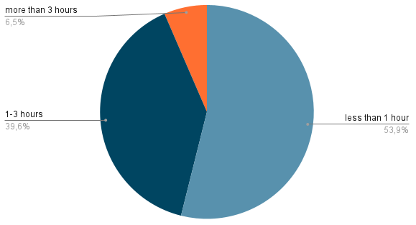

School regulations on appearance
In regard to the question about restrictions or prohibitions regarding appearance by their school, 96.4% out of 220 responded in the affirmative and 3.6% responded "no". When individuals were asked about how students follow the school rules or regulations regarding appearance, 44.7% indicated always, 42% most of the time, 11.4% sometimes follow them, while 1.8% reportedly never follow the rules. Numbers indicate just how great a part institutional regulations play in shaping student presentation and self-concept.
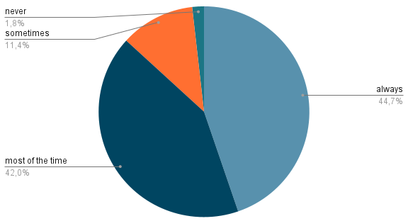
Perception of appearance as a factor in intellectual assessment
The survey tried to find out whether appearance is viewed as an important factor in evaluating intellectual abilities. Out of 219 respondents, 49.8% absolutely disagreed, while 21.5% partially disagreed, showing that the majority do not consider appearance to be an indicator of intelligence. However, 25.6% partially agreed, and 3.2% totally agreed, showing that a small segment of students believe that appearance plays a role in the intellectual evaluation of a person.
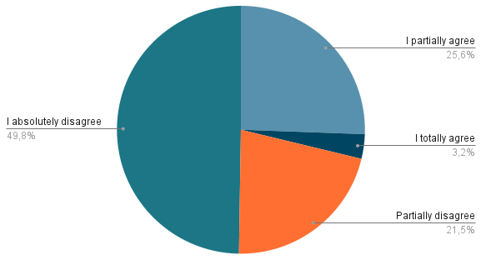
Influence of appearance on teachers’ attitude towards students
Out of the 218 responding, 42.2% partially agreed that the appearance or adherence to standards of beauty would influence the attitude of the teachers towards them, while for totally agreed, the percentage was 11.9%, and partial disagreement constituted 23.9%, with 22% being those that absolutely disagreed; this thus shows division but with a leaning toward attitudes being influenced.
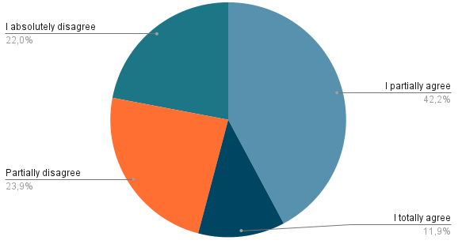
The impact of appearance on mood and academic performance
The survey has also looked into whether students' mood, dictated by their looks, impacts concentration or academic performances. Out of 220 responses, 39.1% agreed somewhat and 16.4% fully that their academic performances are impacted because of how their mood on account of one's appearance creates it. This notwithstanding, the feeling that students did not witness this is corroborated by a relatively higher disagreement recorded as well-27.3% disagreed, while 17.2% somewhat disagreed.
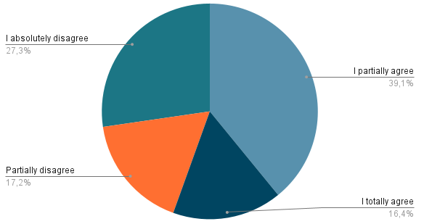
Influence of appearance discussions on academic performance
On one hand, comments regarding students' appearance, jokes, and even criticism may, as the response has shown, have an impact on academic performances. Out of the 219, 48.9% partially agreed while 21.9% of them totally agreed, hence making the majority belief in the minds of students that discussion of appearances does affect their academics. On the other hand, 16.4% partially disagreed and 12.8% completely disagreed, which shows that the minority of students do not consider such discussions to be connected with their academic performances. Further, descriptive statistics showed main trends in responses. The results suggest that comments on beauty may affect students' engagement in school and their self-esteem, though the impact is different for everybody.
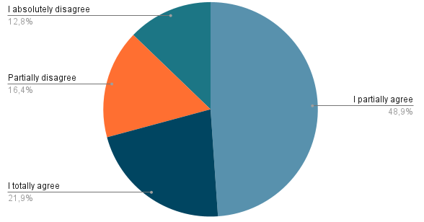
Differences in beauty standards in Kazakhstan compared to other countries
Opinions were divided on whether standards of beauty differ from other countries. 45.7% of 219 participants partly agreed and 28.3% fully agreed that the standards of beauty in Kazakhstan differ from elsewhere, while a smaller proportion of 21.5% partly disagreed and 4.6% completely disagreed. The tendencies within the obtained results support this thought that Kazakhstani standards of beauty differ from that of the globe and add up to the students' self-image and confidence and social pressures.
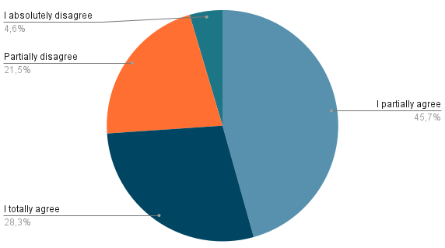
We predict that these beauty pressures will continue to impact students' performances, self-confidence, and participation at varying magnitudes. The effects flow from institutional policies down to the level of societal norms, forming the basis of interaction among students in daily life. These could very well support an enabling learning environment that values well-being over outward appearances.
Another method that we used during our research is qualitative data which is based on these interviews with three psychologists from NIS School in Oskemen that will reveal how beauty standards influence the students' mental condition, whether appearance-based biases take place in regard to academic performance, and how effective school uniforms and programs like KIVA are in overcoming these challenges.
Psychological Effects of Beauty Standards on Students
Psychologist 1 explained that the lessons of personal development are very crucial in guiding the students through issues of body image, especially when they enter adolescent stages characterized by physical and hormonal changes. The discussions help them build confidence in themselves and give them a different self-image. According to Psychologist 2, the pressure to be beautiful may result in anxiety, self-doubt, and social isolation. The students become too concerned with the way others may perceive them; this makes them feel insecure and withdrawn in social situations.Psychologist 3 further explained that such pressures lead to stress-related issues, such as an inability to focus in class or to eat well. Others withdraw from social contact for fear of not being accepted. To this, the psychologist did say that this is where support systems become hand-in-hand in building up self-acceptance and resilience.
How Appearance-Based Prejudices Influence School Performance
Psychologist 1 added that motivational problems may arise in students who are teased or feel ignored because of their appearance, which then affects their schoolwork, though this is not always the case. In addition, according to Psychologist 2, based on her experience, she cannot see a connection between appearance concerns and deteriorating academic performance as some students might be uncomfortable with their looks, but they do not refrain from participating in class. For Instance, Psychologist 3 outlined that "the student may become shy, will not participate in discussions, and even will not take up leadership roles within a group"; though this does not directly affect the grades, some level of discomfort and shyness may arise when approaching learning activities.
Do School Uniforms Have a Positive Impact on Reducing Appearance-Based Biases?
Psychologist 1 believes that school uniforms create some sort of uniformity but give leeway to the students to express themselves in other aspects. Psychologist 2 agreed and added that because of the uniforms, there is less judgment about clothes, making the school environment at least friendlier. On the other side, Psychologist 3 pointed out that even though the wearing of uniforms reduces fashion-related pressure, it does not nullify all the comparisons since students can feel insecure about their body parts. The psychologists added that these uniform policies should go hand in hand with open discussions of self-acceptance and respect if a positive school culture is to be created.
KIVA's Role in Reducing the Social Pressures
Psychologist 1: Since the beginning of KIVA, no student has complained about pressures about outward appearances. Psychologist 2: The KIVA program is not only about standards of beauty but also helps students build emotional intelligence and respect toward one another, thus helping to create a more wholesome environment in schools. Psychologist 3: No program in the world would completely take off the pressures resulting from social intercourse, but KIVA at least provides the students with better coping mechanisms against these pressures.
How effective is KIVA in the school community at NIS?
According to Psychologist 1, KIVA turns out to be very effective to help 7th and 8th graders develop a supportive mindset during a very critical stage of their growth. Psychologist 2 pointed out that for any program to be successful, it must be well-planned and properly executed. To this, Psychologist 3 agreed and went on to elaborate that KIVA can create long-term change only if supported by teachers, staff members, and students, meaning when the whole school unites to elevate kindness and inclusiveness, it is then that programs like KIVA bring positive change into existence.
We predict that according to the findings from the interviews beauty standards and appearance-based biases can significantly impact students’ self-esteem and social confidence, which in turn may affect their engagement in school.

Our third method is focus group discussion, including Kazakhstani students of NIS Öskemen in grades 10 through 12. Three sample groups of 6 to 8 participants, drawn from socio-economic and cultural backgrounds, were randomly selected. The following section presents the qualitative analysis of the responses given by the students regarding how the standards of beauty might have affected academic performances and relations in school. Major results derived from the discussion within the focus group are summarized below.
Manifestation of Societal Beauty Standards Among Students
Based on this, several ways in which the manifestation of these beauty standards was witnessed within the school environment were highlighted by the participants, mainly through hair, clothes, and makeup, especially for female students. One of the participants said, "Girls make their hair curly, wear fashionable clothes, and put on makeup just to be allied with perceived norms". Another participant added that there are categories, such as classic style preferences, hygiene practices like skincare, makeup use that may create some competition among girls. While younger students, mentioned these superficial aspects of style to "fit in" with peers, older students, acknowledged competition and categorized beauty-related behaviors thoughtfully to show a more critical understanding of social norms.
Influence of Appearance on Peer and Teacher Perceptions
Student reactions to the impact of appearance on peer and teacher relationships varied. Some did not find it that important since over time friends and teachers get used to how people look. The others noted that students with an "unusual" appearance can be avoided and teased, therefore, thereby making it more difficult to focus in class. One of the older participants further observed that though in most cases, peer evaluation based on looks decreases over time, these judgments still persist, especially concerning people who lie outside the average norms. She further identified that teachers usually unconsciously give more attention to well-attired or neat students by associating a good appearance with better behavior and intelligence. While younger students focused on teasing and simple teacher behaviors, older students offered insights into more complex dynamics, such as the impact of appearance on long-term confidence and self-esteem.
Common Appearance-Based Challenges
Boys reported feeling pressure from society to be strong in appearance or muscular, while teasing about weight, height, and clothes was experienced by all.
Social media compounded the problem through its facilitation of comparisons with faultless-appearing influencers, thereby inducing complexes, especially among young people with skin problems such as acne. Younger students more often reported bullying and teasing as the big issues. In contrast, the older students highlighted some subtle issues, such as social comparison, anxiety, and difficulty in developing a positive self-concept.
Role of Teacher Training in Mitigating Appearance-Related Bias
The most significant point raised by the students was that teachers need training in order to avoid appearance-related bias. Sometimes, teachers have been found giving more attention to neat or stylish students, apparently because they relate neat appearance to intelligence and good behavior. The trainings necessary to make sure that teachers treat all students equally and that they are supporting those suffering at the hands of appearance-based bullying. Suggestions from younger students tended to be basic, such as "teachers just being nice." Older students focused on how such training would unearth unconscious bias and offer psychological support to students.
School Strategies for Supporting
A number of remedies were suggested for students who felt unconfident due to their appearance. The anti-teasing rules were suggestions by participants such as the KIVA anti-bullying program and encouragement of teachers to side with the bullied student. The younger students suggested simple remedies, like teachers telling children to stop bullying. Long-term psychological interventions, inclusive school environments, and mental health resources were underlined by the older students as important in the creation of a supportive school climate.
Cultural and Global Beauty Standards
As participants noted, traditional beauty standards, such as fair skin and slim figures, remain influential in Kazakhstan. However, social media has introduced Western ideals, blending global and local standards. Although body positivity trends are gaining traction globally, they are still in their early stages in Kazakhstan. Younger students primarily described local norms and social influences within their immediate environment, while older students demonstrated greater awareness of global trends, highlighting the unrealistic nature of both cultural and international beauty ideals.

We predict that beauty standards and prejudices based on appearance significantly affect students' self-esteem, reducing their involvement in school life. It is most likely that students in schools will be influenced by this at varying intensities now and in the future, with those influences becoming standardized in social and educational norms. Schools should offer an environment where the well-being and inclusion of students are valued above appearance judgment.

Conclusion

The findings of the research make known the far-reaching impact beauty standards have on the performance of students at school, confidence levels, and their social relationship within school. Through the use of mixed research methodology like surveys, interview of psychologists, and group discussion, this research provides extensive coverage of the manner in which conformity pressure on appearance standards affects students in NIS Oskemen.

Quantitative findings indicate that students spend differential levels of money and time on their looks, defining the salience of beauty standards in daily life. While the vast majority of students do not think appearance is a factor in determining intelligence consciously, there is a considerable percentage that suggests that it influences teachers’ impressions and opportunities for learning. In addition, mood variation due to appearance concerns is observed to affect learning participation and concentration, with some of the students revealing that compliments, criticism, or discussion about their appearance affects their performance.

Qualitative results obtained through psychologist interviews depict the psychological effect of beauty standards with professionals revealing the presence of anxiety, self-doubt, and loneliness among students. The discussion also elicited how appearance-based prejudices would be in a position to initiate motivational issues, social exclusion, and diversity of participation within the classroom. School uniforms were previously known to be the constricting effect of wearing fewer fashion pressures, but they were not in a position to eliminate all appearance-based comparisons and anxieties. Additionally, the KIVA program was defined as a great program for the establishment of healthy school culture but long-term success depends on recurring reinforcement and community reinforcement.

Also, the focus group interviews facilitated deeper analysis of the students’ representation of the standards of beauty, namely via the clothes, make-up, and looks. The students spoke of pressures to conform, and some went as far as suggesting that appearance influences peer relationship and teacher opinion as well. Younger pupils were more under the influence of teasing and comparison with others, while older pupils were more critically aware of universal and societal standards of beauty. The discussions also raised the issue of training teachers to be sensitive to unconscious stereotypes and providing psychological counseling to pupils who were obsessed with their looks.

Overall, the evidence of this study suggests that beauty standards play an important role in affecting students’ academic achievement, social self-worth, and emotional well-being. Pressure to look has been voiced in virtually all facets of school life, ranging from self-concept to teacher-student relations. Since these are multi-faceted in nature, schools must employ specialized interventions, such as awareness programs, mental health counseling, and teacher training in a bid to build a healthy and respectful school climate.

References:

Brown, C., & Jasper, K. (1993, November). “Why women? Why weight? Why now?”. Weight Preoccupation and Eating Disorders & Toronto: Second Story Press, pp. 16-35. https://d1wqtxts1xzle7.cloudfront.net/108777877/1-libre.pdf?1702326788=&response-content-disposition=inline%3B+filename%3DWestern_Beauty_Pressures_and_Their_Impac.pdf&Expires=1731762722&Signature=FaCrZiL7N1Cts078MUoXEVpt4fX66ZVNjnMpy5ONe0b-4vxTpcmtKtGcjasFbrpiOi83TWay279JGiGBscJbnXCeQAWpKIdvxF71oP43ic-4YnirzZHQPVe5eL4qn03AdtUUTOwXMLThGscpU3klWGJKHc1c1R-dPSOPyMN0w0uGqnIuyip35Ftn9pUqA2d0rafKWWWZphroV66DwBbOrTRPXNq6ifS6k2hLzQb2BSLZgCyq0ZX4rbVE~IO1-4wjAsblGJjsMoecsH2adXqD-DASVSh0UBQDk9Maq8g5moRhVGGvfbb2PpuNXSHr21wflXkBQmFmXmJ5Bpr8pNjqWg__&Key-Pair-Id=APKAJLOHF5GGSLRBV4ZA

Darling-Wolf, F. (2009, January). From airbrushing to liposuction: The technological reconstruction of the female body. International Journal of Gender and Women’s Studies, 6(2), pp. 251-256

https://repository.library.georgetown.edu/handle/10822/930212

Weitz, R. (2008, October 5). Women and their hair: Seeking power through resistance and accommodation. Sociology of the Body, pp. 314-320.

https://d1wqtxts1xzle7.cloudfront.net/108777877/1-libre.pdf?1702326788=&response-content-disposition=inline%3B+filename%3DWestern_Beauty_Pressures_and_Their_Impac.pdf&Expires=1731762722&Signature=FaCrZiL7N1Cts078MUoXEVpt4fX66ZVNjnMpy5ONe0b-4vxTpcmtKtGcjasFbrpiOi83TWay279JGiGBscJbnXCeQAWpKIdvxF71oP43ic-4YnirzZHQPVe5eL4qn03AdtUUTOwXMLThGscpU3klWGJKHc1c1R-dPSOPyMN0w0uGqnIuyip35Ftn9pUqA2d0rafKWWWZphroV66DwBbOrTRPXNq6ifS6k2hLzQb2BSLZgCyq0ZX4rbVE~IO1-4wjAsblGJjsMoecsH2adXqD-DASVSh0UBQDk9Maq8g5moRhVGGvfbb2PpuNXSHr21wflXkBQmFmXmJ5Bpr8pNjqWg__&Key-Pair-Id=APKAJLOHF5GGSLRBV4ZA

Rossini, E. (2015, October 4). The illusionists: A film about the globalization of beauty. Cultural Studies Review, 21(2), 35-40. Retrieved from http://csulb.kanopystreaming.com/video/illusionists-filmabout-globalization-beauty

Order of the Minister of Education and Science of the Republic of Kazakhstan. (2016, January 14) pp. 26, registered with the Ministry of Justice of the Republic of Kazakhstan (2016, February 16)

https://www.gov.kz/memleket/entities/edu?lang=en

Tatyana Deryugina & Olga Shurchkov. (2014, October 6). Does beauty matter in undergraduate education? Economic inquiry Volume 53, pp. 940-961

https://onlinelibrary.wiley.com/doi/full/10.1111/ecin.12152

Ashley Mckay1 , Shannon Moore1 & Wendee Kubik1. (2018, December 21). Western Beauty Pressures and Their Impact on Young University Women. American Research Institute for Policy Development, pp. 2-6.

https://d1wqtxts1xzle7.cloudfront.net/108777877/1-libre.pdf?1702326788=&response-content-disposition=inline%3B+filename%3DWestern_Beauty_Pressures_and_Their_Impac.pdf&Expires=1731762722&Signature=FaCrZiL7N1Cts078MUoXEVpt4fX66ZVNjnMpy5ONe0b-4vxTpcmtKtGcjasFbrpiOi83TWay279JGiGBscJbnXCeQAWpKIdvxF71oP43ic-4YnirzZHQPVe5eL4qn03AdtUUTOwXMLThGscpU3klWGJKHc1c1R-dPSOPyMN0w0uGqnIuyip35Ftn9pUqA2d0rafKWWWZphroV66DwBbOrTRPXNq6ifS6k2hLzQb2BSLZgCyq0ZX4rbVE~IO1-4wjAsblGJjsMoecsH2adXqD-DASVSh0UBQDk9Maq8g5moRhVGGvfbb2PpuNXSHr21wflXkBQmFmXmJ5Bpr8pNjqWg__&Key-Pair-Id=APKAJLOHF5GGSLRBV4ZA

Hamermesh D. S. & Parker A. (2005) Beauty in the classroom: Instructors` pulchritude and putative pedagogical productivity. Economics of education review & ScienceDirect, 24(4), pp.35-40.

https://www.sciencedirect.com/science/article/abs/pii/S0272775704001165

Kjerstin Gruys (2019, May 1). How does appearance affect our success. Nevada Today.

https://www.unr.edu/nevada-today/news/2019/atp-appearance-success

https://d1wqtxts1xzle7.cloudfront.net/108777877/1-libre.pdf?1702326788=&response-content-disposition=inline%3B+filename%3DWestern_Beauty_Pressures_and_Their_Impac.pdf&Expires=1733479717&Signature=YhRUsZd85soEV6GaluGgi5w-Vk~NB8c~L1R-oxp2kn7v6PuRjQy66rpUjaubMM5-4u75-YxJbMycBXB66nvTvbbvPyVIQTdTFghaNJD0sARLtxCQWgny-cmBynBUd87PIisLEFMKd6xeNuB~0HLd38iPMeSSfRkaHQfBqKza~XuOeq8Tf1dTcIag8r9dvcNrhGz70R~onNxfVUTFqZhd5gKWSbtwyeInMut5VbkYH8bVgdK7CgVYLafB1KBRlcU8l56KDJJyZpqNNbvhL4M0kT7coaKaUfcNCuaRCj6MSWc~dvN-0i43x1Z8t1on8mhjBCi-k3eHabDCRiM2to9Lgw__&Key-Pair-Id=APKAJLOHF5GGSLRBV4ZA

https://www.ucl.ac.uk/news/2016/apr/school-affects-girls-chances-being-diagnosed-eating-disorder

