**UDC 637.138**

**МРНТИ 65.63.33**

**M.B. Rebezov 1*, M.V. Timerbayeva 2, T.I. Uryumtseva2**

1*Federal State Budgetary Scientific Institution «Federal Scientific Center for Food Systems named after V.M. Gorbatov», Russia

2Innovative University of Eurasia, Kazakhstan

*(e-mail: rebezov@yandex.ru)

**Results of mathematical analysis of experimental data**

**fermentation of skimmed milk to produce a fermented milk product**

**Annotation**

*The main problem*: Modern research in the development of fermented milk products is focused on increasing the bioavailability of milk components, as well as the use of bacterial components of sourdough, which increase health properties. The use of the fermentation process of skimmed milk with a combined starter consisting of traditional for cottage cheese and starter cultures of probiotic cultures immobilized in a gel of biopolymers is very important.

*Purpose:* The purpose of this study is to determine the optimal amount of starter, consisting of an association of probiotic cultures immobilized in a gel of biopolymers (membranes) to be added to fermented skimmed milk in order to enrich it with functional ingredients.

*Methods:* A one-factor experiment was used. The culture association Propionibacterium freudenreichii subsp. was used as a regulatory factor. *Shermanii, Bifidobacterium lactis* and *Streptococcus thermophilus*, immobilized in a biopolymer gel, added to skimmed milk in the form of membranes (determined as a percentage of the mass of fermented milk). Controlled factors are the main indicators characterizing the efficiency of the skim milk fermentation process, these are active acidity, the logarithm of the number of viable cells of bifidobacteria, the logarithm of the number of viable cells of propionic acid bacteria, and organoleptic evaluation.

*Results and their significance:* Based on the results of a mathematical analysis of the totality of values of controlled factors depending on the amount of starter cultures of probiotic cultures, mathematical models were built to determine the degree of influence of the starter on the quality indicators of the product, using the Table Curve 3D-v4 mathematical computer program.

Key words: fermentation, sourdough, probiotic cultures, bifidobacteria, propionic acid bacteria, skimmed milk, immobilized culture.

**Introduction**

At present, the process of scientific substantiation and practical creation of a fundamentally new generation of milk-based products enriched with functional ingredients is actively developing in Kazakhstan. Their main characteristics are: balanced composition, reduced fat content, easily digestible carbohydrates, high protein content, as well as probiotic properties. At the same time, thanks to modern biotechnological methods in combination with traditional methods of food technology, it is possible to create fermented dairy and milk-containing products that are unique in their composition and properties with a controlled chemical composition and given physiological and biochemical properties [1].

Dairy fermented products occupy an increasing share in human nutrition. The relevance of the development of their technology and production is due to the increase in the number of consumer groups of different ages who have health problems and need products enriched with natural proteins, «fast» carbohydrates, micro- and macroelements [2].

The range of such products is regulated through the use of plant materials, including wild species and cultivated in Kazakhstan, which is necessary for the dynamic development of the agricultural sector of the economy and the processing industry, as part of the implementation of the tasks of the import substitution program. In connection with the foregoing, this direction of scientific research is relevant.

**Materials and methods** [2, 3]

A single -factor experiment was selected. As a factor in regulation X - the Association of Cultures was chosen: *Propionibacterium freudenreichi subsp. shermanii*; *Bifidobacterium lactis*; *Streptococcus thermophilus*, immobilized to the biopolymer gel added to skim milk in the form of membranes (determined as a percentage of the mass of fermented milk).

**Results**

Managed factors have chosen the main indicators characterizing the effectiveness of the processing process of skim milk.

у1 – active acidity, units. рН > 4,4;

у2 – logarithm of the number of viable cells of bifidobacteria,

CFU / cm 3 → max;

у3 – логарифм количества жизнеспособных клеток пропионовокислых

бактерий, CFU / cm 3 → max;

у4 – organoleptic evaluation, points → max.

Table 1 - Results of experimental studies

|  |  |  |  |  |  |  |  |  |  |  |
| --- | --- | --- | --- | --- | --- | --- | --- | --- | --- | --- |
| Sample | Adjustable factor | Managed factors | | | | Rationing of controlled factors | | | |  |
| х1, % | у1, ед. рН | у2, CFU / cm 3 | у3, CFU / cm 3 | у4, points | у1ʹ | у2ʹ | у3ʹ | у4ʹ |
| Control | 0 | 4,20 | - | - | 4,3 | 0,9438 | - | - | 0,860 | 1,8038 |
| Experiment 1 | 0,03 | 4,30 | 7,7781 | 9,0792 | 4,4 | 0,9662 | 0,9790 | 1,9500 | 0,880 | 3,7752 |
| Experiment 2 | 0,05 | 4,44 | 7,9445 | 9,5563 | 5,0 | 0,9977 | 1,0000 | 1,0000 | 1,000 | 3,9977 |
| Experiment 3 | 0,07 | 4,45 | 7,8751 | 9,5051 | 4,6 | 1,0000 | 0,9912 | 0,9946 | 0,920 | 3,9058 |

Then they are converted into dimensionless values by normalizing the controlled factors by the maximum value:

 (1)

yiʹ – the normalized value of the controlled factor;

yi – the experimental value of the controlled factor;

yimax – minimum value of the experimental controlled factor.

The value of the target function, which is the sum of the normalized values of managed factors, is determined by the following formula:

 (2)

y0 – the value of the target function;

– the amount of normalized values of controlled factors.

Based on the results given in table 1, a diagram characterizes the dependence of the values of the target function on the totality of controlled factors was built (Figure 1).

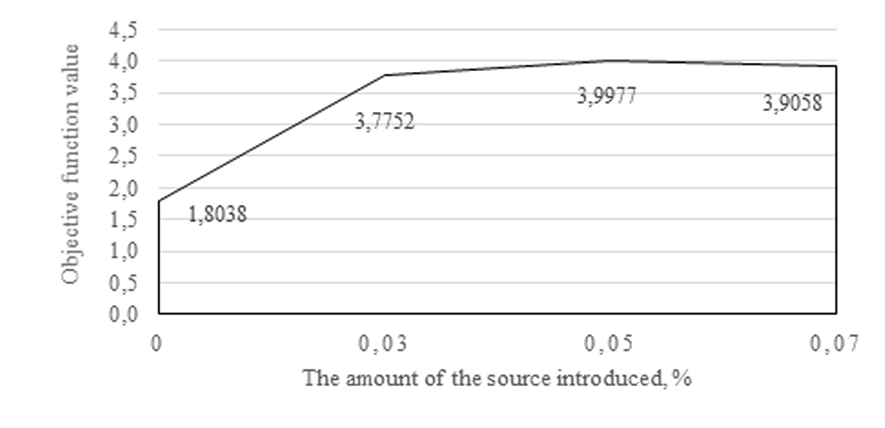

Figure 1 – The dependence of the objective function values on the amount of starter of the association of probiotic cultures, gel-immobilized biopolymers

Based on the results of mathematical analysis of the totality of the values of controlled factors, depending on the number of sourdoughs of probiotic crops, mathematical models are built to establish the degree of influence of the sourdough on the qualitative indicators of the product, using a mathematical computer program Table Curve 3D-v4 [4,5].

Figure 2 shows a graphical illustration of the change in active acidity in fermented milk.

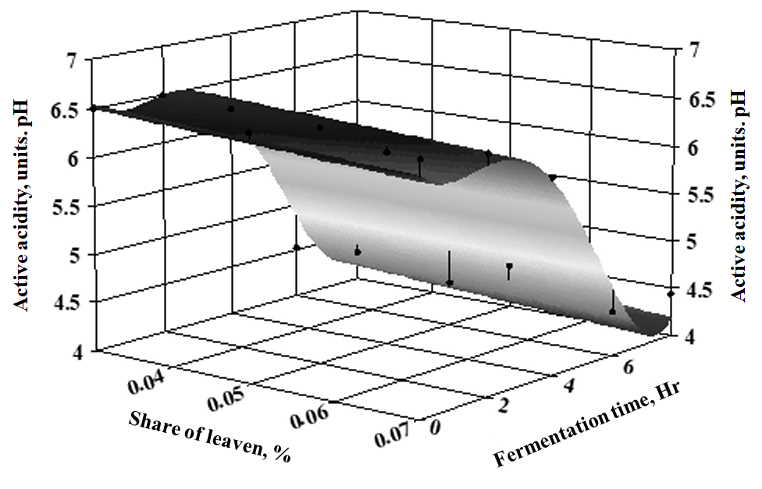

Figure 2 - Response surface of changes in active acidity in fermented milk depending on the dose of starter culture and fermentation time

The regression equation for changes in active acidity during fermentation has the form:

 (3)

z1 – active acidity of fermented milk;

х – starter dose, %;

у – fermentation time, Hr.

The coefficients of the regression equation are equal:

|  |  |  |  |  |  |
| --- | --- | --- | --- | --- | --- |
| а | b | c | d | e | f |
| 6,6925 | -5,0673 | -0,3693 | 0,3241 | -0,0887 | 0,0062 |

The coefficient of determination of the regression equation is 0.92. The correlation coefficient is 0.96. Since the correlation coefficient is close to one, it can be assumed that the presented regression equation adequately describes the change in active acidity from the amount of fermentation and the time of fermentation.

Figure 3 presents the statistical assessment of the error of the regression model, the maximum error of the mathematical model consists in 17 positions and is 15.916 %.

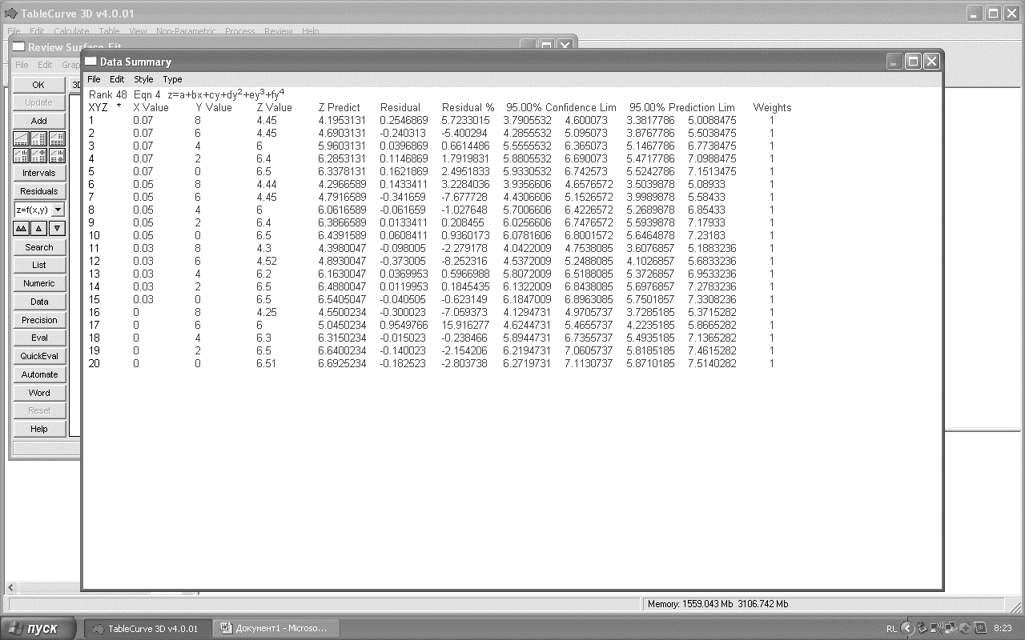

Figure 3 - Assessment of the statistical error of the regression

equation of a change in active acidity

Figure 4 shows the response surface of a change in the amount of bifidobacteria in fermented milk.

The regression equation of a change in the logarithm of the amount of bifidobacteria has the form:

 (4)

z2 – logarithm of the number of bifidobacteria;

х – starter dose, %;

у – fermentation time, Hr.

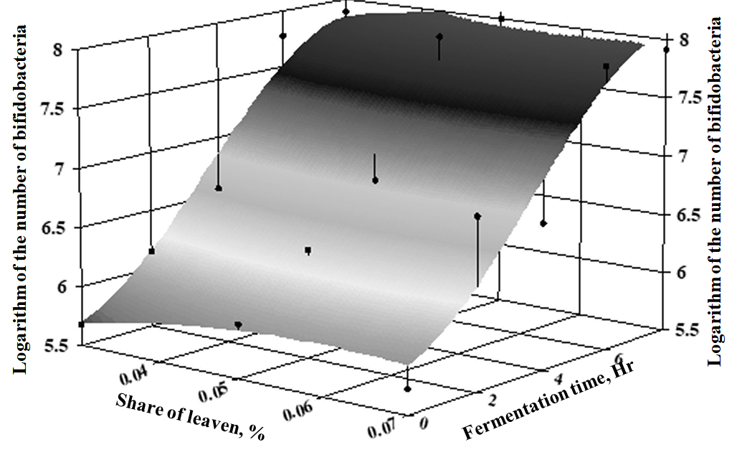

Figure 4 - The response surface of the change in the logarithm of the number of bifidobacteria cells in fermented milk, depending on the dose of starter and fermentation time

The coefficients of the regression equation are equal:

|  |  |  |  |  |  |
| --- | --- | --- | --- | --- | --- |
| a | b | c | d | e | f |
| 4,9551 | 32,5 | -270 | 0,1178 | 0,0688 | -0,0063 |

**Discussion**

With an increase in fermentation time, the number of viable bifidobacteria cells increases. The coefficient of determination of the regression equation is 0,93. The correlation coefficient is 0,96. Therefore, it can be stated that the developed mathematical model of changing the amount of bifidobacteria in the process of fermentation of milk adequately describes the process under study.

Figure 5 presents a statistical report of the error of the regression equation of a change in the number of viable bifidobacteria cells.

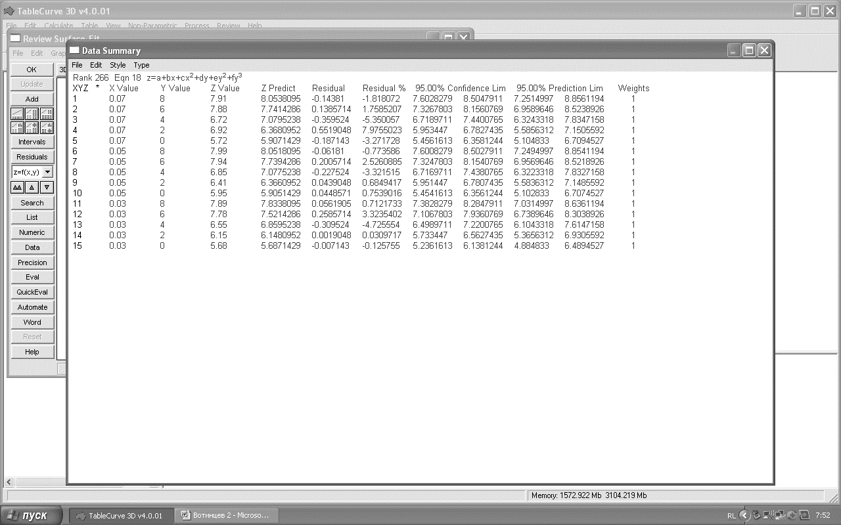

Figure 5 - Statistical error report of a mathematical model of changing the number

of bifidobacteria cells in the process of fermentation

The maximum model of the model is 7,97 % in the fourth position, which does not exceed the permissible value for technological research.

Figure 6 presents a graphic illustration of the surface of the response of the Logarithm of the number of propionic acid cultures.

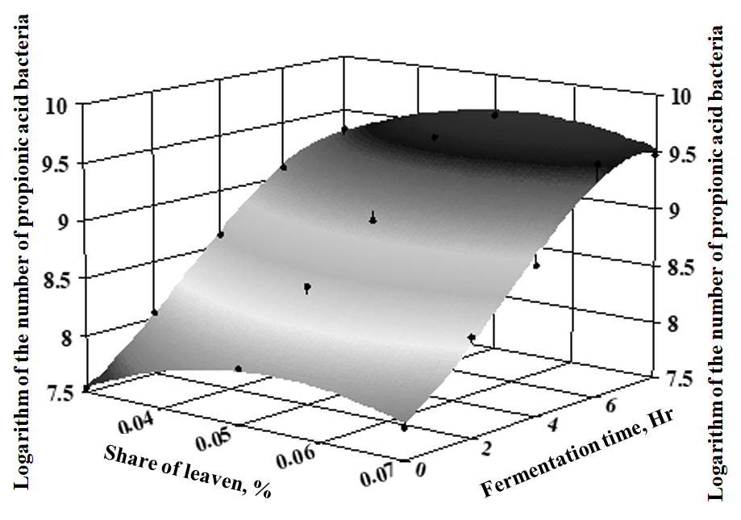

Figure 6 - Response surface of the change in the logarithm of the number of propionic acid

bacteria in fermented milk, depending on the dose

of starter culture and fermentation time

The regression equation for the change in the logarithm of the number of propionic acid bacteria in fermented milk has the form:

 (5)

z3 – logarithm of the number of propionic acid bacteria;

х – starter dose, %;

у – fermentation time, Hr.

The coefficients of the regression equation are equal:

|  |  |  |  |  |  |
| --- | --- | --- | --- | --- | --- |
| a | b | c | d | e | f |
| 5,8788 | 76,8 | -702,5 | 0,1781 | 0,0409 | -0,0045 |

The amount of propionic acid bacteria with an increase in the time of fermentation increases. The coefficient of determination of the regression equation is 0,99. The correlation coefficient of the model is 0,995. The developed mathematical model of changing the number of propionic acid bacteria in the process of fermentation adequately describes the studied process.

Figure 7 presents a statistical report of the error of the regression equation of changes in the number of propionic acid bacteria cells.

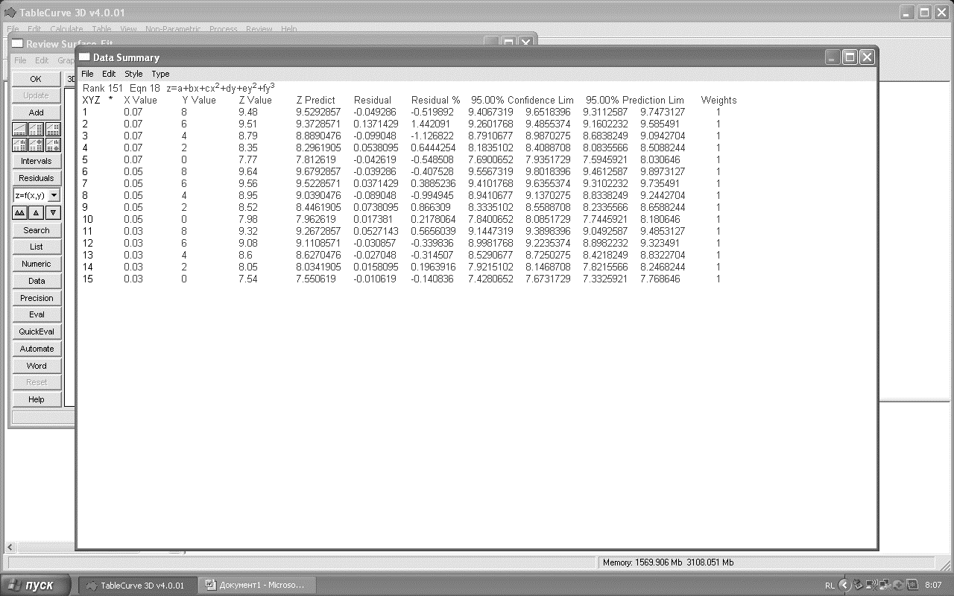

Figure 7 - Statistical error report of a mathematical model of changing the number of propionic

acid bacteria cells in the process of fermentation

The relative statistical error of the model does not exceed 1,5 %. The maximum relative error of the model is in the second position and is equal to 1,44 %.

The developed mathematical models in all three cases are represented by expressions identical in form, which have the form:

 (6)

which indicates the same regularity in the course of the fermentation process, but differ in the values of the coefficients of the regression equations. By the nature of the response surface, they are close to a linear surface. Thus, it was found that an increase in the fermentation time of the product leads to an increase in the number of cells of bifidobacteria and propionic acid bacteria.

**Conclusion**

All mathematical models have a high level of adequacy, the statistical error is minimal.

Therefore, a comprehensive study of the process of fermentation of skimmed milk with a combined starter consisting of traditional for cottage cheese and starter cultures of probiotic cultures immobilized in a gel of biopolymers (membranes) allows us to assume that the mass fraction of the starter of probiotic cultures, which is 0,05 % of the mass of skimmed milk, ensures the efficiency of the process. its fermentation and enrichment of the product with functional ingredients.

**СПИСОК ИСПОЛЬЗОВАННЫХ ИСТОЧНИКОВ**

1. Гаврилова Н.Б. Научные и практические аспекты технологии производства молочно-растительных продуктов: монография / Н.Б. Гаврилова, О.В. Пасько, И.П. Каня. – Омск: Изд-во Омский ГАУ, 2006. – 336 с.

2. Каленик Т.К. Применение инновационных решений для производства натуральных высокобелковых продуктов / Т.К. Каленик, Т.А. Косенко // Пищевая промышленность. – 2015. – № 12. – С. 26-27.

3. Масалова Н.В. Влияние добавления пюре из корня лопуха большого на показатели качества десертов / Н.В. Масалова, Л.В. Левочкина, Н.Ю. Чеснокова // Пищевая промышленность. – 2015. – № 5. – С. 30-33.

4.  [Лисин](https://www.livelib.ru/author/383112) П.А. Компьютерное моделирование производственных процессов в пищевой промышленности: учеб. пособие / П.А. Лисин. – СПб.: Лань, 2016. – 256 с.

5. Лисин П.А. Методология проектирования продуктов питания с заданными свойствами и составом: учеб. пособие / П.А. Лисин, Т.Д. Воронова, Е.А. Молибога. – Омск: Изд-во Омский ГАУ, 2015. – 144 с.

**REFERENCES**

1. Gavrilova, N.B., Pas'ko, O.V., & Kanya, I.P. (2006). *Nauchnyye i prakticheskiye aspekty tekhnologii proizvodstva molochno-rastitel'nykh produktov [Scientific and practical aspects of the technology of production of dairy and vegetable products]*. Omsk: Izdatel'stvo Omskiy GAU [in Russian].

2. Kalenik, T.K., & Kosenko, T.A. (2015). Primeneniye innovatsionnykh resheniy dlya proizvodstva natural'nykh vysokobelkovykh produktov [Application of innovative solutions for the production of natural high-protein products]. *Pishchevaya promyshlennost' - Food industry, 12, 26-27* [in Russian].

3. Masalova, N.V., Levochkina, L.V., & Chesnokova N.Yu. (2015). Vliyaniye dobavleniya pyure iz kornya lopukha bol'shogo na pokazateli kachestva desertov [Effect of adding burdock root puree on the quality indicators of desserts]. *Pishchevaya promyshlennost' - Food industry, 5, 30-33* [in Russian].

4. Lisin, P.A. (2016). *Komp'yuternoye modelirovaniye proizvodstvennykh protsessov v pishchevoy promyshlennosti [Computer simulation of production processes in the food industry]*. Sankt-Peterburg: Lan' [in Russian].

5. Lisin, P.A., Voronova, T.D., & Moliboga, Ye.A. (2015). *Metodologiya proyektirovaniya produktov pitaniya s zadannymi svoystvami i sostavom [Methodology for designing food products with desired properties and composition]*. Omsk: Izdatel'stvo Omskiy GAU [in Russian].

**М.Б. Ребезов 1*, М.В. Темербаева2, Т.И. Урюмцева2**

**1\***«В. М. Горбатов атындағы Федералдық азық-түлік жүйелері ғылыми орталығы» федералдық мемлекеттік бюджеттік ғылыми мекемесі, Ресей

2Инновационный Евразийский университет, Қазақстан

**Эксперименттік деректерді математикалық талдау нәтижелері**

**ашыған сүт өнімдерін өндіру үшін майсыз сүтті ашыту**

*Негізгі проблема:* ашыған сүт өнімдерін әзірлеу саласындағы заманауи зерттеулер сүт компоненттерінің биожетімділігін арттыруға, сондай-ақ денсаулыққа пайдалы қасиеттерін арттыратын қышқылдың бактериялық компоненттерін қолдануға бағытталған. Гель биополимерлеріне иммобилизацияланған пробиотикалық дақылдардың дәстүрлі сүзбесі мен ашытқысынан тұратын аралас ашытқымен майсыз сүтті ашыту процесін қолдану өте маңызды.

*Мақсаты:* осы зерттеудің мақсаты функционалдық Ингредиенттерге байыту мақсатында ферменттелген майсыз сүтке енгізу үшін пробиотикалық дақылдар қауымдастығынан тұратын, гель биополимерлеріне (мембраналарға) иммобилизацияланған ұйытқының оңтайлы мөлшерін анықтау болып табылады.

*Әдістері:* бір факторлы эксперимент қолданылды. Реттеу факторы ретінде *Propionibacterium freudenreichii subs*p мәдениеттер қауымдастығы қолданылды. *Shermanii, Bifidobacterium lactis және Streptococcus thermophilus,* гель биополимерлеріне иммобилизацияланған, майсыз сүтке мембраналар түрінде қосылады (ашытылған сүт массасының пайызымен анықталады). Басқарылатын факторлар майсыз сүтті Ашыту процесінің тиімділігін сипаттайтын негізгі көрсеткіштерді таңдады, олар белсенді қышқылдық, бифидобактериялардың өміршең жасушалары санының логарифмі, пропион қышқылы бактерияларының өміршең жасушалары санының логарифмі, органолептикалық бағалау.

*Нәтижелері және олардың маңыздылығы:* басқарылатын факторлар мәндерінің жиынтығын Математикалық талдау нәтижелері негізінде, пробиотикалық дақылдардың ашытқы санына байланысты, Table Curve 3D-v4 Математикалық компьютерлік бағдарламасын қолдана отырып, ашытқының өнімнің сапалық көрсеткіштеріне әсер ету дәрежесін анықтауға мүмкіндік беретін математикалық модельдер құрылды.

*Түйінді сөздер:* ашыту, ашытқы, пробиотикалық дақылдар, бифидобактериялар, пропион қышқылы бактериялары, майсыз сүт, иммобилизацияланған мәдениет.

**М.Б. Ребезов1*, М.В. Темербаева2, Т.И. Урюмцева2**

**1\***Федеральное государственное бюджетное научное учреждение «Федеральный научный центр пищевых систем им. В.М. Горбатова», Россия

2Инновационный Евразийский университет, Казахстан

**Результаты математического анализа экспериментальных данных**

**ферментации обезжиренного молока для производства кисломолочного продукта**

*Основная проблема:* Современные исследования в области разработки кисломолочных продуктов направлены на повышение биодоступности компонентов молока, а также использование бактериальных компонентов закваски, повышающих полезные для здоровья свойства. Использование процесса ферментации обезжиренного молока комбинированной закваской, состоящей из традиционной для творога и закваски пробиотических культур иммобилизованных в гель биополимеров весьма актуально.

*Цель:* Цель данного исследования является определение оптимального количества закваски, состоящей из ассоциации пробиотических культур, иммобилизованных в гель биополимеров (мембран) для внесения в ферментируемое обезжиренное молоко с целью его обогащения функциональными ингредиентам.

*Методы:* Был использован однофакторный эксперимент. В качестве фактора регулирования использовалась ассоциация культур *Propionibacterium freudenreichii subsp. Shermanii, Bifidobacterium lactis* и *Streptococcus thermophilus*, иммобилизованная в гель биополимеров, добавляемая в обезжиренное молоко в виде мембран (определяется в процентах от массы ферментируемого молока). Управляемыми факторами выбраны основные показатели, характеризующие эффективность процесса ферментации обезжиренного молока, это активная кислотность, логарифм количества жизнеспособных клеток бифидобактерий, логарифм количества жизнеспособных клеток пропионовокислых бактерий, органолептическая оценка.

*Результаты и их значимость:* На основании результатов математического анализа совокупности значений управляемых факторов в зависимости от количества закваски пробиотических культур построены математические модели, позволяющие установить степень влияния закваски на качественные показатели продукта, с использованием математической компьютерной программы Table Curve 3D-v4.

*Ключевые слова:* ферментация, закваска, пробиотические культуры, бифидобактерии, пропионовокислые бактерии, обезжиренное молоко, иммобилизованная культура.

**Сведения об авторах:**

**Ребезов М.Б. -** ауыл шаруашылығы ғылымдарының докторы, профессор, «В. М. Горбатов атындағы Федералдық азық-түлік жүйелері ғылыми орталығы» Федералдық мемлекеттік бюджеттік ғылыми мекемесінің аға ғылыми қызметкері», Мәскеу қ., Ресей. **Ребезов М.Б. -** доктор сельскохозяйственных наук, профессор, старший научный сотрудник Федерального государственного бюджетного научного учреждения «Федеральный научный центр пищевых систем им. В.М. Горбатова», г. Москва, Россия. **Rebezov, M.**- Doctor of Agricultural Sciences, Professor, Senior Researcher of the Federal State Budgetary Scientific Institution «Federal Scientific Center for Food Systems named after V.M. Gorbatov», Moscow с., Russia. Е-mail: rebezov@yandex.ru.

**Темербаева М.В.** –техника ғылымдарының кандидаты, доцент, Инновациялық Еуразия университетінің профессоры, Павлодар қ., Қазақстан Республикасы.**Темербаева М.В. -**кандидат технических наук, профессор Инновационного Евразийского университета г. Павлодар, Республика Казахстан. **Timerbayeva, M.** – candidate of technical sciences, associate Professor, Professor of Innovative Eurasian University, Pavlodar, Republic of Kazakhstan. E-mail: marvik75@yandex.ru.

**Урюмцева Т.И. -** ветеринария ғылымдарының кандидаты, доцент, Инновациялық Еуразия университетінің профессоры, Павлодар қ, Қазақстан Республикасы. **Урюмцева Т.И. -** кандидат ветеринарных наук, доцент, профессор Инновационного Евразийского университета, г. Павлодар, Республика Казахстан. **Uryumtseva, Т. -** candidate of veterinary sciences, associate Professor, рrofessor of Innovative Eurasian University, Pavlodar c., Republic of Kazakhstan. E-mail: vbh2@mail.ru.

**Дата поступления рукописи в редакцию:**