УДК 793/796. 08
O. O. Chernyshova, master of pedagogy, senior teacher
Innovative Eurasian University (Pavlodar, Republic of Kazakhstan)
E-mail: olga.pvl.79@mail.ru
A. A. Sergeev. honored coach of the Republic of Kazakhstan, senior teacher
Innovative Eurasian University (Pavlodar, Republic of Kazakhstan)
E-mail:pfb-kz@mail.ru
- Ye. Baidildina master of philology, senior teacher
Innovative Eurasian University (Pavlodar, Republic of Kazakhstan)
e-mail: baidildina.zhan@mail.ru

Influence of rhythmic gymnastics on the development of coordination abilities of young football players (7-10 years)

Annotation. Currently, the most important problem in sports is the preparation of qualified reserves for professional football. The solution to this problem is largely due to the content and organization of technical training of children at the initial stage of learning the game of football. The article deals with the application of rhythmic gymnastics programs for young football players, aimed at developing such motor qualities as coordination abilities, flexibility, which are necessary to improve the level of playing football.

Keywords: football, rhythmic gymnastics, coordination abilities, flexibility, athlete.

Introduction. Currently, the most important problem in sports is the preparation of qualified reserves for professional football. The solution to this problem is largely due to the content and organization of technical training of children at the initial stage of football training.
In the initial training groups of children's and youth sports schools, the "Foundation" is laid for lagging in the technique of performing the element with an awkward foot (stopping the ball, passing the ball, hitting the goal, leading the ball), which leads to an immediate loss of the ball. In this regard, formed a narrow range or in right field (if convenient right leg) or left (if comfortable left foot). The reasons for this lag lie in the imperfect method of technical training of coordination abilities of young football players.
Training for results, which is possible when quickly mastering the techniques of playing with a comfortable foot, and at the same time ignoring the mastery of techniques with an uncomfortable foot, allow young football players to quickly progress for some time, but by the time they graduate from children's and youth sports schools, the demand for such players decreases, and further growth of their skills can not be achieved.
This is due to the fact that with age, the asymmetry of motor function development, which is expressed in the lagging (unclaimed) uncomfortable leg, increases and it is almost impossible to catch up in childhood[9; 10].
Coordination of movements, an essential attribute of sports life that lends itself to exercise [3; 5,7,8]. Coordination abilities include such concepts as a sense of rhythm, the ability to arbitrarily relax the muscles, the ability to quickly and expediently act in changing conditions, the ability to maintain balance, etc. [1; 4].In the development of this complex quality, such a branch of physical culture and sports as rhythmic gymnastics is able to develop flexibility, form the beauty of movements, and contain elements of art [7; 8].
Theoretical analysis of special scientific and methodological literature has shown that football has accumulated material on training, selection, control of fitness of athletes of different ages, on the organization and planning of competitive and training activities, and the main methodological aspects of teaching the game technique [2; 6].
However, until now, certain issues of technical training of young players have not yet been resolved and deserve further study. All of the above causes the search for new ways and scientific and methodological developments to rationalize methods of teaching game techniques and the development of physical qualities, such as coordination abilities, which are well developed at the initial stage of training in rhythmic gymnastics.
In this regard, the purpose of our study was to determine the impact of rhythmic gymnastics on the development of coordination abilities in young football players aged 7-10 years.
We set the following tasks:
1. to Study the peculiarities of the development of coordination abilities in young football players aged 7-10 years.
2. Identify the level of development of coordination abilities in young football players aged 7-10 years.
3. Develop a rhythmic gymnastics program for young football players (7-10 years old) aimed at developing coordination abilities.
4. to Identify the effectiveness of the influence of the developed rhythmic gymnastics program on the development of coordination abilities of football players aged 7-10 years.
The following research methods were used: analysis of scientific and methodological literature, assessment of the functional state of the cardiovascular system (Harvard step test), testing of coordination abilities (tests to determine dexterity, accuracy, balance, rhythm, level of plasticity, ability to navigate in space, flexibility measurement, pedagogical experiment, methods of mathematical statistics.
We hypothesized that if the rhythmic gymnastics program is introduced into the training process of young football players, the level of coordination abilities of football players will increase, since special exercises will be used outside of the game.
Results. In the course of the research, a rhythmic gymnastics program was developed for young football players (7-10 years old), aimed at developing coordination abilities. It included exercises for the arms and shoulder girdle, exercises for the neck and trunk muscles, and exercises for the legs. With this in mind, the content of rhythmic gymnastics classes for football players included familiar exercises: running, jumping, various types of walking; rhythmic movements combined with half-crouches, side steps, and expressive hand movements.
Rhythmic gymnastics complexes consisted of three parts: water, main and final.
The introductory part included exercises that affect the entire body of young football players. This is a dynamic movement: a variety of options for walking and running, jumping. Also, General development exercises aimed at training large muscle groups, improving coordination of movements, the ability to clearly and rhythmically perform exercises to music.
At the beginning of the main part, a series of rhythmic exercises followed: lifting the arms up, to the sides; exercises for the arms of the neck muscles: various head tilts, accompanied by springy squats or walking in place without lifting the socks off the floor.The next series of exercises – load. Here they offered intensive exercises: various bends, swings of the torso, lunges, squats aimed at developing flexibility. For example, the exercises "bumblebee" (Fig. 1), "Grasshopper" (Fig.2), etc.
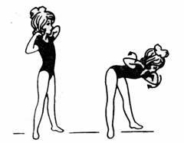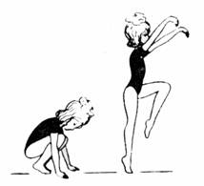
Figure 1 – «Bumblebee» Figure 2 – «Grasshopper»
This series of exercises took place at a fast pace, with special attention to maintaining correct posture.
Then followed a parterre series of exercises from the starting positions of sitting and lying down. This group of exercises designed to develop flexibility of the spine, strengthen back muscles, abdominal, muscle development of legs. These are exercises such as" Tumbler"," butterfly "(Fig.3)," Basket "(Fig.4)," Breeze "(Fig.5)," Cradle "(Fig.6)," Frog " (Fig.7).
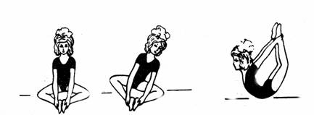

Figure 3 – «Butterfly», «Tumbler» Figure 4 – «Basket»
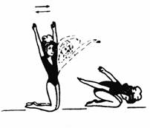
Figure 5 – «Breeze»

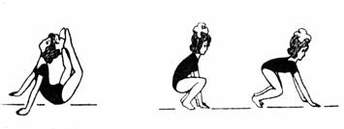
Figure 6 – «Cradle» Figure 7 – «Frog»

All the exercises were performed at a moderate pace, since they require the greatest expenditure of energy. The final main part consisted of a dance-running series of exercises, at an intense pace with a quick change of exercises.
The final part of the rhythmic gymnastics class included relaxation exercises in the initial positions of standing, sitting and lying down. In addition, we used such exercises as shaking the hands, feet, various smooth movements of the hands and feet from the starting positions lying on the back, stomach, kneeling, etc. All the exercises were performed slowly.
During classes, special attention was paid to breathing, so they included a sufficient number of breathing exercises. We took into account the individual characteristics of children, so we made various changes, if necessary. The dosage of the load was gradual.
Performing physical exercises was accompanied by artistic musical works. Elements of music, such as rhythm, tempo, meter, dynamics determine the expressiveness of the content of a musical work and are the means of musical and rhythmic movements that become meaningful and emotionally colored under the music. When choosing a musical composition into account: the age of the athletes, theme, imagery, expressiveness classes, educational moment, the nature of each exercise, the level of preparedness of young players. Also, when choosing music by tempo, the following recommendations were followed: slow tempo-40-60 movements per minute (breathing exercises, relaxation exercises); moderate tempo-70 movements per minute (walking, swinging arms, swinging legs; average tempo-80-90 movements per minute (most dance movements); fast tempo-100-150 movements per minute (Mach, running); very fast pace-160 or more movements per minute (running, fast dancing).
Discussion. The research was carried out with the sports club "Orlan", the football club "Irtysh" in Pavlodar at classes in rhythmic gymnastics with young football players 7-10 years old. 30 athletes participated, which were divided into experimental and control groups. Rhythmic gymnastics classes in the experimental group were held 3 times a week for 1 hour. Also, in the experimental and control groups, football classes were held 3 times a week. The experiment lasted 1.5 years.
At the beginning of the study, we tested the functional state of the cardiovascular system of young football players aged 7-10 years. The Harvard step test was used for this purpose. Initial results allowed us to determine the level of physical fitness of the cardiovascular system in the control and experimental groups (Fig. 8,9).

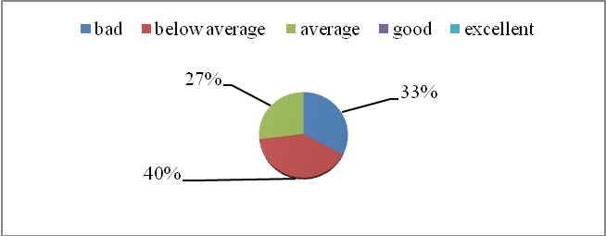

Figure 8-Evaluation of the results of the Harvard step test in the control group

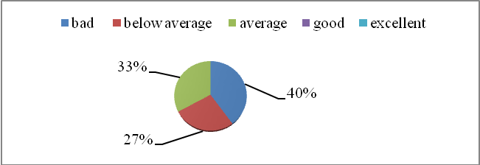
Figure 9-Evaluation of the results of the Harvard step test in the experimental group.

The study of the cardiovascular system revealed that as in the control and experimental groups level of efficiency "good", "excellent" is no; "bad" performance in the experimental group was higher (40%) than in the control (33%); "average" is higher (33%) than in the control group (27%); the index "below average" in the experimental group exceeded (33%).
The results of both groups show that the level of performance is not very high, this may be due to their age and low level of motor readiness.
Repeated testing of the cardiovascular system was performed at the end of the experiment (Fig. 10.11).

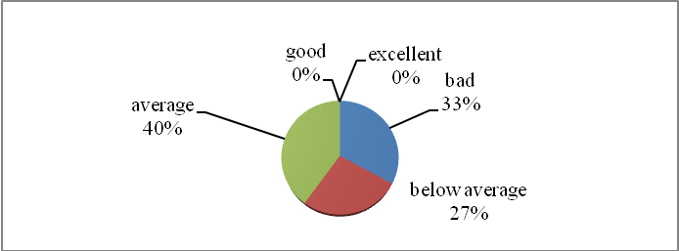

Figure 10-Evaluation of the results of the Harvard step test in the control group

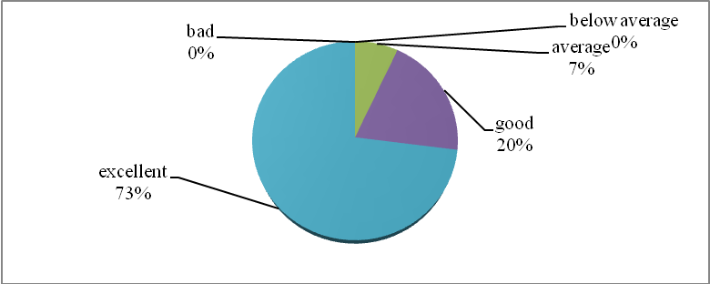

Figure 11-Evaluation of the results of the Harvard step test in the experimental

According to the obtained data, it can be stated that the indicators of the level of cardiovascular health in the experimental group significantly changed in a positive direction in comparison with the control group and amounted to 73% of the excellent result, we believe that this is the result of long-term aerobic work that occurs when practicing rhythmic gymnastics. Thus, during testing, 33% of young athletes from the control group finished climbing a step ahead of schedule, lost their pace, leaned on their hip, and there was an appearance of hyperemia on the skin of the face, coordination instability was observed. Despite the long period of the experiment, a significant part of the children in the control group did not cope with the proposed muscle load after playing football.
Thus, this test for young football players is considered indicative in determining physical performance and is recommended for use in medical and pedagogical control of athletes.
In order to study the indicators of coordination abilities of young football players, the control and experimental groups were asked to perform special exercises-tests to determine dexterity, accuracy, balance, rhythm, plasticity and orientation in space. Testing was performed twice, at the beginning and end of the study.
The results of flexibility testing in the experimental group exceeded the control group by 2-4 cm. In the control group, the increase was also observed and this is understandable, since the age of 7-10 years is favorable for the development of coordination abilities, but still in the experimental group the indicator was higher.
In tests to determine the level of coordination abilities in the experimental group, there was an increase in comparison with the control group. So the level of rhythm increased by 44%, balance by 45%, plasticity -58%, orientation in space -54%. We believe that the result was influenced by the performance of special exercises in rhythmic gymnastics classes.
In the control group, the largest increase in indicators was obtained in tests for determining accuracy and orientation in space - by 15%. The remaining results showed no more than 11%. These results indicate that coordination abilities are developing, but the lack of special tools that promote development gives a small increase.
Analyzing the results of the control and experimental groups, we can state that at the age of 7-10 years, the activity of the nervous system has not yet been formed, which makes it possible to easily learn new, quite complex motor actions. But the severe monotonous stimuli, or the impact of evolving beyond inhibition. Therefore, for a more effective process of developing athletes ' coordination abilities, special exercises should be used, for example, such as elements of rhythmic gymnastics, which bring a variety of tools to the lesson, elements of the game and allow the coach to fully meet the physiological requirements of this age.
Conclusion. Our research on this problem allowed us to solve the tasks and formulate the following conclusions.
When studying the peculiarities of the development of coordination abilities in children aged 7-10 years, we found that the development of coordination movements is carried out from an early age. Therefore, work on the development of coordination abilities should be carried out with the younger groups. But since improving coordination in young children is a complex and difficult process, it is noted that the most favorable period for the development of coordination abilities is the primary school age (7-10 years). The ability to correctly coordinate their movements, the guarantee that the child will correctly perform all the proposed movements. Therefore, work on the formation of coordination movements should be carried out in classes that will be interesting to children, and the complexity will not distract children from work. This type of activity includes rhythmic gymnastics.
We have developed a program for rhythmic gymnastics for football players aged 7-10 years, aimed at developing coordination abilities. The content of the classes included exercises: running, jumping, various types of walking; rhythmic movements combined with half-crouches, side steps, expressive hand movements. General development exercises in rhythmic gymnastics were performed from various starting positions. Classes were accompanied by musical compositions.
During the study, the functional state of the cardiovascular system was checked in athletes, and the level of coordination abilities was determined. The use of rhythmic gymnastics classes in the experimental group allowed to increase their results of the functional state of the cardiovascular system, as well as the level of development of coordination abilities, namely, rhythmicity, plasticity, accuracy, balance and orientation in space.
To determine the effectiveness of the developed rhythmic gymnastics program for football players aged 7-10 years, a comparative analysis of the results of the experimental and control groups was conducted, which allowed us to consider changes in the level of development of the studied abilities. Positive changes in the level of coordination abilities reflect the influence of purposeful pedagogical influence, as evidenced by more pronounced changes in indicators in children of the experimental group compared to the control group. It should be noted that positive changes occurred in the control group, where the results differed from the initial data. However, the growth rate in the experimental group was higher than in the control group.
As a result of the experiment, the effectiveness of the developed program was revealed. The results of the study showed that the use of rhythmic gymnastics programs can be widely used in children's football institutions. In the course of training, the level of coordination abilities of athletes increases, and the best conditions are provided for the formation of skills to manage their movements, that is, to act purposefully, productively, and economically.

REFERENCES

- Benjamin Low. Beauty of sport / trans from English I. P. Monicheva, ed. byV. I. Stolyarov. - Moscow: Raduga, 1984. – 241p.
- Besputchik V. G. Psychomuscular aerobics / / Physical culture in school. - 1993. - №7. - P. 48-49.
- Bogatkova L. N. Dancing for children. - Moscow: Detgiz, 1959. – 175p.
- Borisova I. Dance all / / physical Culture and sport. - 2003. - №5. - P. 24-25.
- Golomazov S. V. Accuracy of movements. - Moscow: gtsolifk, 1979. - 43s.
- Zatsiorsky V. M. Physical qualities of athletes. - M.: physical Culture and sport, 1966. - 196C.
- Kobyakov Yu. P. Training of the vestibular analyzer of the gymnast. - M.: physical Culture and sport, 1976. - 64 p.
- Rotters T. T. Dance exercises in primary classes / / Physical culture in school. - 1988. - №10. - P. 32-34.
- Human Physiology / Edited by G. I. Kositsky. - 3rd ed. - Moscow: Meditsina, 1985. - 544 p.
- Wikipedia «the Free encyclopedia» http://en.wikipedia.org/ .

СПИСОК ИСПОЛЬЗОВАННЫХ ИСТОЧНИКОВ

1 Бенджамин Лоу. Красота спорта / Пер. с англ. И.П. Моничева, под ред. В.И. Столярова. – М.: Радуга, 1984. – 241 с.
2 Беспутчик В.Г. Психомускульная аэробика // Физическая культура в школе. – 1993. - №7. – С.48-49.
3 Богаткова Л.Н. Танцы для детей. – М.: Детгиз, 1959. – 175 с.
4 Борисова И. Танцуют все // Физкультура и спорт. – 2003. - №5. – С. 24-25.
5 Голомазов С.В. Точность движений. – М.: ГЦОЛИФК, 1979. – 43 с.
6 Зациорский В.М. Физические качества спортсменов. – М.: Физкультура и спорт, 1966. – 196 с.
7 Кобяков Ю.П. Тренировка вестибулярного анализатора гимнаста. – М.: Физкультура и спорт, 1976. – 64 с.
8 Роттерс Т.Т. Танцевальные упражнения в начальных классах // Физическая культура в школе. – 1988. - №10. – С. 32-34.
9 Физиология человека / Под ред. Г.И. Косицкого. – 3-е изд. – М.: Медицина, 1985. – 544 с.
10 Википедия «Свободная энциклопедия» http://en.wikipedia.org/.

О. О. Чернышова, педагогика магистрі, аға оқытушы
Инновациялық Еуразия университеті (Павлодар қ., Қазақстан Республикасы)
E-mail: olga.pvl.79@mail.ru
А. А. Сергеев. Қазақстан Республикасының еңбек сіңірген жаттықтырушысы, аға оқытушы
Инновациялық Еуразия университеті (Павлодар қ., Қазақстан Республикасы)
E-mail:pfb-kz@mail.ru
А. Е. Байдильдина филология магистрі, аға оқытушы
Инновациялық Еуразия университеті (Павлодар қ., Қазақстан Республикасы)
e-mail: baidildina.zhan@mail.ru

Жас футболшылардың координациялық қабілеттерін дамытуға ырғақтық гимнастиканың әсері
(7-10 жас))

Қазіргі уақытта спорттағы маңызды мәселе кәсіби футбол үшін білікті резервті дайындау болып табылады. Бұл мәселені шешу көп жағдайда футбол ойынын оқытудың бастапқы кезеңінде балалардың техникалық дайындығының мазмұны мен ұйымдастырылуымен байланысты. Мақалада футболдың деңгейін жақсарту үшін қажетті үйлестіру қабілеті, икемділік сияқты қозғалыс қасиеттерін дамытуға бағытталған жас футболшыларға арналған ырғақты гимнастика бойынша бағдарламаны қолдану қарастырылады.
Түйінді сөздер: футбол, ырғақты гимнастика, үйлестіру қабілеті, икемділік, спортшы.

О. О. Чернышова, магистр педагогики, старший преподаватель
Инновационный Евразийский университет (г. Павлодар, Республика Казахстан)
E-mail: olga.pvl.79@mail.ru
А. А. Сергеев. заслуженный тренер Республики Казахстан, старший преподаватель
Инновационный Евразийский университет (г. Павлодар, Республика Казахстан)
E-mail:pfb-kz@mail.ru
А. Е. Байдильдина магистр филологии, старший преподаватель
Инновационный Евразийский университет (г. Павлодар, Республика Казахстан)
e-mail: baidildina.zhan@mail.ru

Влияние ритмической гимнастики на развитие координационных способностей юных футболистов
(7-10 лет)

В настоящее время важнейшей проблемой в спорте является подготовка квалифицированного резерва для профессионального футбола. Решение этой проблемы во многом обусловлено содержанием и организацией технической подготовки детей на начальном этапе обучения игры в футбол. В статье рассматривается применение программы по ритмической гимнастике для юных футболистов, направленная на развитие таких двигательных качеств, как координационные способности, гибкость, которые необходимы для улучшения уровня игры в футбол.
Ключевые слова: футбол, ритмическая гимнастика, координационные способности, гибкость, спортсмен.

