УДК 378.046.4
MРНТИ 14.37.27
E. V. Prokopets
Innovative University of Eurasia, Kazakhstan
(e-mail: podsolnuschek@mail.ru)

Professional development of teaching staff in the field of innovative educational technologies

Abstract
The main problem: At the moment, the education system no longer has enough traditional tools for organizing classes, so there is a problem of actively using innovative products based on the use of a set of methods and techniques aimed at the effective development of practical skills, knowledge and mental abilities of students.
Objective: In the system of advanced training, it is necessary to develop the structure and content of courses that allow in a limited time to achieve the solution of an important task – the use of IT technologies in the educational process. The article is devoted to the goals and objectives of professional development of teaching staff in the application of innovative educational technologies in online learning.
Methods: The methods of analysis, synthesis and deduction were used in the article. The existing models of professional development in higher education institutions are described in detail.
Results and their significance: The practical result was the developed training program in the field of application of innovative educational technologies by teachers. The training program includes a system for developing interactive multimedia tasks and projects, the content of which stimulates independent and creative work to transfer the acquired knowledge and skills of students.

Keywords: advanced training courses, online training, innovative educational technologies, IT competencies.

Introduction
Currently, professionally relevant information is growing in an avalanche, and the «life cycle of knowledge» is shrinking at a rapid pace. In this regard, the system of advanced training of teachers of universities, colleges, as well as teachers of schools and lyceums needs to be developed ahead of schedule.
In order for a teacher to be competitive, advanced training courses must provide:
- the involvement of each teacher , regardless of his work experience and field of professional activity;
- continuity, which consists of the principles of continuity and systematicity;
- individualization of advanced training courses, achieved by adapting the teacher's education to the level of his competence and personal professional needs;
- providing a high-quality level of professional development for all employees in the field of education, regardless of the qualification category of the teacher, the type of educational institution in which he works (secondary school, gymnasium, preschool educational institution, extracurricular work center, college, university);
- maintaining a high level of scientific and methodological support throughout the entire professional development process.
The main objectives of professional development of teaching staff are highlighted:
- formation of professional competence;
- development of reflection skills of the pedagogical process, as a system as a whole, as well as its results;
- formation of an individualized structural integrity of pedagogical activity.
In addition to the goals, for the successful implementation of advanced training courses, it is also necessary to follow the fundamental tasks. Among the tasks of teacher training are:
– the introduction of modern pedagogical technologies and advanced techniques in teaching activities, which will entail the improvement of pedagogical skills;
– support of professional skills , taking into account the achievements of scientific and practical activities;
– organization and creation of conditions for the development of individual abilities of teachers;
– organization of the procedure for testing new technologies and progressive forms of teacher training in the learning process;
– organization of conditions for providing scientific and methodological support to teachers after completing advanced training courses.
All of the above goals and objectives are aimed at ensuring that the requirements for achieving the quality of modern education are met. [1]
Materials and methods
The analysis carried out by the author of this article of the implementation of plans in the field of professional development of pedagogical staff of universities allowed us to identify the main models of professional development of teachers.
Model No. 1. Professional development is carried out in the traditional form, which is a 72-hour program of additional professional education organized on the basis of the university where the teacher works. Up to 20% of university teaching staff annually go through this model of professional development. As a positive side of this model, it is possible to highlight the possibility of on-the-job training.
Model No. 2. Professional development, organized in the form of 72-hour programs based on leading universities. The disadvantages of this model include limited access to these advanced training programs. Only about 10-20 university teachers go through this model per year.
Model No. 3. Internships in Kazakhstani and foreign universities. Among the positive aspects of this model, it is possible to highlight the design or coordination of the internship program by both universities, the high motivation of students to master the training program, the development of conditions for the application of acquired knowledge and experience in professional activities. [2]
Model No. 4. Advanced training programs with the inclusion of e–learning - online training. This model has been gaining popularity in recent decades, due to the rapid development of educational technologies that allow classes to be conducted in real time.
At the moment, there are external and internal factors of using online learning in the education system.
The following aspects are external factors: changing the nature of the learning process - it becomes continuous, since in the modern information society a person does not have enough «education for life», he needs «education for life»; active and widespread introduction and application of information and communication technologies (ICT).
The following aspects are internal factors: the educational process has become resource-intensive; the availability and effectiveness of educational services has significantly decreased; the shortage of highly qualified specialists with high pedagogical skills has increased. [3]
Results
To solve the problems that have arisen, reduce the resource intensity of the educational process and ensure the accessibility of learning, it is necessary to use innovative teaching methods, introduce modern pedagogical technologies and ICT into the educational process. In addition, new realities require teaching staff to have knowledge in the IT field, the use of ICT and online learning technologies, regardless of the type of professional activity. [4]
In this regard, in accordance with the project «Modernisation of Higher Education in Central Asia Through New Technologies» (HiEdTec) of the Erasmus+ program, a program of advanced training courses for teachers on innovative educational technologies and didactic models for teaching staff was compiled at the Innovative Eurasian University in spring 2020. The main purpose of this program was to familiarize teachers with ICT-based innovative educational technologies. Initially, the training took place in two stages. At the first stage, 10 trainers, active university teachers, were trained in an online format (Figure 1, Figure 2). University teachers from various fields of pedagogical activity were selected to complete the training: These are educators, biologists, computer scientists, machine builders, economists, and e-Learning specialists. This approach was applied so that future coaches could take into account the specifics of teaching various disciplines. At the second stage, the trainers who completed the training courses trained 100 tutors in the use of innovative educational technologies and didactic models in the context of adapting education to the digital generation.

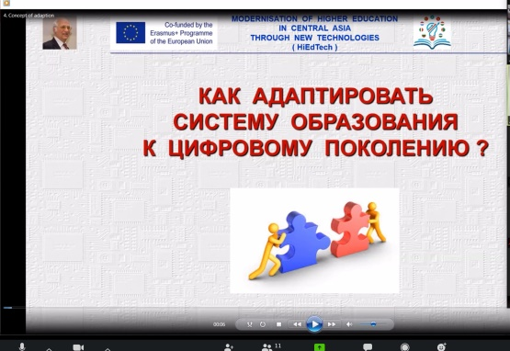

Figure 1 – Online refresher course



Figure 2 – Training of online course trainers

The author of this article acted as a trainer at online refresher courses (Figure 3). In the classroom, teachers were trained to teach classes online, develop video materials and use various Web 2.0 services in teaching.

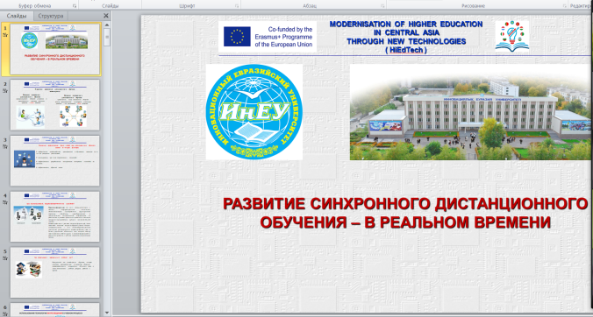

Figure 3 – Training of tutors in online courses

Discussion
As part of the online refresher courses for the teaching staff, the author of the article taught the cadets the rules for creating interactive presentations, how to use the video conference environment and virtual laboratories. In the practical part of the online courses, teachers learned how to develop and publish interactive multimedia textbooks on the subjects taught on the Internet (Figure 4). The teachers who studied at the online courses showed great interest in the Web 2.0 services being studied and began their practical application in online student education.

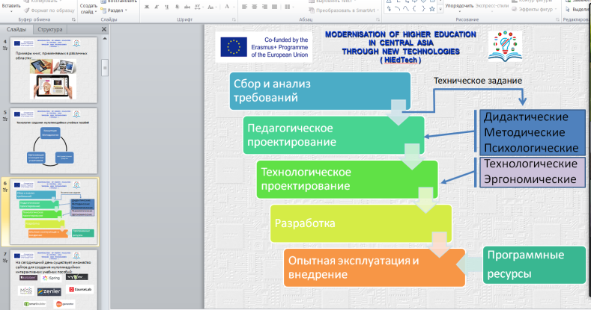

Figure 4 – Creation of interactive multimedia tutorials

Teacher training courses are held annually in offline and online formats. The teaching staff studies technologies and methods of online learning, pedagogical design, learns to develop electronic educational resources and interactive multimedia textbooks.
Conclusion
The current situation around the world has affected all areas of activity, including education. Today, special knowledge is required from teachers, regardless of the disciplines taught, simple skills to turn on the computer and go to Zoom are not enough. Teachers and teachers should have knowledge and skills that will contribute to the successful organization of the educational process of schoolchildren and students in an online format. Teaching staff should acquire the necessary IT competencies and learn how to give assignments, how to work through an online system. The author of this article came to the conclusion that conducting advanced training courses on innovative educational technologies will help to a large extent solve the problems listed above.

THE LIST OF SOURCES

- Колиниченко А. В. Повышение квалификации педагога [Электронный ресурс] / А.В. Колиниченко // Молодой ученый. — 2016. — № 25 (129). — С. 552-554. — Режим доступа: https://moluch.ru/archive/129/35812/
- Игнатович Е.В. Формы профессионального развития научно-педагогических кадров вуза [Электронный ресурс] / Современные проблемы науки и образования. – 2012. – № 6. — Режим доступа: http://www.science-education.ru/ru/article/view?id=7541.
- Тилляшайхова М. А. Интернет-технологии в образовании [Электронный ресурс] / М. А. Тилляшайхова // Педагогическое мастерство: материалы IX Междунар. науч. конф. — 2016. — С. 95-97. — Режим доступа: https://moluch.ru/conf/ped/archive/208/11216/.
- Дистанционное обучение: Учебное пособие для ВУЗов. – М.: Владос, 2018. - 192 c.

REFERENCES

- Kolinichenko A. V. (2016). Povyshenie kvalifikacii pedagoga [Teacher's professional development]. Molodoj uchenyj – A young scientist, Vol. 25 (129), 552-554. Retrieved from https://moluch.ru/archive/129/35812/ [in Russian].
- Ignatovich E.V. (2012). Formy professional'nogo razvitiya nauchno-pedagogicheskih kadrov vuza [Forms of professional development of scientific and pedagogical staff of the university]. Sovremennye problemy nauki i obrazovaniya – Modern problems of science and education, Vol. 6. Retrieved from http://www.science-education.ru/ru/article/view?id=7541 [in Russian].
- Tillyashajhova M. A. (2016) Internet-tekhnologii v obrazovanii [Internet technologies in education]. Pedagogicheskoe masterstvo: materialy IX Mezhdunar. nauch. konf. – Pedagogical skills: materials of the IX International Scientific Conference, 95-97. Retrieved from https://moluch.ru/conf/ped/archive/208/11216/ [in Russian].
- Distancionnoe obuchenie: Uchebnoe posobie dlya VUZov [Distance learning: A textbook for universities] (2018). – M.: Vlados [in Russian].

Е.В.Прокопец
Инновациялық Еуразия Университеті, Қазақстан

Инновациялық білім беру технологиялары саласындағы педагог қызметкерлердің біліктілігін арттыру

Аннотация
Негізгі проблема: Қазіргі уақытта білім беру жүйесінде сабақты ұйымдастырудың дәстүрлі құралдары жеткіліксіз, сондықтан білім алушылардың практикалық дағдыларын, білімі мен ақыл-ой қабілеттерін тиімді дамытуға бағытталған әдістер мен әдістердің жиынтығын пайдалануға негізделген инновациялық өнімдерді белсенді пайдалану мәселесі туындады.
Мақсаты: Біліктілікті арттыру жүйесінде шектеулі мерзімде маңызды мәселені – білім беру процесінде ат технологияларын қолдануға қол жеткізуге мүмкіндік беретін курстардың құрылымы мен мазмұнын әзірлеу қажет. Мақала онлайн оқытуда инновациялық білім беру технологияларын қолдану бойынша педагог қызметкерлердің біліктілігін арттырудың мақсаттары мен міндеттеріне арналған.
Әдістері: Мақалада талдау, синтез және дедукция әдістері қолданылды. Жоғары оқу орындарында біліктілікті арттырудың қолданыстағы үлгілері егжей-тегжейлі сипатталған.
Нәтижелер және олардың маңыздылығы: Автор жүргізген педагогикалық қызметкерлердің біліктілігін арттыру курстарын өткізу қажеттілігін талдаудың практикалық нәтижесі педагогтардың онлайн оқытуда инновациялық білім беру технологияларын қолдану саласында әзірленген оқыту бағдарламасы болды. Оқыту бағдарламасында негізгі танымдық құрамдас бөліктен басқа, интерактивті мультимедиялық тапсырмалар мен жобалар жүйесі ұсынылған, олардың мазмұны алынған білім мен дағдыларды біліктілікті арттыру курстарының тыңдаушыларының кәсіби қызығушылық саласына көшіру бойынша өзіндік және шығармашылық жұмысты ынталандырады.
Түйінсөздер: біліктілікті арттыру курстары, онлайн оқыту, инновациялық білім беру технологиялары, IT-құзыреттіліктер.

Е.В.Прокопец
Инновационный Евразийский университет, Казахстан

Повышение квалификации педагогических работников в области инновационных образовательных технологий

Аннотация
Основная проблема: В настоящий момент в системе образования уже недостаточно традиционных инструментов организации занятия, поэтому назрела проблема активного использования инновационных продуктов, основывающихся на использовании совокупности методов и приемов, направленных на эффективное развитие практических навыков, знаний и умственных способностей обучающихся.
Цель: В системе повышения квалификации необходимо разработать структуру и содержание курсов, позволяющих в ограниченные сроки добиться решения важной задачи – применению ИТ-технологий в образовательном процессе. Статья посвящена целям и задачам повышения квалификации педагогических работников по применению инновационных образовательных технологий в онлайн обучении.
Методы: В статье были использованы методы анализа, синтеза и дедукции. Подробно описаны существующие модели повышения квалификации в высших учебных заведениях.
Результаты и их значимость: Практическим результатом проведенного автором анализа необходимости проведения курсов повышения квалификации педагогических работников стала разработанная программа обучения в области применения педагогами инновационных образовательных технологий в онлайн обучении. В программу обучения помимо базовой познавательной составляющей, предложена система интерактивных мультимедийных заданий и проектов, содержание которых стимулирует самостоятельную и креативную работу по переносу полученных знаний и умений на профессиональную область интересов слушателей курсов повышения квалификации.
Ключевые слова: курсы повышения квалификации, онлайн обучение, инновационные образовательные технологии, IT-компетенции.

Information about the authors:
Prokopets, E.V. – Master of Computer Science, Senior Lecturer at the Faculty of Economics and Engineering of the Innovative Eurasian University, Innovative University of Eurasia, Pavlodar c., Republic of Kazakhstan. Прокопец Е.В. – информатика магистрі, Инновациялық Еуразия университетінің Инновациялық Еуразия университетінің Экономика және инжиниринг факультеттің аға оқытушысы, Павлодар қ., Қазақстан Республикасы. Прокопец Е.В. – магистр информатики, старший преподаватель факультета Экономика и инжиниринг Инновационного Евразийского университета, г. Павлодар, Республика Казахстан. E-mail: podsolnuschek@mail.ru

Date of receipt of the manuscript to the editor:

