**УДК 378**

**MРНТИ 14.35.07**

**E. V. Prokopets**

Innovative University of Eurasia, Kazakhstan

(e-mail: podsolnuschek@mail.ru)

**The model of formation of cognitive independence of students when using electronic textbooks in teaching**

**Abstract**

*The main problem:* The article is devoted to the description of the model of formation of cognitive independence of students, based on the practical application of electronic textbooks in the educational process. The main requirements for the development of this training model and the main aspects that the proposed model should reflect are also considered. The problem of the process of formation of cognitive independence with the use of electronic textbooks in the educational process, investigated by the author in the article, depends entirely on the construction and implementation of a model of the pedagogical process based on the use of electronic textbooks, as well as on the construction and implementation of a model of the formation of cognitive independence of students. Based on the models considered, the strategy of the teacher's activity in teaching students through the use of electronic textbooks is determined, which most favorably and effectively affects the formation of cognitive independence in students.

*Objective:* to describe the technology of constructing a model for the formation of cognitive independence of students through the use of electronic textbooks and its practical application in the educational process based on the proposed strategy of the teacher.

*Methods:* The methods of analysis, synthesis and deduction were used in the article. The analysis of John Dewey's didactic concept and the requirements and principles of building a model of the pedagogical process based on it, aimed at the formation of cognitive independence, with the help of the active use of electronic textbooks, was carried out on the basis of a descriptive and analytical method.

*Results and their significance:* The practical result of the models proposed by the author is a set of organizational and pedagogical conditions, the observance of which contributes to the more intensive development of students' cognitive independence in the learning process through the use of electronic textbooks. The results of the study, in addition to theoretical significance, have practical significance, which consists in the strategy of the teacher's activity, taking into account the requirements for the pedagogical process based on the use of electronic textbooks. The model proposed by the author will contribute to a more effective formation of students' cognitive independence in the process of acquiring knowledge through the use of electronic textbooks.

*Keywords:* cognitive independence, learning model, learning component, learning stage, didactic system.

**Introduction**

A model (from the French «modele») is an object under study, presented in the most general form [1, p. 312]. The development of the model is based on the following approach: it identifies integral systems and examines their functioning. The development of a model in pedagogical science solves the following:

* improvement of the content of educational material;
* optimization of the educational process;
* control of the process of formation of cognitive activity;
* regulation of the educational process;
* Assessment of the current level, further forecasting, design of the learning process [2, p. 67].

In accordance with the above, the process of building a model from a simple to a more complex model takes place by establishing relationships between phenomena or processes and their content.

The chosen topic – the construction of a model of the process of formation of cognitive independence of students when using electronic textbooks – can be considered relevant at the moment. The purpose of the author of this article is to describe aspects of the formation of cognitive independence and, in fact, the model of the educational process itself with the use of electronic textbooks.

**Materials and methods**

When constructing a model of the process of formation of cognitive independence (CI) of students when using electronic training manuals (ETM), the author of this study relied on the aspects that the model of the learning process should correspond to:

* requirements for the quality of professional training of university graduates reflected in the State Educational Standard;
* ways to solve problems faced by teachers in the process of forming students' CI;
* the content of the process of preparing the formation of the CI using the ETM;
* Criteria and levels of CI formation.

In addition, the construction of a model of the process of formation of students' CI using ETM requires taking into account the specifics of the use of ETM in the educational process, as well as the characteristics of the profession and personal qualities of the student.

At the moment, ETM are part of the information learning environment and are used in educational activities at all levels of education [2, 3]. ETM solve the following pedagogical tasks aimed at the formation of students' CI:

* initial familiarization with the discipline, the goals and objectives of its study
* study of theoretical material;
* consolidation of the studied material by performing practical tasks;
* control of acquired knowledge and acquired skills through test tasks;
* focus on the formation of abilities for practical activities, depending on the discipline being studied;
* Repetition of the studied material aimed at restoring knowledge and skills [4].

The use of ETM implements the possibility of organizing feedback in offline and online format, provides an opportunity for students to build an individual learning trajectory with the possibility of programmatic verification of acquired knowledge. In addition, the use of ETM in the learning process increases the PS and activity of students in independent study of the material creates conditions for creative self-expression and elimination of psychological problems that arise during traditional communication of students with teachers [5, p. 9].

The solution of the problem investigated by the author, namely, the process of forming a CI using the ETM in the learning process, largely depends on the construction and implementation of a model for the formation of students' CI (Figure 1).

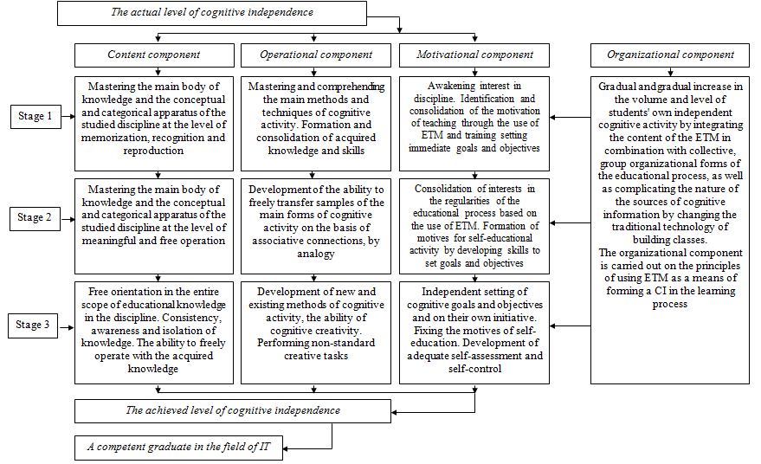

Figure 1 – Model of formation of cognitive independence of students

However, before proceeding directly to the model of CI formation itself, it is necessary to consider the model of building the pedagogical process based on the use of ETM (Figure 2). The model considered was based on the didactic model of John Dewey [3]. John Dewey’s pedagogical concept is based on the following theses:

* The learner is the starting point and is placed at the center of the learning process;
* learning is an active process involving the achievement of knowledge through the mind and no knowledge can be introduced into the learner from the outside;
* It is the trainees who determine the quality of training and the amount of educational material.

The author in this study identified the following negative aspects of the didactic concept of J. Dewey, which must be taken into account in modern conditions:

* exaggeration of the importance of independent cognitive activity of students;
* downplaying the importance of obtaining knowledge for the development of thinking acquired in the learning process;
* Building the content of education only on the basis of the interests of the trainees.

In addition to the negative aspects of John Dewey's didactic system, the author identified a number of positive aspects in the study:

* an integrated approach to the development of the intellect, feelings, will of the trainees and taking into account their cognitive interests and needs;
* creating conditions for the formation of skills to act in non-standard situations, critical thinking;
* creating conditions for the formation of skills to identify, formulate and resolve various theoretical and practical problems and tasks of everyday life;
* organization of collective forms of work;
* Construction of the learning process on an individual trajectory, activation of the formation of students' CI.

**Results**

Taking into account the considered negative and positive aspects of the didactic system of J. Dewey is the author of this study and has developed a model for building a pedagogical process based on the use of ETM (Figure 2)

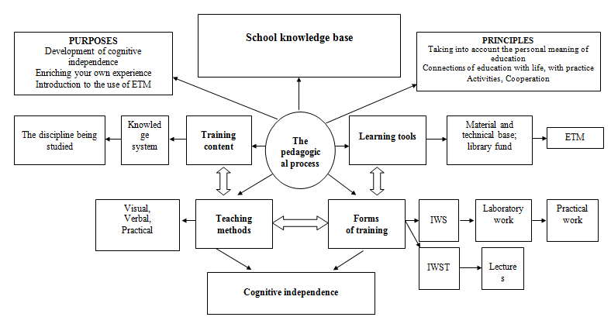

Figure 2 – A model of building a pedagogical process based on the use of ETM

The presented model includes the following components:

* education goals;
* content of education;
* means and methods of obtaining education;
* forms of organization of the educational process;
* the real educational process as a unity of learning, education and development of the learner;
* subjects and objects of the educational process;
* educational environment;
* The result of education.

The proposed model leads to the construction of the learning process with the use of ETM, the result of this learning process will be a CI formed by students.

On the basis of the considered organization of the educational process with the use of ETM, as well as on the basis of the model of building the pedagogical process based on the use of ETM (Figure 2), the author of this study constructed a model that contributes to the process of developing this quality in a more effective form.

The author of this article considers the CI development model as a purposeful, consistent process of gradual change in quantitative and qualitative indicators of the content, operational and motivational components of this quality. This process is achieved by organizing an educational process that combines the integrative content space of the discipline being studied with group organizational forms in the classroom. It should be borne in mind that the educational process should be aimed at increasing the volume and level of students' CI based on the use of ETM. The model of students' CI development is graphically depicted in Figure 1.

The development of the PS based on the developed model takes place in three main stages. Each stage corresponds to three levels of formation of students' CI.

The first stage is characterized by the development of the conceptual and categorical apparatus and the main body of knowledge of the discipline being studied, which occurs at the level of memorization, recognition and reproduction.

At the second stage, the student acquires and develops the ability to freely operate with the knowledge acquired at the previous stage and the conceptual and categorical apparatus, awareness of the need to study the discipline. At this stage, there is a consolidation of interests in the regularities of the educational process, built on the basis of the use of ETM.

The third stage is characterized by the formation of the learner's independence in the application in practice of the entire complex of acquired knowledge and methods of cognitive activity in the field of their application.

The organizational component presented in the developed model implies a gradual increase in the level of students' PS through the active use of collective, group organizational forms of the educational process in the content of the discipline being studied. The organizational component is carried out on the principles of using the ETM as a means of forming a CI.

**Discussion**

Both models developed by the author of this study are based on four interrelated components:

* goal-setting component;
* organizational and content component;
* diagnostic and effective component;
* functional component.

The concept of «students' CI» is an integrative quality of personality, which is a link between motivational, content–operational, activity and regulatory-volitional components, and also acts as a central point in the content basis of the models proposed by the author of the article. The components included in the students' CI are in inseparable unity and continuously interact with each other. Based on the above, the process of CI formation takes place in the conditions of active activity of each student, due to the use of ETM in teaching, and their awareness of the fundamental role of the activity currently performed in the process of their future professional development.

As the first component of the structural and functional models of the process of formation of teaching staff, which ensures the orientation of the process under consideration, the author identifies a *goal-setting component* that determines the goals and specific tasks of the formation of students' CI.

The component that provides management of the process of formation of students' CI is *the organizational and content component*, implemented through:

* factors of CI formation;
* principles contributing to the formation of students' CI;
* the content of the discipline being studied, the independent work of students, as well as the implementation of the use of ETM;
* the main stages of the process of formation of students' CI.

*The diagnostic and effective component* is aimed at:

* diagnostics of the results of the pedagogical process;
* analysis of the results of the pedagogical process;
* comparison of the results obtained with the originally set goal;
* determination of measures aimed at improving the efficiency of the functioning of the model presented by the author by correcting the pedagogical process.

The formation of students' CI is a deterministic process that requires compliance with certain pedagogical conditions. The complex of these conditions is presented in the structural and functional model of the CI formation process:

* formation of students' CI at each stage of the educational process;
* the process of forming students' CI should be based on personal orientation;
* students have a well-formed attitude to active cognitive activity, which is facilitated by the use of ETM in training classes;
* organization of the educational process based on the use of ETM.

Based on the main objective of this study – the formation of CI in teaching students through the use of ETM, the author, using the models considered, defines the teacher's activity strategy as follows:

* active stimulation of independent cognitive learning activities of students using EUP;
* taking into account the knowledge and skills available to students and organizing the content and structure of educational activities based on them;
* assistance from the teacher in the development of organizational skills of students' learning activities;
* Management of students' CI by the teacher, including monitoring, current and final control with subsequent correction to achieve the educational goal and the use of ETM, which will ensure that the student makes his own decisions.

It is determined that the effectiveness of the process of developing students' CI in the classroom using the ETM is provided by the following set of organizational and pedagogical conditions:

* professional competence of the teacher in the field of taught disciplines;
* availability of ETM in disciplines, according to the curriculum;
* library fund, including the necessary literature;
* computer base;
* enrichment of the acquired knowledge by students in the process of introducing them to the use of ETM;
* formation of critical thinking when using various methods of mental activity;
* formation of students' CI, which is facilitated by the use of ETM;
* planning of students' own cognitive activity and creating conditions for reflection of its results;
* informatization of the educational space of the university;
* designing a pedagogical process aimed at the development of the CI of future specialists based on the use of ETM;
* organization of pedagogical monitoring of students' CI development in the classroom with the use of ETM and teachers' readiness for pedagogical support of this process;
* creating opportunities for creative self-realization of students.

**Conclusion**

Based on the considered essence of CI, its structure and levels, as well as the pedagogical conditions of the organization of the learning process with the use of ETM, the author of this study has constructed a model for the development of students' CI, as a result of which the process of developing this quality in students will proceed in a more effective form.

The use of ETM will help to significantly enrich the educational process, will make classes the most effective in the development of students' CI.

**THE LIST OF SOURCES**

1 Алексеев Г.В. Основы разработки электронных учебных изданий: учеб. пос. / Г.В. Алексеев, И.И. Бриденко, Е.И. Верболоз, М.И. Дмитриченко. – СПб.: Лань, 2016. – 144 с.

2 Григорьев С.Г. Образовательные электронные издания и ресурсы: учеб. пос. / С.Г. Григорьев, В.В. Гриншкун. – М., 2009. – 156 с.

3 Мякишев С.Л. Электронные учебные издания: характеристика и особенности подготовки / С.Л. Мякишев, Р.Ю. Макаров // Вестник ВятГУ. – 2011. – №1-3. – С. 20-23.

4 Прокопец Е.В. Методические особенности обучения детей с нарушениями слуха и речи мультимедийным технологиям / Е.В. Прокопец // Вестник Инновационного Евразийского университета. – 2019. - № 4 (76). – С. 17-23

5 Дубровина Е.А. Использование цифровых образовательных ресурсов в современном учебном процессе. [Электронный ресурс] / Е.А. Дубровина // Социальная сеть работников образования nsportal.ru – Режим доступа: http://nsportal.ru/vuz/pedagogicheskie-nauki/library/2014/01/10/ispolzovanietsifrovykh-obrazovatelnykh-resursov-v

**REFERENCES**

1 Alekseev, G.V., Bridenko, I.I. Verboloz, E.I. & Dmitrichenko, M.I. (2016). Osnovy razrabotki elektronnyh uchebnyh izdanij [Fundamentals of the development of electronic educational publications].SPb.: Lan' [in Russian].

2 Grigor'ev, S.G. & Grinshkun, V.V. (2009). Obrazovatel'nye elektronnye izdaniya i resursy [Educational electronic publications and resources].M. [in Russian].

3 Myakishev, S.L. & Makarov, R.YU. (2011). Elektronnye uchebnye izdaniya: harakteristika i osobennosti podgotovki [Electronic educational publications: characteristics and features of training]. Vestnik VyatGU – Bulletin of VyatSU, 1-3, 20-23 [in Russian].

4 Prokopets, E.V. (2019). Metodicheskie osobennosti obucheniya detej s narusheniyami sluha i rechi mul'timedijnym tekhnologiyam [Methodological features of teaching multimedia technologies to children with hearing and speech impairments]. Vestnik Innovacionnogo Evrazijskogo universiteta – Bulletin of the Innovative Eurasian University, 4 (76), 17-23[in Russian].

5 Dubrovina, E.A. (2014). Ispol'zovanie cifrovyh obrazovatel'nyh resursov v sovremennom uchebnom processe [The use of digital educational resources in the modern educational process]. Social'naya set' rabotnikov obrazovaniya nsportal.ru - Social network of education workers nsportal.ru. Retrieved from http://nsportal.ru/vuz/pedagogicheskie-nauki/library/2014/01/10/ispolzovanietsifrovykh-obrazovatelnykh-resursov-v [in Russian].

**Е.В.Прокопец**

Инновациялық Еуразия Университеті, Қазақстан

**Оқытуда электрондық оқу құралдарын пайдалану кезінде студенттердің танымдық дербестігін қалыптастыру моделі**

**Аннотация**

Мақала оқу процесінде электрондық оқу құралдарын практикалық қолдануға негізделген білім алушылардың танымдық дербестігін қалыптастыру моделін сипаттауға арналған. Сондай-ақ, оқытудың осы моделін әзірлеуге қойылатын негізгі талаптар және ұсынылған модель көрсетуі керек негізгі аспектілер қарастырылады. Мақалада автор зерттеген білім беру процесінде электронды оқу құралдарын қолдана отырып, танымдық тәуелсіздікті қалыптастыру процесінің проблемасы толығымен электронды оқу құралдарын қолдану негізінде педагогикалық процестің моделін құруға және жүзеге асыруға, сондай-ақ білім алушылардың танымдық Тәуелсіздігін қалыптастыру моделін құруға және жүзеге асыруға байланысты. Қарастырылған модельдерге сүйене отырып, студенттердің танымдық тәуелсіздігін қалыптастыруға неғұрлым қолайлы және тиімді әсер ететін электрондық оқу құралдарын қолдану арқылы студенттерді оқытудағы оқытушы қызметінің стратегиясы анықталды.

Мақсаты: электрондық оқу құралдарын қолдану арқылы студенттердің танымдық Тәуелсіздігін қалыптастыру моделін құру технологиясының сипаттамасы және оны оқытушы қызметінің ұсынылған стратегиясы негізінде білім беру процесінде практикалық қолдану.

Әдістері: Мақалада талдау, синтез және дедукция әдістері қолданылды. Джон Дьюидің дидактикалық тұжырымдамасын және оның негізінде қалыптасқан талаптар мен принциптерді талдау, Электронды оқу құралдарын белсенді қолдану арқылы танымдық тәуелсіздікті қалыптастыруға бағытталған педагогикалық процестің моделін құру сипаттамалық-аналитикалық әдіс негізінде жүргізілді.

Нәтижелер және олардың маңыздылығы: Автор ұсынған модельдердің практикалық нәтижесі ұйымдастырушылық және педагогикалық жағдайлар кешені болып табылады, олардың сақталуы электронды оқу құралдарын қолдану арқылы оқу процесінде студенттердің танымдық Тәуелсіздігінің қарқынды дамуына ықпал етеді. Зерттеу нәтижелері теориялық маңыздылығынан басқа, электронды оқу құралдарын қолдану негізінде құрылған педагогикалық процеске қойылатын талаптарды ескере отырып, мұғалімнің іс-әрекетінің стратегиясында практикалық маңыздылыққа ие. Автор ұсынған модель электронды оқу құралдарын қолдану арқылы білімді игеру процесінде студенттердің танымдық тәуелсіздігін тиімді қалыптастыруға ықпал етеді.

Түйінсөздер: танымдық Тәуелсіздік, оқыту моделі, оқыту компоненті, оқу кезеңі, дидактикалық жүйе.

**Е.В.Прокопец**

Инновационный Евразийский университет, Казахстан

**Модель формирования познавательной самостоятельности студентов при использовании в обучении электронных учебных пособий**

**Аннотация**

Статья посвящена описанию модели формирования познавательной самостоятельности обучающихся, основывающейся на практическом применении в учебном процессе электронных учебных пособий. Также рассматриваются основные требования к разработке данной модели обучения и основные аспекты, которые должна отражать предложенная модель. Исследуемая автором в статье проблема процесса формирования познавательной самостоятельности с использованием электронных учебных пособий в образовательном процессе, всецело зависит от построения и реализации модели педагогического процесса на основе применения электронных учебных пособий, а также от построения и реализации модели формирования познавательной самостоятельности обучающихся. Исходя из рассмотренных моделей, определена стратегия деятельности преподавателя при обучении студентов посредством применения электронных учебных пособий, наиболее благоприятно и эффективно сказывающаяся на формировании у обучаемых познавательной самостоятельности.

Цель:описание технологии построения модели формирования познавательной самостоятельности студентов посредством использования электронных учебных пособий и ее практическое применение в образовательном процессе на основе предложенной стратегии деятельности преподавателя.

Методы:В статье были использованы методы анализа, синтеза и дедукции. Анализ дидактической концепции Джона Дьюи и сформированных на ее основе требований и принципов построения модели педагогического процесса, направленного на формирование познавательной самостоятельности, с помощью активного применения электронных учебных пособий проведен на основе описательно-аналитического метода.

Результаты и их значимость:Практическим результатом предложенных автором моделей является комплекс организационных и педагогических условий, соблюдение которых способствует более интенсивному развитию познавательной самостоятельности студентов в процессе обучения посредством применения электронных учебных пособий. Результаты исследования, помимо теоретической значимости, имеют и практическую значимость, заключающуюся в стратегии деятельности преподавателя с учетом требований к педагогическому процессу, построенному на основе применения электронных учебных пособий. Предложенная автором модель будет способствовать более эффективному формированию познавательной самостоятельности студентов в процессе усвоения знаний посредством применения электронных учебных пособий.

Ключевые слова: познавательная самостоятельность, модель обучения, компонент обучения, этап обучения, дидактическая система.

**Information about the authors:**

**Prokopets, E.V. –** Master of Computer Science, Senior Lecturer of the Faculty of Engineering and Technology of the Innovative Eurasian University, Innovative University of Eurasia, Pavlodar c., Republic of Kazakhstan. **Прокопец Е.В.** – информатика магистрі, Инновациялық Еуразия университетінің Инновациялық Еуразия университетінің инженерлік-технологиялық факультетінің аға оқытушысы, Павлодар қ., Қазақстан Республикасы. **Прокопец Е.В.** – магистр информатики, старший преподаватель инженерно-технологического факультета Инновационного Евразийского университета, г. Павлодар, Республика Казахстан. E-mail: podsolnuschek@mail.ru

**Date of receipt of the manuscript to the editor:**