**UDC 637.3.04**

**M.B. Rebezov**, Doctor of Agricultural Sciences, professor

Federal State Budgetary Scientific Institution «Federal Scientific Center for Food Systems named after V.M. Gorbatov» (Moscow, Russia)

Е-mail: rebezov@yandex.ru

**M.V. Temerbayev,** candidate of technical sciences, associate professor,

Innovative University of Eurasia (Pavlodar, Kazakhstan Republic)

Е-mail: marvik75@yandex.kz

**T.I. Uryumtseva,** candidate of veterinary sciences, associate professor,

Innovative University of Eurasia (Pavlodar, Kazakhstan Republic)

Е-mail:vbh2@mail.ru

**Mathematical modeling of the results of experimental studies of the influence of the type and dose of cheese melting salt on the qualitative indicators of melted cheeses**

**Abstract.** *The article is devoted to the mathematical modulation of a complex of experimental data obtained in the process of experimental studies of processed cheese products, processed by mathematical methods. The purpose of this study is to establish the type and amount of the melting salt that promotes the formation of the plastic structure of the processed cheese product. The analysis of scientific research in the field of food technologies showed that mathematical modeling is used in the following areas: clarification of the modes of technological processes, design of recipes and assessment of the quality of finished products, as well as forecasting the shelf life of new products when they are put into production. The most relevant in describing the processes of food production are models of multivariate variance-regression analysis using methods of mathematical planning of the experiment. The authors carried out mathematical modeling and established graphical dependencies characterizing the degree of influence of the regulated factors X1 and X2 on the controlled ones that determine the quality and safety of processed cheese products. It is important that the mathematical analysis of the graphical dependences of the rheological parameters on the adjustable factors indicates the reliability of the data obtained. It is concluded that an increase in the melting salt dose leads to an increase in the – limit shear stress, which reflects the nature and state of the consistency of the processed cheese product. The process of normalization of the controlled factors by the maximum value was carried out. Graphical dependencies were built and regression analysis was performed, the results of which allow an objective assessment of the degree of influence of the type and dose of the melting salt on the chemical and organoleptic characteristics of the test products. The authors have proven that the optimal efficiency of transforming the structure of the constituent components of the recipe into a plastic structure of a processed cheese product that is stable during storage is provided by a combination of adjustable factors X1 (Solva 85) and X2 (Solva 120) taken in a ratio of 1: 1, with a total amount of 1,2 mas.%. At the same time, the quality indicators of the experimental products are characterized by the following values of the controlled factors: У1 – 1280 Pa; У2 – 9 points, У3 – 9,301 (2,0-2,2⋅109 colony forming units / g).*

***Keywords:*** *mathematical modeling, controlled factors, controlled factors, melting salt, ultimate shear stress, objective function, graphical dependencies.*

**Introduction.** The development of a new generation of melted cheese technologies is based on the use of established correlations between characteristics within these conditional groups, as well as between groups. So, a qualitative or quantitative change in the component composition makes it possible to regulate product quality criteria or quality management [1, P.27].

When developing the technology of a new cheese product, rennet fat and low-fat cheeses are used as the main raw material for its production for melting in propionic bacteria.

The structure of melted cheese products and their properties are determined by the state of the protein network, including fat droplets, proteolysis products, low molecular weight compounds and water. The primary element of the spatial network of the gel is the casein macromolecule, and the gelation itself occurs in several stages. When heated, casein particles aggregate to form small chains and conglomerates, from which a spatial network subsequently emerges. This network is quite incoherent; this network is quite inhomogeneous; dense areas of casein particles are interspersed with areas not containing casein. These casein-free areas turn out to be quite large pores filled with liquid. The possibility of the appearance of such structures has been repeatedly proven by computer modeling, and gelation is presented as the appearance of fractal structures. The chaotic breaking of bonds and the existence of an activation volume affects the compactness of the resulting floccules and the geometry of the randomly formed spatial network, but does not qualitatively change the overall picture. It has been proven that hydrophobic electrostatic interactions take part in the formation of a spatial network of casein gels, van der Waals forces take place, as well as steric entroy effects associated with the peculiarities of the confirmation state of the protein.

The most important criterion for the quality of melted cheese is the state of its consistency, which depends on the characteristics of the structure formation. The main factor providing the structural transformation of paracasein under heat exposure during the melting process is known. It is a melting salt, which acts as a calcium removing agent and promotes the breakdown of casein micelles into submicelles, which causes the dispersion and peptization of the elements of the protein framework with the formation of a sol phase [2, P.4].

The purpose of this study is to establish the influence of the type and amount of cheese melting salt on the formation of the structure of a melted cheese product with functional properties.

**Materials and methods.** The prototypes were based on the protein-fat base of melted cheese product, determined on the basis of experimental studies and mathematical processing of the data obtained. The following requirements are set as the main requirements for the consistency of a new product: the consistency must be homogeneous, viscous, paste-like, moderately dense.

When choosing the type of melting salts, first of all, were guided by such important criteria as minimizing the influence of the melting salt on the taste and smell of the cheese product, preserving the natural spicy sour-milk cheese taste of the main raw material - rennet cheese with propionic bacteria. The effect of the melting salt on the shift in the pH of the raw material was also taken into account, that is, adhered to the requirement that the pH value of the finished processed cheese product should not differ significantly from the pH of the main raw material.

The efficiency of the process of structure formation (new terminology - cream formation), the essence of which is the transformation of the basic structure of the components of the protein-fat base into a three-dimensional structure due to the combined action of physical factors: temperature, mixing and chemical - the action of the melting salt.

Based on the above, for the experimental study, the melting salts Solva-85 and Solva-120 were selected, which are recommended by the manufacturer by «BK Jolini» (Germany), since the recommendation does not provide for the exact dosage of the melting salt, it is of scientific and practical interest to establish for new multi-component system type and dose of melting salt. Three series of experiments were carried out, in which the type and dose of the melting salt were varied.

For an objective judgment on the degree of influence of the type and dose of the melting salt on the quality indicators of the test products, a mathematical modeling of the complex of experimental data obtained in the process of experimental research, processed by mathematical methods was carried out. [3, P.31].

Statistical processing of the experimental results was carried out using regression analysis on a personal computer. [4, P. 12]. The reliability of the results was determined using the Cochran's Q Test; the Brandon method was used to describe the mathematical model [5, P. 32].

To identify and eliminate gross experimental errors (blunders), they were processed by methods of mathematical statistics. For this, the homogeneity of the variance estimates was determined using the Cochran's Q Test according to the following relationship [6, P. 24]:

 (1)

where: max  – maximum variance of a series of parallel experiments;

– sum of variances.

For each series of parallel experiments, the arithmetic mean of the response function was calculated:

 (2)

The variance of the experiments was calculated by the formula:

 (3)

where i is the series number;

k – number of parallel experiments carried out under the same conditions;

N – number of series of experiments (number of variance estimates).

The hypothesis of dispersion homogeneity was accepted if the calculated value of Cochran's Q Test Gр is less than tabular Gtabl т.е. Gр < Gtabl, Critical, i.e. the maximum permissible values of Cochran's criteria were determined according to tables [7, P.11].

To find the Cochran criterion G, it is necessary to know the total number N of variance estimates and the number of degrees of freedom f associated with each of them, and f = k-1. Experiments are considered reproducible when the condition Gр <= Gtabl. If the experiments are reproducible, then the calculation of the variance of reproducibility of a series of parallel experiments is calculated by the formula:

 (4)

In this case, the number of degrees of freedom is determined by the formula:

 (5)

Determination of the regression coefficients. The relationship between the response function of Y and the selected factors in the study area has linear character.

In this regard, there is a search for a correspondence in the form of a linear regression equation:

 (6)

In matrix form, the system of normal equations can be written as follows:

The matrix of independent variables was represented in the form:

, (7)

Vector matrix as observations in the form:

, (8)

Matrix as a column of coefficients of the regression equation:

, (9)

When using the least squares method, the system of normal equations to determine the coefficients b0 , b1, … bk, is:

, (10)

The column matrix of b coefficients is defined as follows:

 (11)

The calculation of the regression coefficients was carried out according to the algorithm we developed in computer systems MathCAD 2001 Pro and Maple-7 [8, P.94].

Testing the hypothesis about the significance of the regression coefficients bi. To establish whether the coefficient is significant or not, it is necessary to calculate the variance estimate with which it is determined:

(12)

It is known that the regression coefficient is significant if the condition is:

 (13)

where t – the value of the Student criterion is determined from the table at the specified reliability of the experiment (р) and the number of degrees of freedom (f).

Having received the regression equation, its adequacy is checked, i.e. the ability to describe the response surface well enough and to predict the results of experiments. To check the adequacy, the estimate of the variance of the adequacy was calculated by the formula:

 (14)

where В is a number of significant regression coefficients;

yэi , ypi – experimental and calculated value of the response function

in i experiment;

N – number of full factorial experiment runs.

The estimate of the variance of adequacy is associated with the number of degrees of freedom f = N - B.

**Results.** The purpose of mathematical modeling is to establish the type and amount of the melting salt which contributes to the formation of the plastic structure of the processed cheese product. Complex data of experimental studies are given in the table 1.

The regulated factors are: Х1 – amount of Solva 85 melting salt, mass content %; Х2 – amount of Solva 120 melting salt, mass content %.

Controlled factors that objectively characterize the consistency state of the test products were selected: У1 – yield value, Pa. delimitation, not > 1300 Pa; У2 – organoleptic estimation of consistency, points → max (9 points); У3 – logarithm of the number of viable cells of probiotic cultures, CFU/G of product → max.

To implement the set tasks, it is necessary to carry out the process of normalizing the controlled factors by the maximum value. Normalization of the controlled factors by the maximum value is carried out according to the formula:

, (15)

where – normalized control factor value;

 – experimental value of the controlled factor;

 – maximum value of the experimental controlled factor.

The objective function is the sum of the normalized values of the controlled factors and is determined by the formula:

 (16 )

where  – objective function value;

 – the sum of the normalized values of the controlled factors.

The conversion of controlled factors into dimensionless number s is given in the table 1. To achieve this goal, mathematical models were built in a specific sequence. Graphical dependencies were mathematically established that characterize the degree of influence of the regulated factors Х1 and Х2 on the controlled ones that determine the quality and safety of melted cheese products.

Table 1 Comprehensive data characterizing the degree of influence of cheese melting salts on the quality indicators of test products

|  |  |  |  |  |  |  |  |  |  |
| --- | --- | --- | --- | --- | --- | --- | --- | --- | --- |
| Product | Regulated factors | | Controlled factors | | | Conversion of controlled factors into dimensionless numbers | | |  |
| Х1 | Х2 | У1,Pa | У2, points | У3, CFU / g | У1 | У2 | У3 |
| Experience 1 | 0,8 | - | 265,0 | 6,0 | 8,954 | 1,00 | 1,00 | 1,13 | 3,13 |
| Experience 2 | 1,0 | - | 400,0 | 6,5 | 8,914 | 1,51 | 1,08 | 1,25 | 3,84 |
| Experience 3 | 1,2 | - | 680,5 | 6,8 | 8,898 | 2,57 | 1,13 | 1,12 | 4,82 |
| Experience 4 | 1,4 | - | 780,0 | 7,0 | 8,813 | 2,94 | 1,17 | 1,11 | 5,22 |
| Experience 5 | 1,6 | - | 900,0 | 7,5 | 8,716 | 3,40 | 1,25 | 1,10 | 5,75 |
| Experience 6 | 1,8 | - | 1040,0 | 8,0 | 8,602 | 3,92 | 1,33 | 1,08 | 6,33 |
| Experience 7 | - | 0,8 | 270,5 | 6,0 | 8,778 | 1,02 | 1,00 | 1,11 | 3,13 |
| Experience 8 | - | 1,0 | 450,0 | 6,5 | 8,716 | 1,70 | 1,08 | 1,10 | 3,88 |
| Experience 9 | - | 1,2 | 720,0 | 6,8 | 8,602 | 2,72 | 1,13 | 1,08 | 4,93 |
| Experience 10 | - | 1,4 | 840,0 | 7,0 | 8,505 | 3,17 | 1,17 | 1,07 | 5,41 |
| Experience 11 | - | 1,6 | 1010,0 | 7,2 | 8,301 | 3,81 | 1,20 | 1,05 | 6,06 |
| Experience 12 | - | 1,8 | 1100,0 | 7,8 | 7,939 | 4,15 | 1,30 | 1,00 | 6,45 |
| Experience 13 | 0,4 | 0,4 | 620,5 | 7,5 | 9,079 | 2,34 | 1,25 | 1,14 | 4,73 |
| Experience 14 | 0,5 | 0,5 | 1005,0 | 8,0 | 9,342 | 3,79 | 1,33 | 1,18 | 6,30 |
| Experience 15 | 0,6 | 0,6 | 1280,0 | 9,0 | 9,301 | 4,83 | 1,50 | 1,17 | 7,50 |
| Experience 16 | 0,7 | 0,7 | 1310,0 | 8,5 | 8,991 | 4,94 | 1,42 | 1,13 | 7,48 |
| Experience 17 | 0,8 | 0,8 | 1480,0 | 7,5 | 8,929 | 5,58 | 1,25 | 1,12 | 7,95 |
| Experience 18 | 0,9 | 0,9 | 1600,0 | 7,0 | 8,875 | 6,04 | 1,17 | 1,12 | 8,33 |

Dependence diagrams (pictures 1-9) were built and regression analysis (table 2) was performed, the results of which allow one to give an objective assessment of the degree of influence of the type and dose of the melting salt on the chemical and organoleptic characteristics of the test products.

|  |  |  |
| --- | --- | --- |
|  |  |  |
| Picture 1- Effect of the type and dose of the Solva 85 melting salt on active acidity |  | Picture 2 - Influence of the type and dose of the Solva 120 melting salt on active acidity |
|  |  |  |
| Picture 3 - Influence of the type and dose of the combination of salts Solva-85 and Solva-120 on active acidity |  | Picture 4 - Influence of the type and dose of the Solva 85 melting salt on organoleptic characteristics |
|  |  |  |
| Picture 5 – Influence of the type and dose of the Solva 120 melting salt on organoleptic characteristics |  | Picture 6 – Influence of the type and dose of the combination of the salts Solva-85 and Solva-120 on organoleptic characteristics |

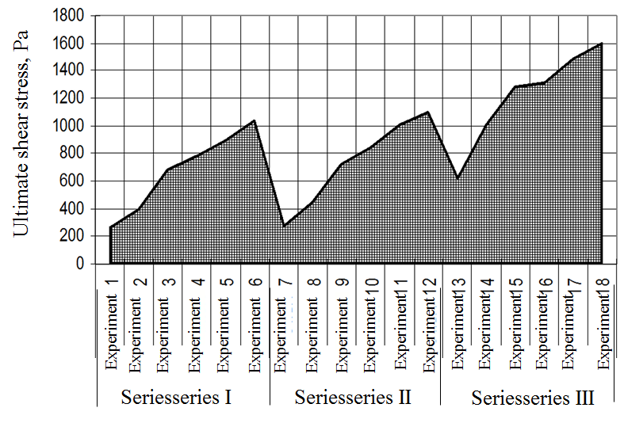

Picture 7 - Influence of the type and dose of the melting salt on the rheological parameters of the test products

Table 2 – Regression analysis of changes in active acidity and organoleptic parameters of test products depending on the type and dose of the melting salt

|  |  |  |
| --- | --- | --- |
| Option | Regression equation | The value of the approximation accuracy (R^2) |
| Active acidity | | |
| Series I | Y = -0,3929x2 + 1,8114x + 3,7666 | R2 = 0,843 |
| Series II | Y = 0,2009x2 + 0,442x + 4,5875 | R2 = 0,984 |
| Series III | Y = 0,5893x2 + 1,3025x + 4,6772 | R2 = 0,907 |
| Organoleptic indicators | | |
| Series I | Y = 0,3571x2 + 0,9571x + 5,0771 | R2 = 0,986 |
| Series II | Y = 0,0446x2 + 1,4982x + 4,855 | R2 = 0,966 |
| Series III | Y = -23,214x2 + 28,893x - 0,3786 | R2 = 0,850 |

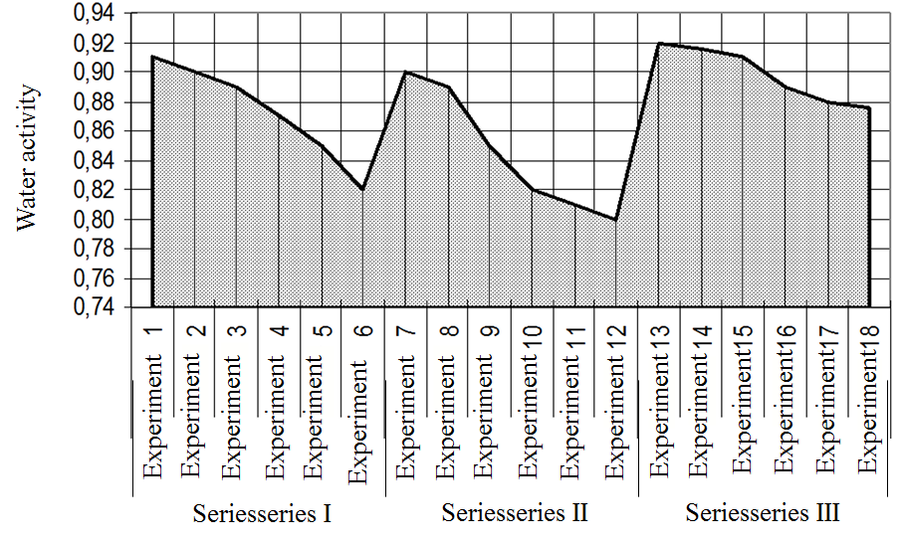

Picture 8 - Influence of the type and dose of the melting salt on the water activity in the test products

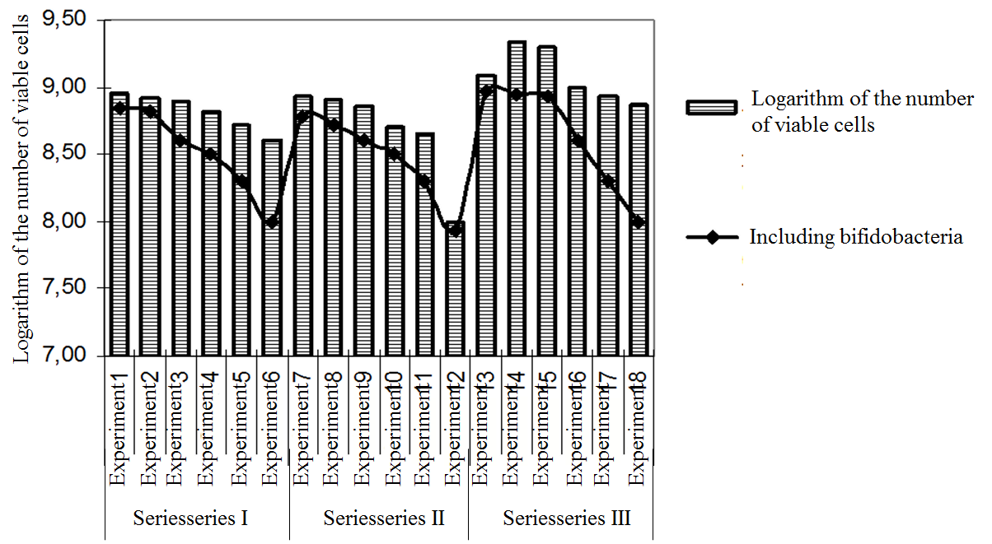

Picture 9 - Influence of the type and dose of the melting salt on the microbiological parameters of the test products

**Discussion.** The mathematical analysis of the graphical dependencies of rheological parameters on the regulated factors indicates the reliability of the data obtained.

An increase in the dose of the melting salt leads to an increase in the indicator of the yield value, which reflects the nature and state of the consistency of the melted cheese product.

Some decrease in microbiological parameters in the test products, characterized on the graphs by the logarithm of the total number of viable cells of microorganisms, was established: lactic, propionate and bifidus bacteria.

**Conclusion.** As a result of the experimental studies and mathematical analysis of the data obtained, it was found that the high efficiency of transforming the structure of the constituent components of the recipe into the plastic structure of the melted cheese product, stable during storage, is provided by a combination of controlled factors Х1 (Solva 85) and Х2 (Solva 120) taken in the 1:1 ratio, with the total number 1,2 mass content %.

At the same time, the quality indicators of the experimental products are characterized by the following values of the controlled factors:

У1 (yield value) – 1280 Pa;

У2 (organoleptic estimate of product consistency) – 9 points;

У3 (logarithm of the total number of viable cells of probiotic microflora) – 9,301 (2,0-2,2⋅109 CFU/G).

**THE LIST OF SOURCES**

1. Temerbayeva M.V. Biotechnological aspects of the production of specialty foods: Мonograph – Pavlodar: Expert Group, 2018. – 120 p.

2. Marina Temerbayeva, Maksim Rebezov, Olga Gorelik. Using of creamy bioadditives in the production of melted cheese. International Journal of Engineering & Technology: 2018. – № 4 (38) – Р. 1240 -1242.

3. Лисин П.А. Компьютерное моделирование производственных процессов в пищевой промышленности: учеб. пос. / П.А. Лисин. – СПб.: Лань, 2016. – 256 с.

4. Макаричев Ю.А., Иванников Ю. Н. Методы планирования эксперимента и обработки данных: учеб. пос. / Ю.А.Макаричев, Ю.Н.Иванников – Самара: Самарский государственный технический университет, 2016. – 131 с.

5. Сидняев Н.И. Введение в теорию планирования эксперимента: учебник / Н.И. Сидняев. - М.: Московский государственный технический университет им. Н. Э. Баумана, 2017. - 799 с.

6. Реброва И. А. Планирование эксперимента: Учебное пособие. – Омск: СибАДИ, 2010. – 105 с.

7. Статистические методы анализа: учеб. пос. / И.С. Шорохова, Н.В. Кисляк, О.С. Мариев. –Екатеринбург: Изд-во Урал. ун-та, 2015. – 300 с.

8. Ахмадиев Ф. Г., Гильфанов Р. М. Математическое моделирование и методы оптимизации: учеб. пос. / Ф.Г. Ахмадиев, Р.М. Гильфанов. – Казань: Казанское государственное издательство. архитектор-строит. ун-та, 2017. – 178 с.

**REFERENCES**

1. Temerbayeva, M.V.(2018) Biotechnological aspects of the production of specialty foods: Monograph – Pavlodar: Expert Group. – 120 p.

2. Marina Temerbayeva, Maksim Rebezov, Olga Gorelik.(2018) Using of creamy bioadditives in the production of melted cheese. International Journal of Engineering & Technology. – № 4 (38) – R. 1240 -1242.

3. Lisin, P.A. (2016). *Komp'yuternoye modelirovaniye proizvodstvennykh protsessov v pishchevoy promyshlennosti* *[Computer modeling of production processes in the food industry]*. Saint Petersburg: Lan' [in Russian].

4. Makarichev, YU.A. & Ivannikov YU. N. (2016). *Metody planirovaniya eksperimenta i obrabotki dannykh* *[Methods of planning experiment and data processing]*. Samara: Samarskiy gosudarstvennyy tekhnicheskiy universitet [in Russian].

5. Sidnyayev, N.I. (2017). *Vvedeniye v teoriyu planirovaniya eksperimenta* *[Introduction to the theory of experiment planning]*. Moscow: Moskovskiy gosudarstvennyy tekhnicheskiy universitet im. N. E. Baumana [in Russian].

6. Rebrova, I. A. (2010). *Planirovaniye eksperimenta* *[Planning an experiment]*. Omsk: SibADI [in Russian].

7. Shorokhova, I.S., Kislyak N.V. & Mariyev O.S. (2015). *Statisticheskiye metody analiza* *[Statistical analysis methods]*. Yekaterinburg: Izdatel'stvo Ural'skogo universiteta [in Russian].

8. Akhmadiyev, F. G. & Gil'fanov R. M. (2017). *Matematicheskoye modelirovaniye i metody optimizatsii* *[Mathematical modeling and optimization methods]*. Kazan: Kazanskoye gosudarstvennoye izdatel'stvo. arkhitektor-stroit. un-ta [in Russian].

***М. Б. Ребезов,*** *ауыл шаруашылығы ғылымдарының докторы, профессор*

*Федералды мемлекеттік бюджеттік ғылыми мекеме «Азық-түлік жүйелерінің Федералды ғылыми орталығы. В. М. Горбатова» (Мәскеу қ., Ресей)*

*Е-mail: rebezov@yandex.ru*

***М.В. Темербаева,*** *техника ғылымдарының кандидаты,*

*Инновациялық Еуразия университеті (Павлодар қ, Қазақстан Республикасы)*

*Е-mail:* *marvik75@yandex.kz*

***Т.И. Урюмцева,*** *ветеринария ғылымдарының кандидаты,*

*Инновациялық Еуразия университеті (Павлодар қ, Қазақстан Республикасы)*

*Е-mail:vbh2@mail.ru*

***Тұз-балқытқыштың түрі мен дозасының балқытылған ірімшік өнімінің сапалық көрсеткіштеріне әсерін эксперименттік зерттеу нәтижелерін математикалық модельдеу***

*Мақала математикалық әдістермен өңделген балқытылған ірімшік өнімдерін эксперименттік зерттеу процесінде алынған эксперименттік мәліметтер жиынтығын математикалық модельдеуге арналған. Бұл зерттеудің мақсаты-балқытылған ірімшік өнімінің пластикалық құрылымын қалыптастыруға ықпал ететін балқытылған тұздың түрі мен мөлшерін анықтау. Азық-түлік технологиялары саласындағы ғылыми зерттеулерді талдау Математикалық модельдеудің келесі салаларда қолданылатындығын көрсетті: технологиялық процестердің режимдерін нақтылау, рецептураларды әзірлеу және дайын өнімнің сапасын бағалау, сондай-ақ жаңа өнімдер өндіріске енгізілген кезде сақтау мерзімін болжау. Тамақ өнімдерін өндіру процестерін сипаттау кезінде экспериментті математикалық жоспарлау әдістерін қолдана отырып, көп өлшемді дисперсиялық-регрессиялық талдау модельдері ең өзекті болып табылады. Авторлар X1 және X2 реттелетін факторларының бақыланатын факторларға әсер ету дәрежесін сипаттайтын, өңделген ірімшік өнімдерінің сапасы мен қауіпсіздігін анықтайтын математикалық модельдеуді жүргізді және графикалық тәуелділіктерді анықтады. Реологиялық параметрлердің реттелетін факторларға графикалық тәуелділіктерін Математикалық талдау алынған мәліметтердің дұрыстығын көрсететіні маңызды. Балқытылған тұздың дозасын жоғарылату балқытылған ірімшік өнімінің табиғаты мен консистенциясы күйін көрсететін максималды ығысу кернеуінің жоғарылауына әкеледі деген қорытынды жасалды. Бақыланатын факторларды максималды мәнге қалыпқа келтіру процесі жүзеге асырылды. Графикалық тәуелділіктер құрылды және регрессиялық талдау жүргізілді, оның нәтижелері зерттелетін өнімдердің химиялық және органолептикалық сипаттамаларына балқытылған тұздың түрі мен дозасының әсер ету дәрежесін объективті бағалауға мүмкіндік береді. Авторлар рецепт компоненттерінің құрылымын сақтау кезінде тұрақты балқытылған ірімшік өнімінің пластикалық құрылымына түрлендірудің оңтайлы тиімділігі X1 (Solva 85) және X2 (Solva 120) реттелетін факторларының 1: 1 қатынасында, жалпы құрамы 1,2 мас.%. Сонымен қатар тәжірибелік өнімнің сапалық көрсеткіштері бақыланатын факторлардың мынадай мәндерімен сипатталады: У1 - 1280 Па; У2 - 9 балл, У3 - 9 301 (109 КОЕ / г 2,0-2,2).*

***Түйін сөздер:*** *математикалық модельдеу, бақыланатын факторлар, басқарылатын факторлар, балқу тұзы, шекті ығысу кернеуі, мақсатты функция, графикалық тәуелділік.*

***М.Б. Ребезов,*** *доктор сельскохозяйственных наук, профессор*

*Федеральное государственное бюджетное научное учреждение «Федеральный научный центр пищевых систем им. В.М. Горбатова» (г. Москва, Россия)*

*Е-mail: rebezov@yandex.ru*

***М.В. Темербаева,*** *кандидат технических наук,*

*Инновационный Евразийский университет (г. Павлодар, Республика Казахстан)*

*Е-mail:* *marvik75@yandex.kz*

***Т.И. Урюмцева,*** *кандидат ветеринарных наук,*

*Инновационный Евразийский университет (г. Павлодар, Республика Казахстан)*

*Е-mail:vbh2@mail.ru*

***Математическое моделирование результатов экспериментальных исследований влияния вида и дозы соли-плавителя на качественные показатели плавленого сырного продукта***

*Статья посвящена математическому моделированию комплекса экспериментальных данных, полученных в процессе экспериментальных исследований плавленых сырных продуктов, обработанных математическими методами. Цель этого исследования - установить тип и количество плавящейся соли, которая способствует формированию пластичной структуры плавленого сырного продукта. Анализ научных исследований в области пищевых технологий показал, что математическое моделирование используется в следующих областях: уточнение режимов технологических процессов, разработка рецептур и оценка качества готовой продукции, а также прогнозирование сроков хранения новые продукты, когда они запускаются в производство. Наиболее актуальными при описании процессов производства пищевых продуктов являются модели многомерного дисперсионно-регрессионного анализа с использованием методов математического планирования эксперимента. Авторами проведено математическое моделирование и установлены графические зависимости, характеризующие степень влияния регулируемых факторов X1 и X2 на контролируемые, определяющие качество и безопасность плавленых сырных продуктов. Важно, что математический анализ графических зависимостей реологических параметров от регулируемых факторов свидетельствует о достоверности полученных данных. Сделан вывод о том, что увеличение дозы плавящейся соли приводит к увеличению предельного напряжения сдвига, которое отражает характер и состояние консистенции плавленого сырного продукта. Осуществлен процесс нормализации контролируемых факторов на максимальное значение. Построены графические зависимости и проведен регрессионный анализ, результаты которого позволяют объективно оценить степень влияния типа и дозы плавящейся соли на химические и органолептические характеристики исследуемых продуктов. Авторами доказано, что оптимальная эффективность преобразования структуры составляющих компонентов рецепта в пластичную структуру плавленого сырного продукта, стабильную при хранении, обеспечивается комбинацией регулируемых факторов X1 (Solva 85) и X2 (Solva 120) в соотношении 1: 1, с общим содержанием 1,2 мас.%. В то же время качественные показатели опытной продукции характеризуются следующими значениями контролируемых факторов: У1 - 1280 Па; У2 - 9 баллов, У3 - 9 301 (2,0-2,2⋅109 КОЕ / г).*

***Ключевые слова:*** *математическое моделирование, контролируемые факторы, управляемые факторы, плавильная соль, предельное напряжение сдвига, целевая функция, графические зависимости.*