UDC 621.77
MRNTI 53.43.33

E. Panin^{1*}, A. Esbolat¹
¹Karaganda Industrial University, Kazakhstan
*(e-mail: ye.panin@tttu.edu.kz)

Investigation of the influence of geometric factors in equal-channel angular pressing on the energy-force parameters of deformation

Abstract: Equal-channel angular pressing is the method to realize severe plastic deformation in the volume of deformable metal that is one of the most frequently mentioned in scientific articles devoted to the study of the properties of various ultrafine-grained materials. At the same time, this method of deformation has many variations of technical and technological design, which are based on the principle of implementing shear or alternating strain in the entire volume of the deformable metal. Identification of the influence of geometric factors on energy-power parameters is one of the important tasks of studying the process of equal-channel pressing. That is why this work is devoted to the study of the influence of geometric factors such as the design of matrices, the junction angle of the matrix channels and the length of the matrix channels for pressing on the deformation force during equal-channel pressing of workpieces. The study of the influence of geometric factors on the deformation force was carried out using computer modeling in the DEFORM-2D software package. The analysis of the influence of various geometric factors on the deformation force during equal-channel pressing showed that most of them have a significant effect on the deformation force. Therefore, only the choice of rational geometric parameters of the tool for equal-channel angular pressing will allow to obtain ferrous or non-ferrous metal with a sub-ultrafine-grained structure with minimal energy consumption.
Keywords: equal-channel angular pressing, computer modeling, deformation force, factors, matrix.

Introduction
Since the mid-90s of the last century to the present, scientists from around the world engaged in research in the field of improving the quality of metal processed pressed in hot and cold conditions have proposed and comprehensively studied many different ways of grain refinement during deformation processing to an ultrafine-grained state. A special group of methods for processing metals and alloys by pressure, which make it possible to achieve significant grain grinding without significantly changing the initial dimensions of the workpiece, includes methods that implement the so-called "severe plastic deformation".
Obtaining an ultrafine-grained structure by severe plastic deformation is possible under the following conditions [1-2]:
1) implementation of high degrees of strain for grain grinding (ɛ > 6);
2) providing high hydrostatic pressure that prevents the sample destruction (1 GPa and above);
3) deformation at temperatures of about 0.4 of the melting point and below to prevent recrystallization;
4) ensuring the deformation non-monotonicity, which contributes to the formation of high-angle intergrain boundaries.
It is possible to obtain these conditions when processing metal by such methods as high-pressure torsion, equal-channel angular pressing, screw extrusion, comprehensive forging, and others.
One of the most famous and at the same time one of the oldest methods of grain refinement during deformation of metals and alloys to an ultrafine-grained and nanostructured state is high-pressure torsion [3]. In the process of implementing this method of deformation, it is possible to obtain small samples in the form of disks or rings made of ferrous and non-ferrous metals and alloys with a very well-ground structure. In some alloys and metals, it was possible to obtain a structure with a grain size of up to 20 nm. Although this method of deformation has been well studied, it is still used only in laboratory conditions, since it has two significant disadvantages – firstly, the size of the workpieces being processed, and secondly, the low durability of the tool itself.
Another of the oldest methods of grinding grain during the deformation of metals and alloys to an ultrafine-grained and nanostructured state is equal-channel angular pressing (ECAP). This method already allows you to obtain larger blanks of rectangular (square) cross-section. When implementing this method, it is possible to obtain a homogeneous ultrafine-grained structure with a grain size of 120-210 nm. This method was invented more than 40 years ago [4] for grinding the cast structure of ingots. The ECAP technology and its various variations is most fully described in [5].
Materials and methods
During the study of the energy-force parameters of the equal-channel pressing process, the influence of geometric factors on the deformation force, such as the design of matrices, the joint angle and the length of the channel, was primarily revealed. To study the effect of the matrix design on the deformation force, four variants of equal-channel matrices were considered: angular matrices with a channel junction angle of 90° (Fig. 1a) and 130° (Fig. 1b); a simple step matrix with a channel junction angle of 130° (Fig. 1c); a step matrix with rollers and a channel junction angle of 130° (Fig. 1d). To determine the deformation forces in these matrices, computer simulation of the pressing process was performed using the DEFORM-2D system.
One of the important geometric factors in a simple step matrix is the channel junction angles. To study the effect of channel joint angles on the deformation force, the pressing process was simulated on a computer in step matrices with joint angles 110° (Fig. 2a); 120° (Fig. 2b); 130° (Fig. 1c); 140° (Fig. 2c) and 150° (Fig. 2d).
To study the effect of channel length on the deformation force, the next pressing processes in stepped matrices with the lengths of the inclined channel of the matrix 15 mm (Fig. 1c); 30 mm (Fig. 3a) and 45 mm (Fig. 3b) were simulated.

а) 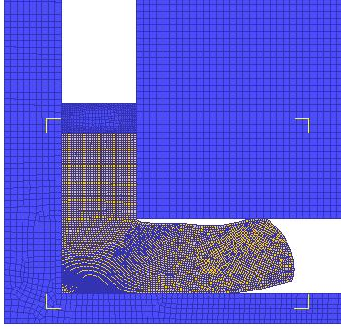 | b) 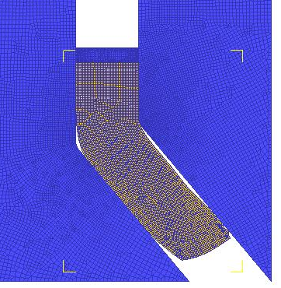
c) 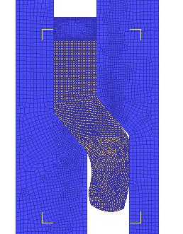 | d) 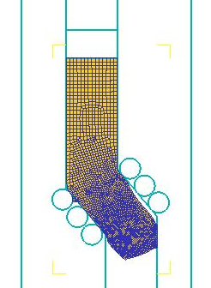

Figure 1– Equal–channel pressing in matrices of various designs: a – angular matrix with a channel junction angle 90°; b - angular matrix with a channel junction angle 130°; c - simple step matrix with a channel junction angle 130°; d - step matrix with rollers and a channel junction angle 130°.
а) 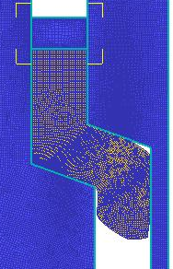 | b) 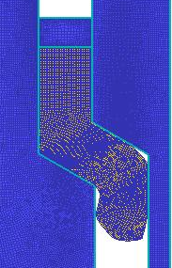
c)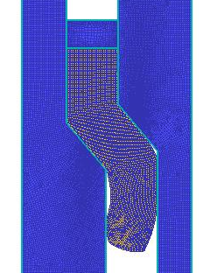 | d)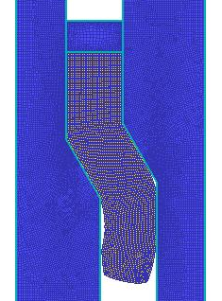

Figure 2 – Equal-channel pressing in stepped matrices with different channel joint angles: a – 110°; b – 120°; c - 140°; d - 150°.

а)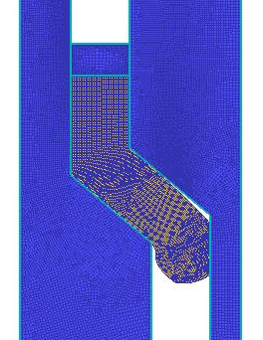 | b)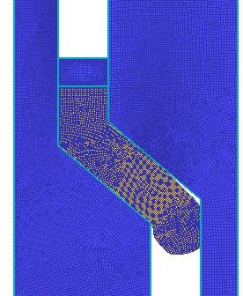

Figure 3 – Equal–channel pressing in step matrices with different lengths of the inclined channel of the matrix: a – 30 mm; b - 45 mm.
Results
As a result of the simulation, graphs of the change in the deformation force depending on the stroke of the punch were constructed (Fig. 4-7).

а)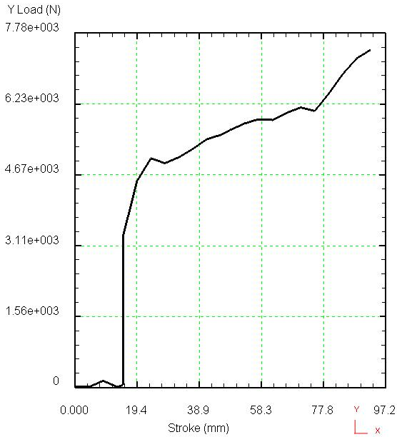 | b)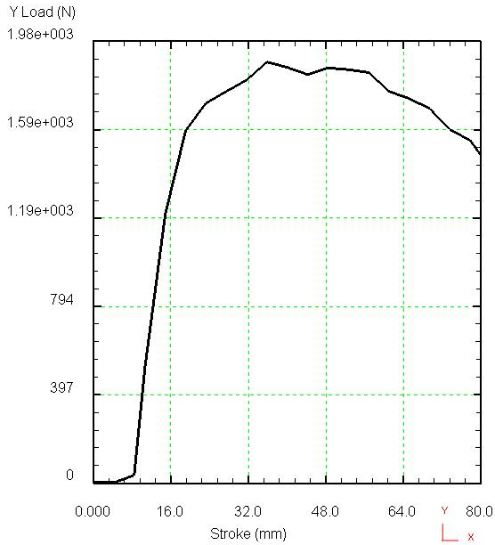
c)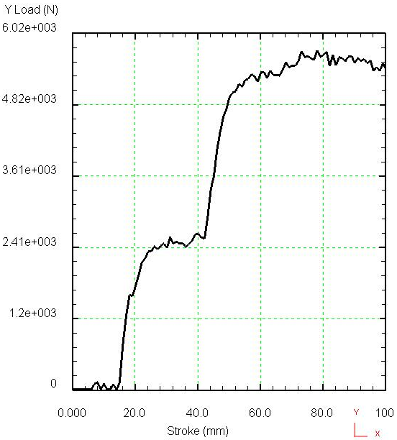 | d)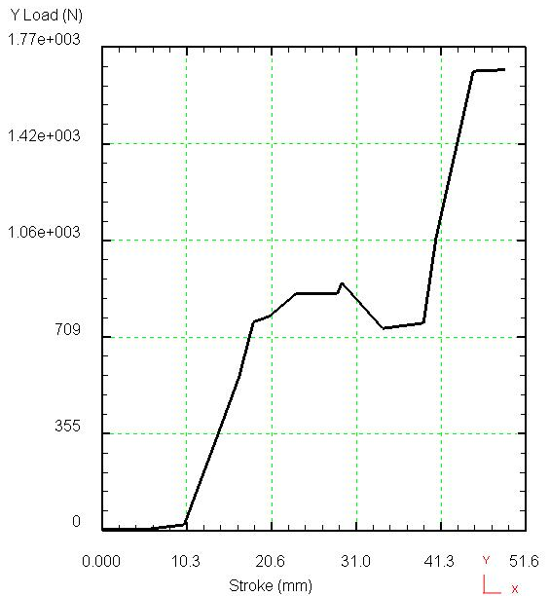

Figure 4 – Graphs of changes in deformation forces depending on the stroke of the punch in matrices of various designs: a – angular matrix with a channel junction angle 90°; b – angular matrix with a channel junction angle 130°; c - simple step matrix with a channel junction angle 130°; d - step matrix with rollers and a joint angle channels 130°.

Discussion
The constructed graphs (Fig. 4) show that the influence of the structural designs of the matrices is primarily noticeable on the nature of the change in deformation forces. In step matrices, unlike angular matrices, the growth of forces occurs in two stages, which is associated with alternating strain of the workpiece in one pass.

а)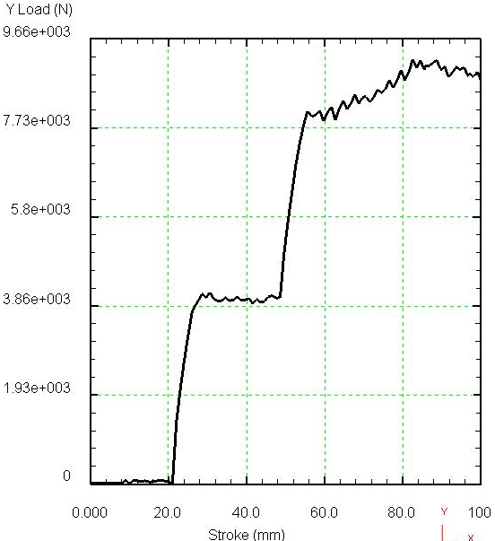 | b)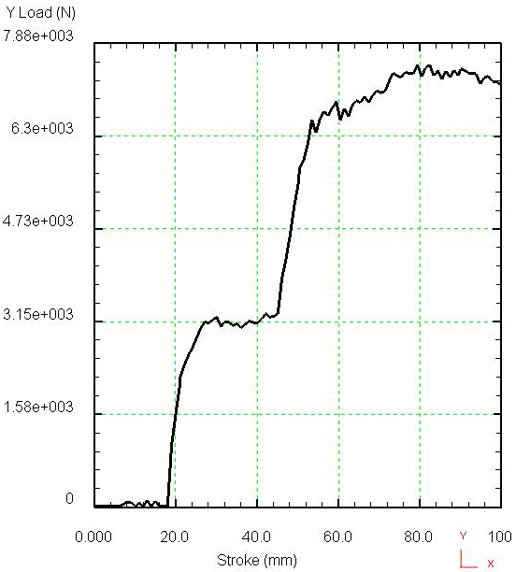
c)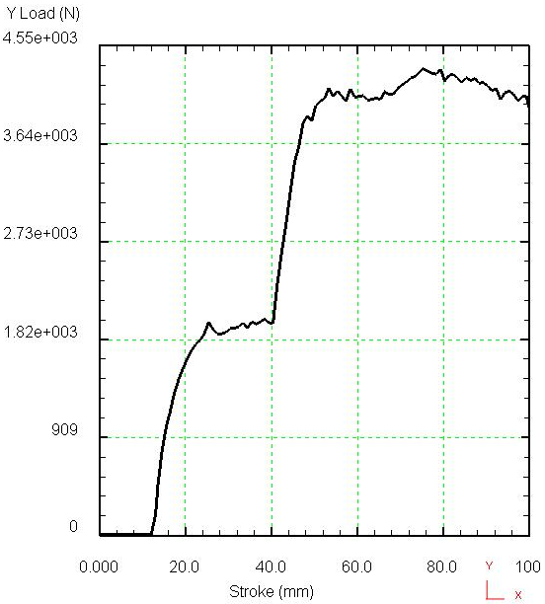 | d)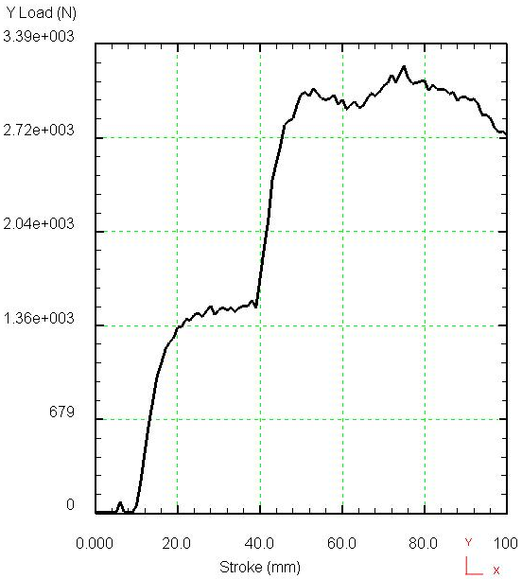

Figure 5 – Graphs of the change in deformation forces depending on the punch stroke at different angles of the channels junction of the step matrix: a – 110°; b – 120°; c - 140°; g - 150°
а)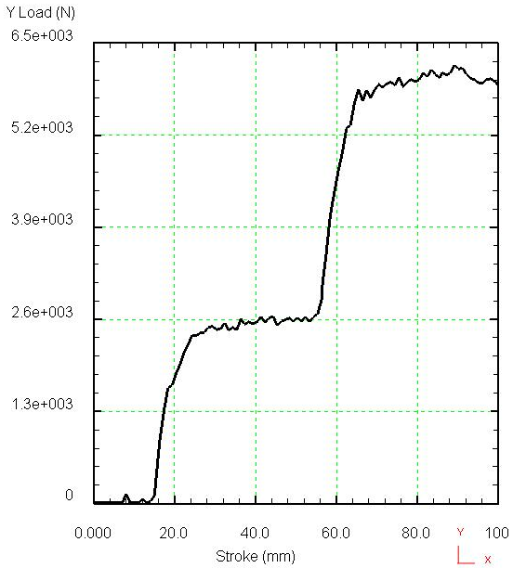 b)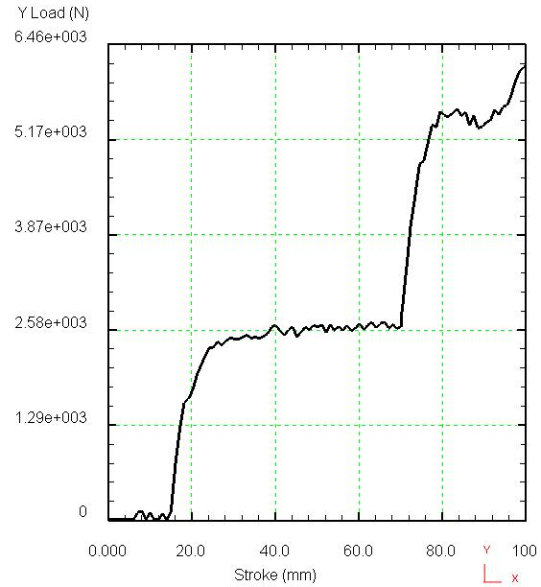

Figure 6 – Graphs of the change in deformation forces depending on the punch stroke at different lengths of the inclined channel of the step matrix: a – 30 mm; b – 45 mm

а)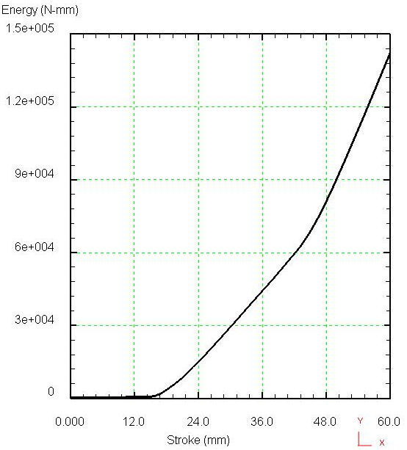 b) 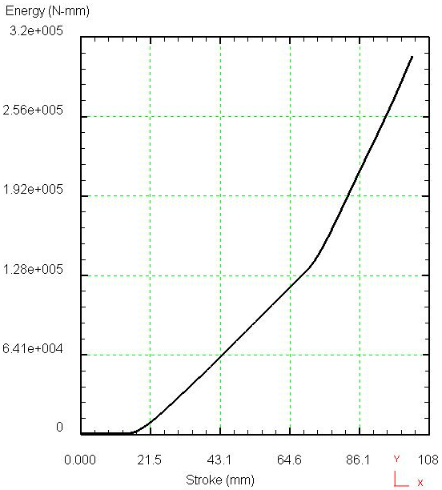

Figure 7 – Graphs of changes in the energy costs of the deformation process depending on the punch stroke at different lengths of the inclined channel of the step matrix: a – 15 mm; b – 45 mm.

Quantitatively, it can be noted that pressing a workpiece in an angular matrix with a channel junction angle of 130° requires 4 times less force (Fig. 4b) than in an angular matrix with a channel junction angle of 90° (Fig. 4a). But at the same time, it is necessary to take into account what level of metal processing occurs at increase in the joint angle, and whether a decrease in effort is comparable to a change in processing. To do this, additional research is needed.
When pressing the workpiece in a stepped matrix with a channel junction angle of 130°, the force decreases only 1.5 times compared to an angular matrix with a channel junction angle of 90° (Fig. 4c). However, the alternating strain of the workpiece in a stepped matrix in one pass, due to the double rotation of the channel, makes it possible to obtain a comparable or even greater processing of the metal than in an angular matrix with a channel junction angle of 90°.
When pressing the workpiece in a stepped matrix with rollers and a joint angle of 130°, replacing sliding friction with rolling friction by installing rotating rollers on the inclined channel of the matrix allows at first to significantly reduce the deformation force (Fig. 4d) compared with other matrices. However, the sharp drag at the second turn of the channel causes the metal to flow in directions of less resistance, i.e. to fill the gaps between the rollers. This leads to jamming of the workpiece and does not allow further continuation of the process. The disadvantages of this matrix can also be attributed to a decrease in reliability due to the complexity of the design.
As a result of the above analysis, it can be concluded that pressing the workpiece in a simple step matrix is rational from the point of view of reducing the deformation force when obtaining the necessary metal processing. Thus, further investigation of the influence of other geometric factors on the energy-force parameters of deformation is advisable for a simple step matrix.
The graphs of changes in deformation forces constructed as a result of modeling (Fig. 4c and Fig. 5a-d) do not differ much from each other in nature. In all graphs, there is a two-stage increase in deformation forces due to alternating strain of the workpiece during double rotation of the workpiece in the matrix.
At the same time, the change in the angle of the junction of the channels affects the magnitude of the deformation forces. For example, an increase in the angle of channel joints from 110° to 150° leads to a 3-times reduction in the deformation force. However, an excessive increase in the angle of the channel joints, i.e. a decrease in steepness, worsens the processing of the workpiece metal. In this regard, it is necessary to choose the optimal value of the channel junction angle both from the point of view of reducing energy consumption and from the point of view of improving metal processing. This requires a generalized analysis of the results of the study of the effect of the angle of channel joints on the deformed state and on the deformation force.
As it was revealed above, the magnitude of the deformation forces in step matrices primarily depends on the angle of the junction of the channels. Therefore, with the same values of the channel joint angle (130°) for different channel lengths, the greatest amount of deformation forces achieved in the second rotation of the matrix channel is almost the same (Fig. 4c, Fig. 6a-b).
At the same time, it should be noted that the advantage of equal-channel pressing in step matrices is the implementation of alternating strain in the second rotation of the matrix channel. With an increase in the length of the inclined channel, more punch stroke is required to carry out alternating strain. For example, if, with a length of an inclined channel of 15 mm, alternating strain begins when the punch is moved by 45 mm (Fig. 4c), then with a length of 45 mm it begins when moving by 70 mm (Fig. 6b).
With the onset of alternating strain, the deformation force increases to a maximum value. As a result, with an increase in length with the same amount of deformation force, more energy costs will be required to carry out alternating strain. For example, with a length of 15 mm, 150 kJ of energy is spent to carry out alternating strain of the front end of the workpiece (Fig. 7a), then with a length of 45 mm, the energy consumption is 350 kJ (Fig. 7b), i.e. the energy consumption increases 2.3 times. As a result of the above analysis, it can be concluded that an excessive increase in the length of the inclined channel of the step matrix is undesirable from the point of view of energy consumption, although the length of the channel does not affect the magnitude of the deformation forces.
Conclusion
The analysis of the influence of various geometric factors on the deformation force during equal-channel pressing, which makes it possible to obtain metal with a sub-ultrafine-grained structure, showed that such geometric factors as the design of matrices for pressing, the length of the matrix channels, the junction angle of matrix channels have a significant effect on the deformation force. And only the choice of rational geometric parameters of the deformation tool will make it possible to obtain a metal with a sub-ultrafine-grained structure with minimal energy consumption.

THE LIST OF SOURCES

1 Estrin, Y., & Vinogradov, A. (2013). Extreme Grain Refinement by Severe Plastic Deformation: A Wealth of Challenging Science, Acta Materialia, 61, 782-817.
2 Valiev, R.Z. (2014). Superior Strength in Ultrafine-Grained Materials Produced by SPD Processing, Materials Transactions, 55, 13-18.
3 Alhamidi, A., & Horita, Z. (2015). Grain Refinement and High Strain Rate Superplasticity in Alumunium 2024 Alloy Processed by High-Pressure Torsion, Materials Science and Engineering A, 622 139-145.
4 Сегал В.М. Способ прессования / В.М. Сегал // Авторское свидетельство СССР № 575892, 1977.
5 Valiev, R.Z., & Langdon, T.G. (2006). Principles of Equal-Channel Angular Pressing as a Processing Tool for Grain Refinement, Progress in Materials Science, 51, 881-981.

REFERENCES

1 Estrin, Y., & Vinogradov, A. (2013). Extreme Grain Refinement by Severe Plastic Deformation: A Wealth of Challenging Science, Acta Materialia, 61, 782-817.
2 Valiev, R.Z. (2014). Superior Strength in Ultrafine-Grained Materials Produced by SPD Processing, Materials Transactions, 55, 13-18.
3 Alhamidi, A., & Horita, Z. (2015). Grain Refinement and High Strain Rate Superplasticity in Alumunium 2024 Alloy Processed by High-Pressure Torsion, Materials Science and Engineering A, 622 139-145.
4 Segal, V.M. (1977). Sposob Pressovanija [Pressing Method], Authors’ Certificate 575892 USSR (in Russian).
5 Valiev, R.Z., & Langdon, T.G. (2006). Principles of Equal-Channel Angular Pressing as a Processing Tool for Grain Refinement, Progress in Materials Science, 51, 881-981.

Е.А. Панин¹, А.Б. Есболат¹
¹Қарағанды индустриялық университеті КЕАҚ, Қазақстан

Тең арналы бұрыштық престеу кезіндегі геометриялық факторлардың деформацияның энергетикалық параметрлеріне әсерін зерттеу
Тең арналы бұрыштық престеу-әртүрлі ультра ұсақ түйіршікті материалдардың қасиеттерін зерттеуге арналған ғылыми мақалаларда жиі айтылатын, Деформацияланатын металл көлемінде қарқынды пластикалық деформацияны жүзеге асыру тәсілі. Сонымен қатар, бұл деформация әдісі техникалық және технологиялық орындаудың көптеген вариацияларына ие, олардың негізінде Деформацияланатын металдың барлық көлеміндевигысу немесе ауыспалы деформацияларды жүзеге асыру принципі жатыр. Геометриялық факторлардың энергия параметрлеріне әсерін анықтау тең арналы престеу процесін зерттеудің маңызды міндеттерінің бірі болып табылады. Сондықтан бұл жұмыс Геометриялық факторлардың әсерін зерттеуге арналған, мысалы, матрицалық дизайн, матрицалық арналардың түйісу бұрышы және матрицалық арналардың престеу ұзындығы дайындамаларды тең арналы престеу кезінде деформация күшіне. Геометриялық факторлардың деформация күшіне әсерін зерттеу DEFORM-2D бағдарламалық кешеніндегі компьютерлік модельдеу арқылы жүргізілді. Әр түрлі геометриялық факторлардың тең арналы престеу кезінде деформация күшіне әсерін талдау олардың көпшілігі деформация күшіне айтарлықтай әсер ететіндігін көрсетті. Сондықтан тең арналы бұрыштық престеуге арналған құралдың ұтымды геометриялық параметрлерін таңдау ғана минималды энергия шығыны бар субультромельді құрылымы бар қара немесе түсті металды алуға мүмкіндік береді.
Кілт сөздер: тең арналы бұрыштық басу, компьютерлік модельдеу, деформация күші, факторлар, матрица.

Е.А. Панин¹, А.Б. Есболат¹
¹Карагандинский индустриальный университет, Казахстан

Исследование влияния геометрических факторов при равноканальном угловом прессовании на энергосиловые параметры деформирования
Равноканальное угловое прессование является одним из самых часто упоминаемых в научных статьях, посвященных исследованиям свойств различных ультрамелкозернистых материалов, способом реализации интенсивной пластической деформации в объеме деформируемого металла. При этом данный способ деформирования имеет множество вариаций технического и технологического исполнения, в основе которых лежит принцип реализации сдвиговых или знакопеременных деформаций во всем объеме деформируемого металла. Выявление влияния геометрических факторов на энергосиловые параметры является одной из важных задач исследования процесса равноканального прессования. Именно поэтому данная работа посвящена исследованию влияния геометрических факторов, таких как конструкция матриц, угол стыка каналов матрицы и длина каналов матрицы для прессования на усилие деформирования при равноканальном прессовании заготовок. Исследованию влияния геометрических факторов на усилие деформирования было проведено с помощью компьютерного моделирования в программном комплексе DEFORM-2D. Проведенный анализ влияния различных геометрических факторов на усилие деформирования при равноканальном прессовании показал, что большинство из них оказывают существенное влияние на усилие деформирования. Поэтому только выбор рациональных геометрических параметров инструмента для равноканального углового прессования позволит получить черный или цветной металл с субультромелкозернистой структурой с минимальными энергозатратами.
Keywords: равноканальное угловое прессование, компьютерное моделирование, усилие деформирования, факторы, матрица.

Сведения об авторах:
Панин Е.А. – PhD, қауымдастырылған профессор, "Қарағанды индустриялық университеті" КЕАҚ профессоры, Теміртау қ., Қазақстан Республикасы. Панин Е.А. – PhD, ассоциированный профессор, профессор НАО «Карагандинский индустриальный университет», г. Темиртау, Республика Казахстан. Panin, E. – PhD, Associate Professor, Professor of NPJSC "Karaganda Industrial University", Temirtau с., Republic of Kazakhstan. E-mail: ye.panin@tttu.edu.kz
Есболат А.Б. – "Қарағанды индустриялық университеті" КЕАҚ оқытушысы, Теміртау қ., Қазақстан Республикасы. Есболат А.Б. – преподаватель НАО «Карагандинский индустриальный университет», г. Темиртау, Республика Казахстан. Esbolat, A. – lecturer of NPJSC "Karaganda Industrial University", Temirtau с., Republic of Kazakhstan. E-mail: esbolat.a@mail.ru

Дата поступления рукописи в редакцию:

