УДК 663.031.1; 666.098.2
МРНТИ 62.13.53

Ye.B. Nikitin¹*, L.I. Proskurina³, B.A. Sharov², O.A. Slatvinskaya²
¹Innovativee University of Eurasia, Kazakhstan
² «BoNa» LLP, Kazakhstan
³ Primorsky State Agricultural Academy, Ussuriysk, Russia
*(e-mail: yegeniynikitin1964@gmail.com)

Results of application of organomineral fertilizer obtained with biocatalytic processes

Annotation
The results of a study on the use of organomineral fertilizers obtained using biocatalytic processes for detoxification of poultry waste and their influence on the growth and development of plants during the growing season are presented. For poultry farms, it is necessary to create and introduce waste-free technologies for the preparation of fertilizers. To increase the efficiency of the fertilizer as a biological catalyst, we used a bacterial growth stimulator sodium humate, obtained by us according to a previously developed technology from brown coal from the Maikubenskoye deposit in the Republic of Kazakhstan (RK) («Method for producing sodium humate» Patent No. 4600 RK), as well as a sorbent based on sodium humate (a by-product of obtaining sodium humate), which was used to detoxify the feedstock and the resulting product from heavy metals and their salts due to its absorption-adsorption and complexing properties. For the developed technology for producing organic fertilizers, an application has been submitted for obtaining a Patent for the invention of the Republic of Kazakhstan «Method for producing organic fertilizers» (priority No. 2021-22818, dated July 13, 2021). Studies to determine the effectiveness of the resulting fertilizer were carried out on the experimental plots of the peasant farm (KH) «Flame», Pavlodar district of Pavlodar region of the Republic of Kazakhstan. In the soil intended for growing seedlings of tomatoes of the «Pepper-shaped Orange» variety and peppers of the «Bogatyr» variety, the resulting fertilizer was applied in an amount of 1 kg per 1 m² of soil, which was dug to a depth of 8-10 cm and used for growing seedlings in greenhouses and in subsequent for planting it in open ground. The soil without fertilization was used as a control. The process of preparing the soil of open ground, intended for planting seedlings, was carried out for an experimental field with application and a control field without fertilization. Experimental and control studies were carried out under equivalent climatic conditions, scheme and technology of watering plants. In total, 100 bushes of each plant species were used in the experiment. The use of the obtained organomineral fertilizer makes it possible to increase the yield of vegetable crops (tomatoes, peppers) by 20-25% in comparison with the control. In addition, in the experimental samples, an increase in the number of fruits on the bush was noted with an increase in their size, a decrease in the growing season and the number of damaged fruits.
Keywords: bird droppings, sodium humate, biocatalysis, detoxification, organic fertilization, field trials, flowering, ovary, vegetation.

Introduction. In agriculture, namely in crop production, one of the most important problems is to increase soil fertility and, consequently, crop yields.
Poultry farm waste is practically not recycled, resulting in pollution of the lands, water bodies and air closest to poultry farms. For poultry farms, it is necessary to create and implement waste-free technologies for the preparation of fertilizers [1, 2, 3, 4].
The goals of improving the ecological state in the area of ​​activity of poultry farms and obtaining highly effective organomineral fertilizers with their subsequent application to the soil are associated with the development and use of organomineral fertilizers obtained using biocatalytic processes that provide for the detoxification of poultry waste, and the effect of such fertilizers on the growth and development of plants [5] .
In this regard, the use of poultry waste disposal products in order to obtain highly effective organomineral fertilizers on their basis and use them to increase the yield of cultivated plants is relevant and has further scientific and practical significance.
The purpose of the research: to study the effectiveness of the use of organomineral fertilizer from poultry waste, obtained using biocatalytic processes on the growth and development of plants.
Materials and methods. In the studies conducted, organomineral fertilizers from poultry manure were used. To increase its effectiveness, sodium humate, a bacterial growth stimulator, obtained by us using a previously developed technology from brown coal of the Maikubenskoye deposit in the Republic of Kazakhstan (RK) (“Method for producing sodium humate” Patent No. 4600 RK) was used as a biological catalyst, as well as a sorbent based on sodium humate (an accompanying product of sodium humate production), which was used to detoxify the feedstock and the resulting product from heavy metals and their salts due to its absorption-adsorption and complexing properties. An application for a Patent for the invention of the Republic of Kazakhstan "Method for obtaining organic fertilizer" (priority No. 2021/0429.1, dated 13.07.2021) has been submitted for the developed technology for obtaining organic-mineral fertilizer.
The study of the composition of organomineral fertilizer obtained from chicken manure showed a high content of the main components: nitrogen, phosphorus, potassium and humic acids and the absence of soluble salts of heavy metals in the product, which implies that the sequence of the proposed technological methods and modes ensure the preservation of organic and mineral substances in the final product and the removal of soluble toxic elements from it, and, therefore, guarantee the production of high-quality complex organo-mineral fertilizer from bird excrement, which is a characteristic sign of good soil digestibility [6].
Tests to determine the effectiveness of the obtained fertilizer were carried out on the experimental plots of the peasant farm (KH) "Flame", Pavlodar district of Pavlodar region of the Republic of Kazakhstan.
During the production field experiment, the resulting fertilizer was applied to the soil intended for growing seedlings of tomatoes of the “Pepper-shaped Orange” variety and peppers of the “Bogatyr” variety in the amount of 1 kg per 1 m2 of soil, which was dug up to a depth of 8-10 cm and used for growing seedlings in closed ground and subsequently for planting it in open ground. Soil without fertilization was used as a control. The process of soil preparation for open ground, intended for planting seedlings, was carried out for the experimental field with the introduction and control without fertilization. Experimental and control studies were carried out under equivalent climatic conditions, the scheme and technology of watering plants.
In total, 100 bushes of each plant species were used in the experiment.
Statistical processing of the analyzed data was performed by the generally recognized method of variation statistics according to Student.
The determination of the economic efficiency of the developed technology when using the obtained organomineral fertilizer in the open ground when growing tomatoes of the “Bogatyr” variety was carried out as follows:
The economic efficiency of the application of the developed technology was characterized by the amount of additional net income per unit weight of fertilizers, per 100 roots of crops and 1000 tenge of costs used for the preparation and application of fertilizers. When calculating the economic efficiency of using the developed technology, the cost of gross output was determined based on the purchase prices for fresh tomatoes and peppers that were in effect in the Pavlodar region as of August 2021.
Results. Table 1 shows that the timing of the beginning of flowering in experimental tomato crops is reduced by 6, and in peppers by 5 days compared with the control group of plants. The timing of the appearance of the first ovary is also accelerated, respectively, by 5 for tomatoes and 8 days for peppers.
The total number of fruits from a bush of tomatoes in the experimental group of plants was significantly higher than in the control group by 44.4%, peppers - by 55.5%.
The yield of a bush of tomatoes after fertilization increases in comparison with the control by 1.4 times (42%), peppers by 1.8 times (44.4%).
The shape of tomato fruits in the experimental group of plants is regular round-oval, in the control group it is oblong-oval and the average size (length/width in the section) is significantly more than 85/40 mm compared to the control samples of plants 72/30 mm.
The shape of pepper fruits of the experimental plants is even, with a pronounced short tail, the control ones are segmented, gradually tapering to the tail and the average size (length/width in the section) in plants grown without fertilization (65/35mm) is somewhat inferior to the experimental samples (70/40mm).

Table 1 - Results of the field experiment to determine the effectiveness of the use of fertilizer obtained using sodium humate (n=200, M ±m)

Indicators | Tomato |  | Pepper
Indicators | experiment (n=50) | control (n=50) | experiment (n=50) | control (n=50)
Flowering start date | 28 May | 3 June | 12 May | 17 May
The date of the appearance of the first ovary | June 1 | June 6 | May 13 | May 21
Average number of fruits per bush | 13±2,1* | 9±1,3 | 9±1,5* | 5±0,9
Bush yield (g) | 1250±91* | 880±34 | 520±71* | 360±22
Shape of ripe fruits, average size (mm) (length/width in section) | regular round-oval,  85/40 | oblong-oval , 72/30 | with a pronounced short tail, 70/40 | segmented, gradually tapering to tail, 65/35
Vegetation period before fruit ripening (days) | 47 | 51 | 44 | 46
% damaged fruits | 3 | 7 | 2 | 5
Note: * - the difference in relation to the control group is significant * - (P<0.05).

The vegetation period before the beginning of fruit ripening in plants of the experimental groups of tomatoes and pepper after fertilization is reduced by 4 and 2 days, respectively. The percentage of damaged fruits of tomatoes and peppers (late blight, sunburn) after the application of organomineral fertilizer is reduced by 2.3 and 2.5 times, respectively. Visually, the results of the field experiment are presented in Figures 1, 2, 3.
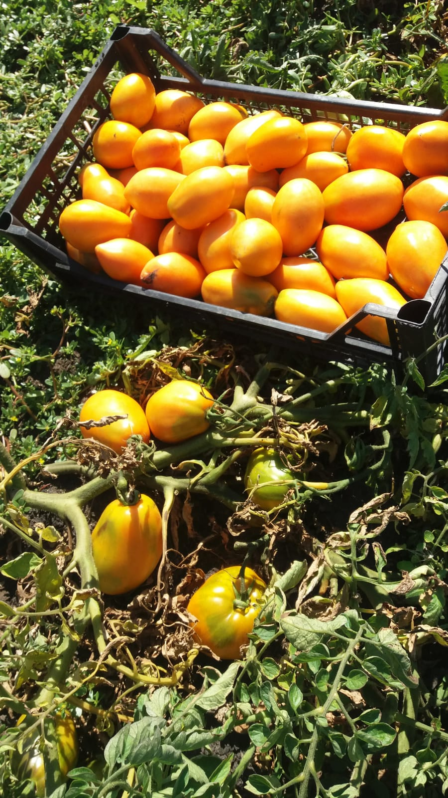
Figure 1 - The results of the field experiment in growing tomatoes with the application of the developed organomineral fertilizer (experiment
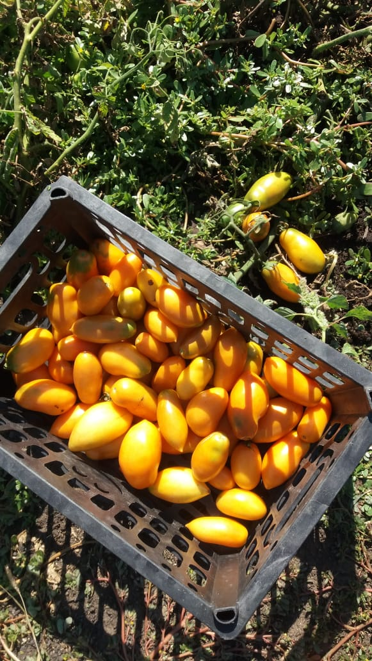
Figure 2 - Results of the field experiment when growing tomatoes without applying the developed organomineral fertilizer (control)
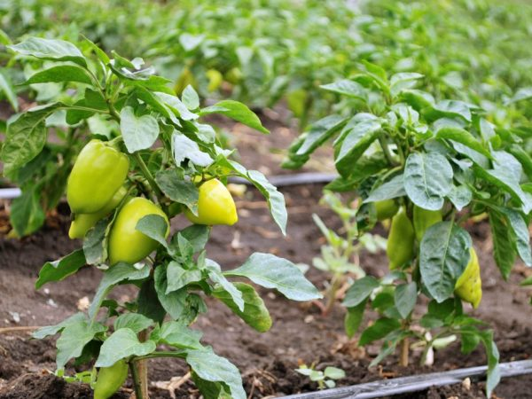
Figure 3 - Results of the field experiment when growing peppers (left - experience, right - control)

Based on the processing of the data presented in the description of the technological process, the market value of vegetable growing products in the Pavlodar region for August-September 2021, it was found that the economic efficiency of the developed technology when using the obtained organomineral fertilizer in the open ground when growing tomatoes of the "Pepper Orange" variety and peppers of the "Bogatyr" variety. It is established that the economic efficiency is at 1000 tenge of fertilizer production costs 3200 tenge for growing peppers and 7400 tenge of tomatoes at average prices for products in the Pavlodar region for the autumn of 2021 at 400 tenge per 1 kg.
Discussion. Based on the conducted research, a technology for obtaining organic fertilizer from poultry waste by anaerobic digestion of chicken manure with humidity as a temperature of 27-50⁰C with the addition of sodium humate has been developed.
The fertilizer is intended for use in agricultural production, horticulture, floriculture, forestry, urban farming, on household plots in order to increase productivity, quality of crop production. It is recommended for planting, fertilizing all types of crops, as well as for resuscitation and recultivation of soils.
As a result of the research, a method for obtaining organic fertilizer has been developed, including fermentation of the initial product, removal of biogas, sedimentation, characterized in that the reaction mixture is pre-fermented with the addition of 200 % water and 1-2 % sodium humate, after the end of fermentation, during which the fermentation mixture is self-heated to a temperature of 37 to 51 degrees Celsius, and removal of biogas from the fermentation product, a humic sorbent is added to the reaction mixture in an amount of 1 to 2% mass fraction, stirred for 12-24 hours, by means of sedimentation, the dense component of the initial product is separated, and the liquid component is defended until the separation level of the solid fraction and the liquid is reached in a ratio from 1 to 5 to 1 to 7, dense fraction is removed, and the superadded fraction is used as a liquid organic fertilizer.
The developed technology has been applied for a Patent for the invention of the Republic of Kazakhstan "Method for obtaining organic fertilizer" (priority No. 2021/0429.1, dated 13.07.2021). The invention makes it possible to significantly reduce the fermentation time, enrich the product with organic and mineral products contained in sodium humate, convert heavy metal salts into an insoluble state, and increase the environmental friendliness of the method.
The implementation of the developed technology ensures the complete and safe disposal of extremely aggressive waste from poultry farms, and therefore provides a significant improvement in the environmental situation, in particular, in the regions where poultry farms are located. The developed method of obtaining organic fertilizer significantly reduces the fermentation time, ensures complete and safe disposal of extremely aggressive waste from poultry farms, and therefore provides a significant improvement in the environmental situation, in particular, in the regions where poultry farms are located.
Conclusion. The use of the obtained fertilizer in the field experiment makes it possible to increase the yield of vegetable crops (tomatoes, peppers) by 20-25% higher compared to the control. In addition, the experimental samples showed an increase in the number of fruits on the bush with an increase in their size, a decrease in the growing season, as well as the number of damaged fruits.
Based on the processing of the data presented in the description of the technological process, the market value of vegetable growing products in the Pavlodar region for August-September 2021, it was found that the economic efficiency of the developed technology when using the obtained organomineral fertilizer in the open ground when growing tomatoes of the "Pepper Orange" variety and peppers of the "Bogatyr" variety. It is established that the economic efficiency is at 1000 tenge of fertilizer production costs 3200 tenge for growing peppers and 7400 tenge of tomatoes at average prices for products in the Pavlodar region for the autumn of 2021 at 400 tenge per 1 kg.
Funding information
The work was carried out as a result of the implementation of the grant funding project of the Ministry of Education and Science of the Republic of Kazakhstan (project “Development of poultry waste detoxification technology using biocatalytic processes”, IRN AP09562121)

REFERENCE

1 Sposob utilizatsii i obezzarazhivaniya kurinogo pometa [Method of disposal and disinfection of chicken manure]. (2018) Russian Federation patent RU2645901C1 [in Russian].
2 Sposob polucheniya organo-mineral'nogo udobreniya [Method of obtaining organo-mineral fertilizers]. (1997) Russian Federation patent RU086 522C1 [in Russian].
3 Sposob prigotovleniya organomineral'nogo udobreniya [Method of preparing organic fertilizer]. (2006) Russian Federation patent RU2270825C2 [in Russian].
4 Sposob utilizatsii i obezzarazhivaniya kurinogo pometa [Method of disposal and disinfection of chicken manure]. (2015) Russian Federation patent RU2541399C1 [in Russian].
5 Organomineral'noye udobreniye i sposob yego izgotovleniya [Organomineral fertilizer and method for its production]. (2002) Russian Federation patent RU2191764С1 [in Russian].
6 Sposob polucheniya organicheskogo udobreniya [Method of obtaining organic fertilizer]. (2015) Russian Federation patent RU2013139068A [in Russian].
7 Sposob polucheniya gumata natriya [Method for producing sodium humate]. (2002) Russian Federation patent RU2191798C1 [in Russian].
8 Guminovyy sorbent, sposob yego polucheniya; sposob detoksikatsii zemel' i rekul'tivatsii pochv sel'skokhozyaystvennogo naznacheniya s ispol'zovaniyem etogo guminovogo sorbenta [Humic sorbent, method for its production; method of land detoxification and soil reclamation for agricultural purposes using this humic sorbent]. (2018) Russian Federation patent RU2205165С2 [in Russian].
9 Lysenko V.P. (2015). Ptichiy pomet-otkhod ili pobochnaya produktsiya [Bird droppings-waste or by-products]. Ptitsevodstvo – Poultry, 6, 55-56 [in Russian].
10 Semenchenko, S.V., Nefedova, V.N., & Savinova, A.A. (2015). Utilizatsiya i pererabotka pometa v usloviyakh ptitsefabriki [Disposal and processing of manure in a poultry farm]. Vestnik Donskogo gosudarstvennogo agrarnogo universiteta – Bulletin of the Don State Agrarian University, 4-1, 28-36 [in Russian].
11 Glavnaya problema ptitseproma. Ekonomicheskiy aspekt [The main problem of the poultry industry. Economic aspect]. (n.d.). webpticeprom.ru Retrieved from http://webpticeprom.ru/ru/articles-processingwaste.html?pageID=1328710142 [in Russian].
12 Antonova, O.I., Chikharin, A.A., & Andreyev M.Ye. (2016). Effektivnost' organo-mineral'nykh udobreniy na osnove pometa pod yarovuyu pshenitsu [The effectiveness of organo-mineral fertilizers based on dung for spring wheat]. Agricultural Science – Agriculture: XI Mezhdunarodnaya nauchno-prakticheskaya konferentsiya (4-5 fevralya 2016 hoda) - 11th International Scientific and Practical Conference. (pp. 3-4). Barnaul: RIO Altayskogo GAU [in Russian].
13 Ernst, L.K., Zlochevskiy, F.I., & Yerastov, G.I. (2004). Pererabotka otkhodov zhivotnovodstva i ptitsevodstva [Processing of animal and poultry waste]. Zhivotnovodstvo Rossii – Livestock in Russia, 9, 23 [in Russian].
14 Neverova, O.P., Zuyeva, G.V., & Sarapulova, T.V. Ekosistemnyy podkhod k utilizatsii pometa [Ecosystem approach to litter disposal]. Agrarnyy vestnik Urala – Agrarian Bulletin of the Urals, 8, 38-41 [in Russian].
15 Zapevalov. M.V., & Zapevalov. S.M. (2011). Tekhnologiya prigotovleniya organomineral'nogo udobreniya na osnove ptich'yego pometa [Technology for the preparation of organomineral fertilizers based on poultry manure]. Vestnik Altayskogo gosudarstvennogo agrarnogo universiteta – Altai State Agrarian University Bulletin, 5, 84-90 [in Russian].
16 Aver'yanov, YU.I., Starunov, A.V., & Zonova, I.A. (2010). Analiz sushchestvuyushchikh sposobov utilizatsii ptich'yego pometa [Analysis of existing methods of disposal of poultry manure]. APK Rossii – Agro-industrial complex of Russia, 56, 11-14 [in Russian].
17 Utilizatsiya podstilki posle soderzhaniya broylerov [Disposal of litter after broiler housing]. (n.d.). webpticeprom.ru Retrieved from http://webpticeprom.ru. [in Russian].
18 Kanadskaya tekhnologiya utilizatsii kurinogo pometa [Canadian technology for the disposal of poultry manure]. (n.d.). webpticeprom.ru Retrieved from http://webpticeprom.ru/ru/articlesprocessing-waste.html?pageID=1298890290 [in Russian].
19 Tekhnologiya uskorennogo kompostirovaniya i utilizatsii vsekh vidov pomota [Technology for accelerated composting and disposal of all types of manure]. (n.d.). www. nngst.ru Retrieved from http://www. nngst.ru/products/1-bioxymin-compost. [in Russian].
20 Utilizatsiya ptich'yego pometa na ptitsefabrikakh [Disposal of poultry manure in poultry farms]. (n.d.). webpticeprom.ru Retrieved from http://www.webpticeprom.ru/ru/articlesprocessing-waste.html?pageID=1228313017. [in Russian].

Е.Б. Никитин¹*, Л.И. Проскурина³, Б.А. Шаров², О.В. Слатвинская²
¹Инновационный Евразийский университет, Казахстан
² ТОО «БоНа», Казахстан
³ Приморская государственная сельскохозяйственная академия,Уссурийск, Россия
*(e-mail: yegeniynikitin1964@gmail.com)

Цель исследования - изучение эффективности применения органоминерального удобрения из отходов птицеводческих производств, полученного с помощью биокаталитических процессов на рост и развитие растений. В удобрении в качестве биологического катализатора применялся стимулятор роста бактерий гумат натрия, полученный нами по ранее разработанной ранее технологии из бурого угля Майкубенского месторождения в Республике Казахстан (РК) («Способ получения гумата натрия» Патент № 4600 РК), а также сорбент на основе гумата натрия (сопутствующий продукт получения гумата натрия), который использовали для детоксикации исходного сырья и получаемого продукта от тяжелых металлов и их солей за счет его абсорбционно-адсорбционных и комплексообразующих свойств. На разработанную технологию получения органоминерального удобрения подана заявка на получение Патента на изобретение РК «Способ получения органического удобрения» (приоритет № 2021/0429.1, от 13.07.2021). Исследования по определению эффективности полученного удобрения проводили на опытных участках крестьянского хозяйства (КХ) «Пламя», Павлодарского района Павлодарской области РК. В почву, предназначенную для выращивания рассады томатов сорта «Перцевидный Оранжевый» и перцев сорта «Богатырь», вносили полученное удобрение в количестве 1 кг на 1 м² почвы, которую перекапывали на глубину 8-10 см и использовали для выращивания рассады в закрытом грунте и в последующем для высадки её в открытый грунт. В качестве контроля использовали почву без внесения удобрения. Процесс подготовки почвы открытого грунта, предназначенного для высадки рассады, осуществляли для опытного поля с внесением и контрольного без внесения удобрения. Опытные и контрольные исследования проводили при равнозначных климатических условиях, схеме и технологии полива растений. Всего в эксперименте было использовано по 100 кустов каждого вида растений. Применение полученного органоминерального удобрения позволяет повысить урожайность овощных культур (томаты, перцы) на 20-25% по сравнению с контролем. Кроме того, в опытных образцах отмечен прирост количества плодов на кусте при увеличении их размеров, снижении срока вегетации и количества повреждённых плодов.
Ключевые слова: птичий помёт, гумат натрия, биокатализ, детоксикация, органическое удобрение, полевые испытания, цветение, завязь, вегетация.

Е.Б. Никитин¹*, Л.И. Проскурина³, Б.А. Шаров², О.В. Слатвинская²
¹Инновациялық Еуразия университеті, Қазақстан
² «БоНа» ЖШС, Қазақстан
³ Приморский мемлекеттік ауылшаруашылық академиясы,Уссурийск қ., Ресей*
(e-mail: yegeniynikitin1964@gmail.com)

Зерттеудің мақсаты өсімдіктердің өсуі мен дамуына биокаталитикалық процестерді қолдану арқылы алынған құс қалдықтарынан минералды органикалық тыңайтқыштарды қолданудың тиімділігін зерттеу. Тыңайтқышта биологиялық катализатор ретінде Қазақстан Республикасындағы (ҚР) Майкөбе кен орнының қоңыр көмірінен бұрын әзірленген технология бойынша біз алған бактериялардың өсу стимуляторы натрий гуматы пайдаланылды («Натрий гуматын өндіру әдісі). ” № 4600 ҚР патенті), сондай-ақ сіңуіне байланысты шикізатты және алынған өнімді ауыр металдар мен олардың тұздарынан детоксикациялау үшін пайдаланылған гуматты натрий негізіндегі сорбент (натрий гуматы өндірісінің ілеспе өнімі) адсорбциялық және комплекс түзу қасиеттері. Органикалық-минералды тыңайтқыштарды алудың әзірленген технологиясына Қазақстан Республикасының «Органикалық тыңайтқыштарды алу әдісі» өнертабысы патентіне өтінім берілді (басымдық № 2021/0429.1, 13.07.2021 ж.). Алынған тыңайтқыштың тиімділігін анықтау бойынша зерттеулер Қазақстан Республикасы Павлодар облысы Павлодар ауданы «Жалын» шаруа қожалығының (ҚҚ) тәжірибелік учаскелерінде жүргізілді. «Бұрыш пішінді апельсин» сортының қызанақ көшеттерін және «Богатырь» сортының бұрышын өсіруге арналған топырақта алынған тыңайтқыш 1 м2 топыраққа 1 кг мөлшерінде енгізілді, ол тереңдікте қазылған. 8-10 см және көшеттерді жабық жерге өсіру үшін, содан кейін оны ашық жерге отырғызу үшін қолданылады. Бақылау ретінде тыңайтқышсыз топырақ пайдаланылды. Тәжірибелік алқапқа көшет отырғызуға арналған ашық жерге топырақты дайындау процесі тыңайтқышсыз интродукциямен және бақылаумен жүргізілді. Эксперименттік және бақылау зерттеулері эквивалентті климаттық жағдайларда, өсімдіктерді суару схемасы мен технологиясы бойынша жүргізілді. Тәжірибеде әр өсімдік түрінен барлығы 100 түп пайдаланылды. Алынған минералды органикалық тыңайтқышты пайдалану көкөніс дақылдарының (қызанақ, бұрыш) өнімділігін бақылаумен салыстырғанда 20-25% арттыруға мүмкіндік береді. Сонымен қатар, тәжірибелік үлгілерде бұтадағы жемістер санының көбеюі олардың мөлшерінің ұлғаюы, вегетациялық кезеңнің азаюы және зақымдалған жемістер санының азаюы байқалды.
Түйін сөздер: құс саңырауқұлағы, натрий гуматы, биокатализ, детоксикация, органикалық тыңайтқыш, далалық сынақтар, гүлдену, аналық без, өсімдік жамылғысы.

Сведения об авторах:
Никитин Е.Б. – ветеринария ғылымдарының докторы, Инновациялық Еуразия университетінің профессоры, Павлодар қ., Қазақстан Республикасы. Никитин Е.Б. – доктор ветеринарных наук, профессор Инновационного Евразийского университета, г. Павлодар, Республика Казахстан. Nikitin, Ye. - doctor of veterinary sciences, Professor of Innovative University of Eurasia, Pavlodar с., the Republic of Kazakhstan. Е–mail: yevgeniynikitin1964@gmail.
Проскурина Л.И. - ветеринария ғылымдарының докторы, профессор Приморский мемлекеттік ауылшаруашылық академиясы,Уссурийск қ., Ресей. Проскурина Л.И. – доктор ветеринарных наук, профессор, Приморская государственная агротехническая академия, г. Уссурийск, Россия. Proskurina L.I. - , Doctor of Veterinary Sciences, Professor, Primorsky State Agrotechnical Academy, Ussuriysk, , Russia. Е–mail: lyudmila_proskur@mail.ru.
Шаров Б.А. - «БоНа» ЖШС, Павлодар қ., Қазақстан Республикасы. Шаров Б.А. - ТОО «БоНа», г. Павлодар, Республика Казахстан. Sharov, B. - «BoNa» LLP, Pavlodar с., the Republic of Kazakhstan. Е-mail: bona-zavod15@mail.ru
Слатвинская О.В. - «БоНа» ЖШС, Павлодар қ., Қазақстан Республикасы. Слатвинская О.В. - ТОО «БоНа», г. Павлодар, Республика Казахстан. Slatvinskaya, О. - «BoNa» LLP, Pavlodar с., the Republic of Kazakhstan. Е-mail: bona-zavod15@mail.ru

