**UDC 372.881.111.1**

**МРНТИ 14.07.09**

**Ramazanova Zh.Zh.1, Niyazova A.E.**1

*1Eurasian National University named after L.N. Gumilyov, Republic of Kazakhstan, Astana*

*(e-mail: [zhannaramazanova00@mail.ru](mailto:zhannaramazanova00@mail.ru))

**Developing cross-cultural competence in the foreign language teaching and learning process**

**Annotation**

In today's globalized world, effective cross-cultural proficiency is integral to the teaching and learning of foreign languages. This article embarks on a journey to uncover the crucial insights derived from a comprehensive research study in this domain.

*Main Problem*: The primary issue at the heart of this research is the challenge of fostering meaningful communication and understanding in cross-cultural interactions within the realm of foreign language education. This problem stems from the recognition that language proficiency alone is insufficient in a multicultural world where nuances of culture heavily influence effective communication.

*Purpose*: The overarching purpose of this study is to illuminate the pivotal role of cross-cultural proficiency within the context of language education. It seeks to identify, articulate, and disseminate innovative strategies that can seamlessly integrate cultural elements into the process of language teaching and learning.

*Methods*: To unravel these insights, this research adopts a constructivist paradigm and employs a qualitative research approach. It heavily relies on the researcher's nuanced interpretations of theoretical foundations, drawing from rich pedagogical experiences and subjecting data to rigorous analysis.

*Results and Their Originality*: The outcomes of this study are twofold in their impact and originality. Firstly, they yield practical strategies that empower educators to incorporate culture into language education effectively. Secondly, this research contributes original insights by emphasizing a student-centered approach that recognizes individual learning differences and styles. By bridging the gap between linguistic proficiency and cultural awareness, this research fosters not just language fluency but also the development of culturally astute global citizens.

In the following sections, we delve deeper into each facet of this research, exploring the main problem, elucidating the purpose, detailing the employed methods, and unveiling the unique results, all of which underscore the critical significance of cross-cultural proficiency in the realm of foreign language education

*Keywords: proficiency, instruction, cultural elements, cross-cultural competence, language acquisition, English*

**Introduction**

From the perspective of teaching and learning English as a foreign language, it should be pointed out that the aspect of cross-cultural competence is often overlooked. This may be due to the fact that teachers usually focus on language skills and grammar, overlooking the importance of cultural context.

This observation indicates that foreign language teaching usually focuses on the development of linguistic skills and knowledge, while often neglecting the aspect of the cultural context surrounding the language being learnt.

With the emergence of new methodologies and research approaches in various fields, as well as the development of theories in sociolinguistics and other areas of linguistics, approaches that take into account the importance of cultural context in foreign language teaching have emerged. These methodologies are in line with the recommendations and norms set by state educational organisations such as the Ministry of Education and Science.

This emphasises the need to use methods that foster a deeper understanding of the culture concerned, especially in the context of foreign language teaching. This factor plays a huge role as languages offer the opportunity to better understand the cultures of their speakers.

This results in a more active approach to teaching and language learning. Teachers and learners are encouraged to incorporate cultural aspects into the learning process in order to establish links and connections between language and culture. This includes matching the cultural elements of the target language with those of the learners' mother tongue to make the comprehension process easier. It is important to note that language teaching inevitably pays attention to the cultural values of language and society, which gives English teachers the opportunity to reinforce the cultural values of their mother tongue.

To achieve this goal, it is important for students to familiarise themselves with the foreign culture, which will enable them to understand the cultural elements that facilitate adequate cross-cultural communication and enhance their knowledge. This, in turn, will help them to appreciate their own identity more. Harris (2011) highlights the close relationship between culture and language and how language methods and models can be applied to understanding cultures.

This demonstrates that the concept of 'cultural' can be applied to different areas of human knowledge, including life and foreign language learning. Foreign language teaching should not be limited to formal aspects, but should be seen as an integral part of effective engagement with culture, which is essential for future professionals.

**Pedagogical aspects related to the incorporation of culture**

Culture, being an integral part of language, becomes not only a means of enriching the student's vocabulary, but also opens a window to the world of collective experience and values. Teaching culture while learning a foreign language promotes a deep understanding of how people of different cultures think, feel and communicate. It helps students develop their empathy and cultural competence, which is especially important in today's multicultural world.

Teaching culture in the context of foreign language learning also emphasises the importance of innovation in the educational process. Effective techniques and tools must be developed so that students can fully perceive and integrate cultural aspects into the curriculum. This includes the use of modern technology, interactive lessons, and multicultural and interdisciplinary approaches.

Pedagogical aspects related to the inclusion of culture in the process of teaching a foreign language play a fundamental role in the formation of quality education. Teaching a foreign language is not limited to the mere transmission of grammatical and lexical elements. It must also take into account the cultural aspects that are inherent in the speakers of the language. In this context, it is the teacher's responsibility to actively implement a variety of methods and activities based on his or her cultural competence in relation to the language being learnt. These activities provide students with a unique opportunity to become deeply acquainted with the cultural elements relevant to the target language in order to achieve more effective, contextualised and natural communication.

Culturally orientated activities not only contribute to language comprehension, but also actively promote the acquisition of the foreign language itself. They play a key role in shaping students' linguistic skills, enabling them to understand the language in the context of its cultural roots. In this context, the responsibility of teachers to bring students closer to the culture appropriate to the language being learnt is emphasised. This involves taking into account traditions, beliefs and customs, which facilitates the comparison and integration of different aspects of culture and thus a fuller understanding of the language being learnt.

The integration of culture and language in the educational process is an important dichotomous relationship that enhances language comprehension and acquisition. This is supported by the fact that language cannot be learnt by separating it from culture, as culture significantly influences its structure and use. This aspect emphasises the inherent link between foreign language learning and culture, which contributes to a deeper understanding of language structures.

With the use of modern technologies in the educational process, cultural aspects can be integrated even more effectively into the curriculum. Technology facilitates access to cultural knowledge related to the language learnt and contributes to the creation of dynamic and interactive lessons. They also allow students to have virtual access to the cultural contexts and experiences of native speakers, which makes the learning process more attractive and realistic.

It is interesting to note how today's society, saturated with mobile cultures and access to information, perceives the learning of foreign languages as a means to redefine worldviews and enrich knowledge. Languages become tools for exploring cultural differences, for learning and for better managing new technologies. In this context, teachers play a key role in facilitating this process by supporting students in their quest for social and cultural integration.

Thus, the pedagogical aspects involved in incorporating culture into foreign language learning enrich education and contribute to deep understanding and language acquisition. The integration of cultural aspects into the educational process opens students to the fascinating world of cultural differences and enriches their social experience, making language learning more immediate and effective.

**Methodology**

Taking into account the main aim of this study, which is to identify the importance of cross-cultural competence in the process of foreign language teaching, various methods and approaches that student teachers develop in the process of language teaching are examined. The main objective is to stimulate a dialogue about cultural aspects related to language learning and to investigate possible alternative methods for their implementation in the educational process.

**Method**

Within the framework of our article, the method used in the study is in line with the constructivist paradigm and is qualitative. This method is based on the analysis of data, which is carried out by the researcher taking into account the theoretical framework to which he/she refers. It also takes into account the pedagogical experience and analyses relevant literature sources.

**Participants**

In this study, 27 students enrolled in a Master's programme in English Language were selected as the research subjects. Among them, there were 20 females and 7 males. It's important to note that all participants willingly volunteered for the study, and their ages spanned from 18 to 39 years old.

Table 1

|  |  |
| --- | --- |
| **Gender** | **Age Range** |
| Male : 7 | 18-23: 11 |
| Female: 20 | 24-28: 4 |
|  | 29-33: 9 |
|  | 34-39: 3 |

**Instruments**

The study was conducted in an online format using the Google Forms tool, which allowed participants to complete the questionnaire at their convenience. The questionnaire included three sections and a total of 17 questions. The first section, designed to explore participants' cultural awareness, contained four questions. The second section, designed to assess participants' interactions with compatriots, consisted of ten items. The third section, designed to assess participants' interactions with people from other countries, consisted of three questions. In addition to the questionnaire itself, participants were provided with information about the study and were asked to consent to participate in the study by signing a consent form. This was to ensure that participants were fully informed and voluntarily agreed to participate in this study. A comprehensive list of these questions can be found in the Appendix.

**Results and Discussion**

The results of this study emphasise the importance of developing cross-cultural communicative competence in the context of foreign language teaching and can serve as a starting point for future research in this area.

It turned out that the majority of the survey participants belong to families where a common cultural environment prevails. At the same time, only a small proportion of respondents have experience of travelling abroad. Some participants have visited only one country, while others preferred not to answer this question. The results suggest that the level of cultural interaction and cross-cultural awareness varies among the participants(Figure 1).

This can be observed, for example, in the participants' varying activity in making contact with people from other cultures, in their desire to learn more about different cultures, and in their experiences of travelling abroad. For students who have never had the opportunity to travel abroad, stimulating cultural interactions can be beneficial as travelling helps to broaden cultural horizons and provides an opportunity to immerse oneself in different aspects of other national communities.

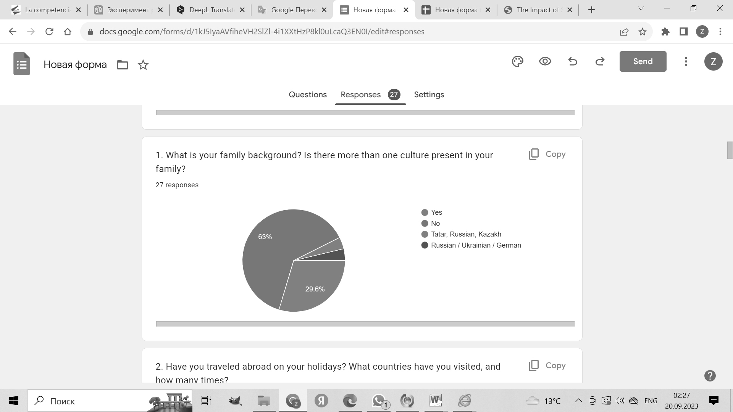

Figure 1

The data from the second section, which analyses the level of cultural awareness and empathy ability of the participants, highlights that not all participants are aware of the importance of and sensitive to the comfort of others in the moments of their presence, and not all easily adapt to people from different backgrounds. It should be noted that effective cross-cultural communication represents an integral part of the foreign language learning process and enhances cultural diversity in personal social networks.

The analysis of the results indicates that all the participants of the survey show an active approach to understanding and adapting to the customs and norms of behaviour of people from different countries while in their company. This is achieved by carefully observing the behaviour and reactions of the group and, in the case of unsuccessful communication, analysing the reasons that may have led to such a situation. These results emphasise students' readiness to learn and cooperate with people from different cultures, their willingness to understand and respect the differences between cultures, and their readiness to make efforts to achieve effective cross-cultural communication(Figure 2).

To successfully develop cross-cultural communicative competence, it is also important to pay attention to the non-verbal aspects of communication. The survey participants admitted that they occasionally ignore non-verbal cues such as facial gestures and facial expressions if they are not familiar with them. To improve students' non-verbal communication skills, resources that focus on non-verbal means of communication, such as body language and gestures, in different cultural contexts could be helpful.

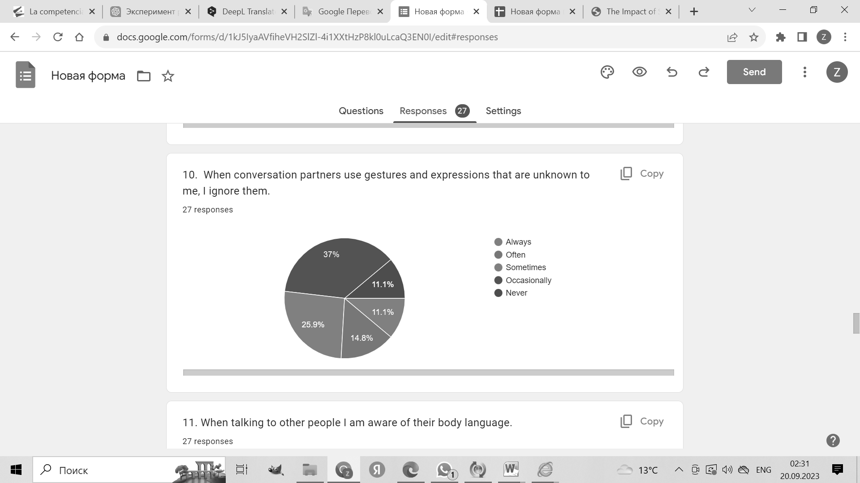

Figure 2

The responses received from participants who indicated their frequent or persistent avoidance of contact with people from other cultures due to rejection raises an important question about what factors may influence the formation of cross-cultural competence in the process of teaching and learning a foreign language. These responses caution us against underestimating the importance of cross-cultural competence and call for a closer look at the mechanisms that contribute to its development(Figure 3).

Avoiding contact with people from other cultures can be the result not only of individual biases, but also of insufficient training and support within educational programmes. It may also be due to a lack of understanding of the importance of cultural competence in foreign language learning. In this context, educational institutions and educators play a crucial role in developing cross-cultural awareness and openness in their students.

More research is needed to identify the factors that contribute to the formation of bias and rejection and to develop effective strategies to overcome these barriers. Educational programmes should actively incorporate cultural aspects and ways of developing cross-cultural competence as part of the learning process. In addition, educators should have the appropriate training and competences to teach students not only language but also cultural interaction.

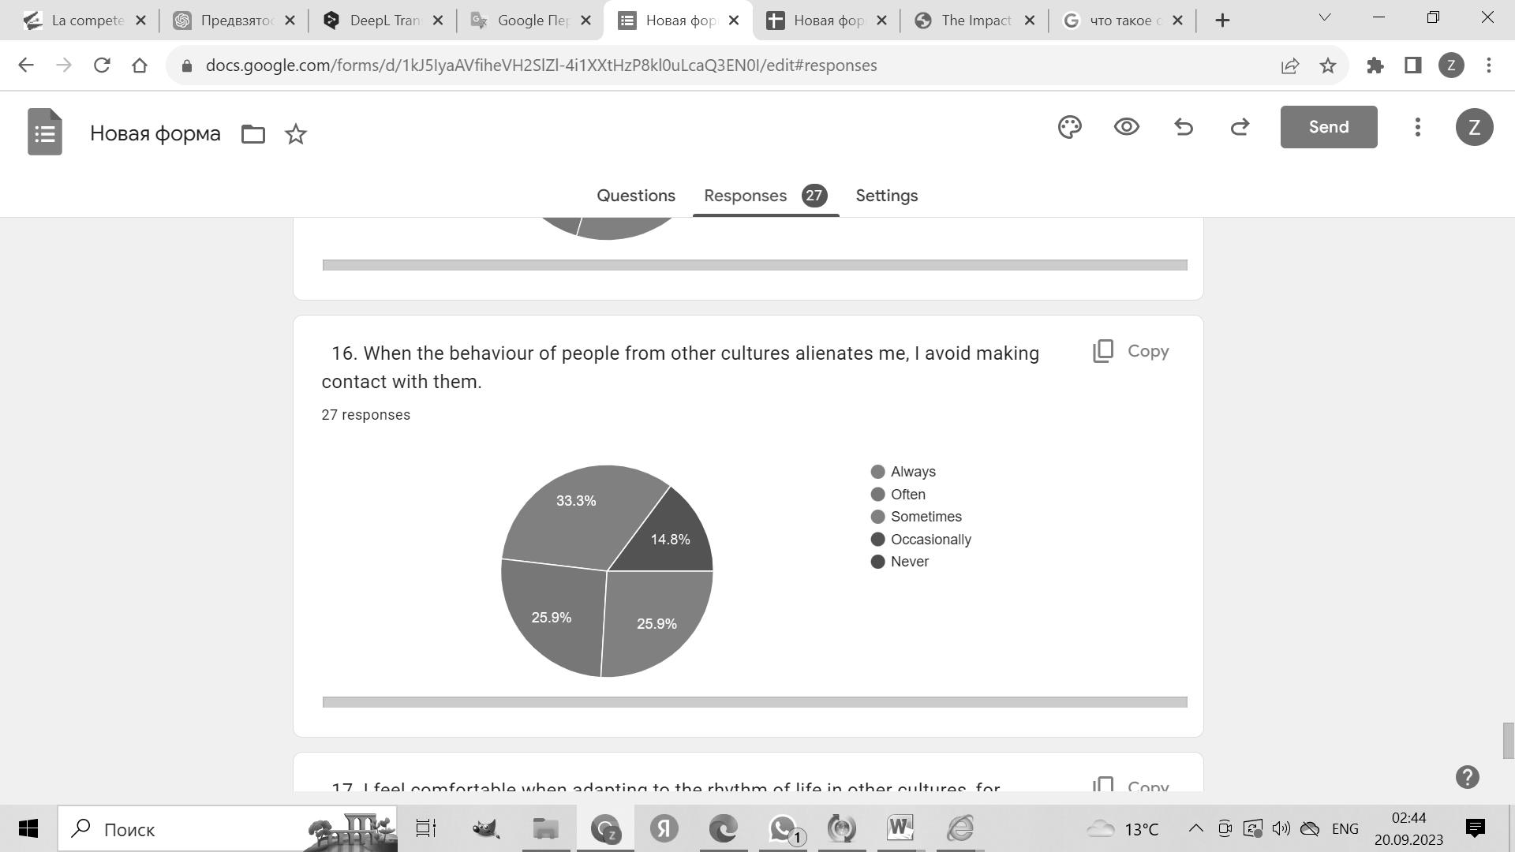

Figure 3

**Conclusion**

In conclusion, this study emphasises the need to pay attention to the development of intercultural communicative competence in foreign language teaching and learning. The analyses demonstrate that our ability to interact effectively with people from different cultures is of great importance in today's global world.

The results of the study highlight the importance of introducing activities aimed at developing intercultural awareness and respect for differences between cultures into the curriculum. Educational institutions should actively incorporate intercultural skills training as an important part of foreign language learning. In addition, teachers should be equipped with the appropriate knowledge and competences to teach students not only language but also cultural adaptation.

The challenge for further research is to identify the factors that influence the formation of bias and rejection in the context of foreign language learning and to develop effective strategies to overcome these barriers. We encourage educational institutions and educators to not only teach language, but to prepare students to successfully interact in a diverse and multicultural environment.

Our world is becoming increasingly connected and diverse, and the ability to communicate and collaborate effectively with people from other cultures is becoming a key skill. By integrating intercultural competence into the foreign language teaching process, we prepare the new generation to enrich their own knowledge and experience through encountering the diversity of world cultures and create the basis for harmonious international relations.

**References**

1. *Yakovleva L.N*. Mezhkul`turnaya kommunikacziya kak osnova obucheniyu vtoromu inostrannomu yazy`ku / L. N. Yakovleva // Inostr. yazy`ki v shkole. -2001.

2*. Solovova, E. N.* Metodika obucheniya inostranny`m yazy`kam / E. N. Solovova / M.: Prosveshhenie, 2002. 239 с.

3. *Apal`kov V. G.,* Sy`soev P. V. Metodicheskie princzipy` obucheniya

inostrannomu yazy`ku s czel`yu formirovaniya mezhkul`turnoj kompetenczii // Vestnik TGU. 2008. Vy`pusk 7 (63).

4. *Gerasimova I.G*. Struktura mezhkul`turnoj kompetenczii // Izvestiya

Rossijskogo gosudarstvennogo pedagogicheskogo universiteta im. A.I.

Gerczena. 2008.

5. *F.Brotto, J.Huber, K.Karwacka-Vögele, G.Neuner, R.Ruffino, R.Teutsch.* Intercultural Competence for All: Preparation for Living in a Heterogeneou World, // Council of Europe, June 2012

6. *Byram, M., Gribkova, B., & Starkey, H.* Developing the intercultural dimension in language teaching: A practical introduction for teachers. Strasbourg // Council of Europe., 2002.

7. *Hismanoglu, M.* An investigation of ELT students’ intercultural communicative competence in relation to linguistic proficiency, overseas experiences and formal instruction // International Journal of Intercultural Relations, 2011.

8. *Kunanbaeva S.* The Modernization of Foreign Language Education: The Linguocultural-Communicative Approach. // Hertfordshire Press Ltd, UK, 2013.

9. *Ming-Mu Kuo, Cheng-Chieh Lai.* Linguistics across Cultures: The Impact of Culture on Second Language Learning // Journal of Foreign Language Instruction, 2006.

**Appendix**

Assessment of Competency in Cross-Cultural Communication Questionnaire

Section A

1. What is your family background? Is there more than one culture present in your family?
2. Have you traveled abroad on your holidays? What countries have you visited, and how many times?
3. Do you have friends or contacts abroad?
4. Do you have friends, family or contacts in your home country that you think would qualify as 'belonging to another culture'? If so, how would you describe that culture?

Section B

1. I seek contact with other people in order to learn as much as possible about their culture.
2. When other people don’t feel comfortable in my presence, I notice it.
3. I find it difficult to adapt to people from diverse origins.
4. When I am a newcomer in a group with people from a different country, I try to find out the customs in this group by observing their behaviour.
5. When a conversation with people from different countries fails, I reflect on why this may have happened.
6. When conversation partners use gestures and expressions that are unknown to me, I ignore them.
7. When talking to other people I am aware of their body language.
8. In conversations with speakers of other languages I avoid unclear or ambiguous words
9. I feel comfortable when encountering the different customs of people from other cultures.
10. It feels fairly normal to me to communicate with people of different cultures, for example, coping with misunderstandings, a different sense of humour, etc.

Section C

1. When I observe people in other countries, I guess how they are feeling.
2. When the behaviour of people from other cultures alienates me, I avoid making contact with them.
3. I feel comfortable when adapting to the rhythm of life in other cultures, for example, getting used to different mealtimes, etc.

**Рамазанова Ж.Ж.1, Ниязова А.Е.1**

1Евразийский национальный университет имени Л.Н. Гумилева, Республика Казахстан, Астана

**Разивитие кросс-культурной компетенции в процессе преподавания и изучения иностранного языка**

В современном глобализированном мире эффективная межкультурная компетенция является неотъемлемой частью преподавания и изучения иностранных языков. Данная статья посвящена раскрытию важнейших идей, полученных в результате комплексного исследования в этой области.

*Основная проблема*: В основе данного исследования лежит проблема развития полноценного общения и понимания в межкультурном взаимодействии в рамках обучения иностранным языкам. Эта проблема обусловлена тем, что в поликультурном мире, где культурные нюансы в значительной степени влияют на эффективность коммуникации, одного знания языка недостаточно.

*Цель*: Основной целью данного исследования является выявление ключевой роли межкультурной компетенции в контексте языкового образования. Задача состоит в том, чтобы определить, сформулировать и распространить инновационные стратегии, позволяющие органично интегрировать культурные элементы в процесс преподавания и изучения языка.

*Методы:* Для раскрытия этих вопросов в данном исследовании используется конструктивистская парадигма и качественный исследовательский подход. Исследование в значительной степени опирается на тонкую интерпретацию теоретических основ исследователем, опирается на богатый педагогический опыт и подвергает данные тщательному анализу.

*Результаты и их оригинальность*: Результаты данного исследования двояки по своему воздействию и оригинальности. Во-первых, это практические стратегии, позволяющие педагогам эффективно включать культуру в языковое образование. Во-вторых, данное исследование вносит оригинальный вклад, поскольку в нем особое внимание уделяется подходу, ориентированному на студента и учитывающему индивидуальные различия и стили обучения. Преодолевая разрыв между языковым и культурным знанием, данное исследование способствует не только свободному владению языком, но и формированию культурно развитых граждан мира.

В следующих разделах мы углубляемся в каждый аспект данного исследования, изучаем основную проблему, уточняем цель, подробно описываем использованные методы и раскрываем уникальные результаты, которые подчеркивают критическое значение кросс-культурного владения в сфере обучения иностранным языкам.

*Ключевые слова: владение, обучение, культурные элементы, кросс-культурная компетенция, овладение языком, английский язык*

Рама**занова Ж. Ж. 1, Ниязова А. Е. 1**

1Л. Н. Гумилев атындағы Еуразия ұлттық университеті, Қазақстан Республикасы, Астана

**Шет тілін оқыту және үйрену процесінде мәдениетаралық құзыреттілікті дамыту**

Қазіргі жаһанданған әлемде тиімді мәдениетаралық құзыреттілік шет тілдерін оқыту мен үйренудің ажырамас бөлігі болып табылады. Бұл мақала осы саладағы жан-жақты зерттеу нәтижесінде алынған маңызды идеяларды ашуға арналған.

*Негізгі проблема:* бұл зерттеу шет тілдерін оқыту шеңберінде мәдениетаралық өзара әрекеттестікте толыққанды қарым-қатынас пен түсінуді дамыту проблемасына негізделген. Бұл мәселе мәдени нюанстар коммуникацияның тиімділігіне айтарлықтай әсер ететін көпмәдениетті әлемде тілді білудің өзі жеткіліксіз екендігіне байланысты.

*Мақсаты:* осы зерттеудің негізгі мақсаты тілдік білім беру контекстіндегі мәдениетаралық құзыреттіліктің негізгі рөлін анықтау болып табылады. Міндет-мәдени элементтерді тілді оқыту мен үйрену процесіне органикалық түрде біріктіруге мүмкіндік беретін инновациялық стратегияларды анықтау, тұжырымдау және тарату.

*Әдістері*: осы сұрақтарды ашу үшін бұл зерттеу конструктивистік парадигма мен сапалы зерттеу тәсілін қолданады. Зерттеу негізінен зерттеушінің теориялық негіздерін нәзік түсіндіруге сүйенеді, бай педагогикалық тәжірибеге сүйенеді және деректерді мұқият талдауға ұшыратады.

*Нәтижелер және олардың өзіндік ерекшелігі*: бұл зерттеудің нәтижелері оның әсері мен өзіндік ерекшелігі бойынша екі жақты. Біріншіден, бұл мұғалімдерге мәдениетті тілдік білімге тиімді енгізуге мүмкіндік беретін практикалық стратегиялар. Екіншіден, бұл зерттеу ерекше үлес қосады, өйткені ол студентке бағытталған және жеке айырмашылықтар мен оқу стильдерін ескеретін тәсілге ерекше назар аударады. Тілдік және мәдени білім арасындағы алшақтықты еңсере отырып, бұл зерттеу тілді еркін меңгеруге ғана емес, сонымен қатар әлемнің мәдени дамыған азаматтарының қалыптасуына да ықпал етеді.

Келесі бөлімдерде біз осы зерттеудің барлық аспектілерін қарастырамыз, негізгі мәселені зерттейміз, мақсатын нақтылаймыз, қолданылған әдістерді егжей-тегжейлі сипаттаймыз және шет тілдерін оқыту саласындағы мәдениетаралық білімнің маңызды маңыздылығын көрсететін бірегей нәтижелерді ашамыз.

*Түйінді сөздер: меңгеру, оқыту, мәдени элементтер, мәдениетаралық құзыреттілік, тілді меңгеру, ағылшын тілі*

**Сведения об авторах:**

**Рамазанова Ж.Ж** – 2-ші оқу жылының магистранты, 7м01719 Шет тілі: екі шет тілі (базалық ағылшын тілі) (шет тілдерінің теориясы мен практикасы); Л. Н.Гумилев атындағы Еуразия ұлттық университеті, Қазақстан Республикасы, Астана қаласы. E-mail: [zhannaramazanova00@mail.ru](mailto:zhannaramazanova00@mail.ru)  **Рамазанова Ж.Ж** – Магистрант 2-го года обучения, 7М01719 Иностранный язык: Два иностранных языка (базовый английский) (Теория и практика иностранных языков); Евразийский Национальный Университет имени Л.Н. Гумилева, Республика Казахстан, г. Астана. E-mail: zhannaramazanova00@mail.ru. **Ramazanova Zh.Zh** – 2nd year master-student, 7M01719 Foreign Language: Two Foreign Languages (Basic English) (Theories and Practice of Foreign Languages); Eurasian National University named after L.N. Gumilyov, Republic of Kazakhstan, Astana,. E-mail: [zhannaramazanova00@mail.ru](mailto:zhannaramazanova00@mail.ru)

**Ниязова А.Е** - к.п.н., и.о.доцента, Евразийский Национальный Университет имени Л.Н. Гумилева, Республика Казахстан, г. Астана.**Ниязова А.Е** - к.п.н., и.о.доцента, Евразийский Национальный Университет имени Л.Н. Гумилева, Республика Казахстан, г. Астана**. Niyazova A.E.** - Candidate of Pedagogical Sciences, Acting Associate Professor, L.N. Gumilev Eurasian National University, Republic of Kazakhstan, Astana.