**UDC 620.9, 577.23**

**V.Ya. Fedyanin,** doctor of technical sciences, professor

Polzunov Altai State Тechnical University (AltSTU) (Barnaul, Russian Federation)

Е-mail: [fedyanin054@mail.ru](mailto:fedyanin054@mail.ru)

**A. D. Umurzakova,** candidate of technical sciences, associate professor

Pavlodar State University named after S. Toraigyrova (Pavlodar, the Republic of Kazakhstan)

E-mail: [granat_72@mail.ru](mailto:granat_72@mail.ru)

**А.T. Zhumagazhinov**, master of engineering

Innovative University of Eurasia (Pavlodar, the Republic of Kazakhstan)

Е-mail: [zhumagazhinov1970@mail.ru](mailto:zhumagazhinov1970@mail.ru)

**Т. А.** **Smaylov*,*** *магистрант*

Innovative University of Eurasia (Pavlodar, the Republic of Kazakhstan)

*Е-mail:* [smaylovtlek_98@mail.ru](mailto:smaylovtlek_98@mail.ru)

**Influence of ultrasonic treatment on the efficiency of biogas production**

***Abstract.*** *This paper presents the results of the influence of ultrasonic treatment in the co-fermentation of the cattle manure mixture (cattle) with the leaven from the rumen of ruminants on the process of biogas production.*

*Anaerobic digestion was carried out in matinence periodic operation at the mesophilic temperature of 38 C ̊. As a substrate, a mixture with a content of 70% cattle manure and 10 % leaven from rumen of ruminants was used. Treatment with ultrasound of the mixture was carried out at an intensity of 10 W/cm2 and an amount of input energy of 9350 kJ/kg of dry matter (DM), which completely eliminated the processes of stratification and sedimentation.*

*Decomposition of organic matter (OM) in the periodic regime with the enzyme and ultrasound treatment occurred within 8 days, the usual substrate during this time OM decomposed 3.0 times less (only 14%).*

*The process of fermentation of methane in continuous and periodic modes treated with ultrasound, as at other temperatures, was stable, as can be judged by the values of volatile fatty acids (VFA) Volatile fatty acids (VFAs), alkalinity, pH, and biogas.*

*The energetical efficiency of methane fermentation is estimated by comparing the volume of fuel (biogas) and heat consumption for technological needs.*

*As shown by the comparison of efficiency of different regimes , the largest amount of commercial energy in the form of biogas was obtained in the mode of joint fermentation of a mixture of cattle manure (cattle) with a ferment from the rumen of ruminants treated with ultrasound — 3 times more than without treatment.*

*(space)*

***Keywords:*** *ultrasound, fermentation, organic waste, mode of operation, biogas.*

**Introduction.** The use of agricultural and processing waste such as manure and organic waste for biogas production has significant environmental benefits in terms of heat and electricity generation and its use as biofuels. Biogas plants can make a significant contribution to sustainable development in rural areas, as well as providing farmers and processors with new income opportunities.

The most promising in this regard are technologies based on microbiological processing of manure in anaerobic conditions. These include methane fermentation of manure, which uses biological processes under oxygen-free conditions to stabilize organic substances by converting into methane and inorganic end products, including carbon dioxide and ammonia [1].

The process of methane formation is influenced by the temperature, the composition of organic waste, the time of the methanogenesis process, as well as the pre-treatment of organic waste.

The methane fermentation is characterized by 3 temperature regimes: psychrophilic — <+30°C, mesophilic — +30 °C ÷ +40 °C and thermophilic — +40°C ÷ +55°C. [1].

For a psychrophilic temperature range the technological equipment for biogas production is not normally used, since the fermentation period is long, heating of the material is not required, and a large volume of fermentation chambers is required.

The metabolic activity and reproductive capacity of microorganisms vary depending on the processing methods. To increase the yield of biogas, various methods (chemical, thermal, mechanical, ultrasound, enzyme) can be applied, and manure can be fermented with other waste to achieve a synergistic effect that make the anaerobic digestion process profitable.

Using pretreatment, it is possible to accelerate the hydrolysis of organic matter, thereby increasing the solubility of oxygen (ChOC) oxygen solubility (COD) , which in many cases leads to an increase in the yield of methane. Alkaline or acid hydrolysis, enzymatic hydrolysis, mixing, heat treatment or ultrasound can be applied for pre-treatment, the latter method is considered one of the most multipurpose. [2].

So far, ultrasonic pretreatment studies found in the literature have mainly focused on sewage sludge [3, 4].

Various researchers have studied the interaction of manure fermentation with a wide range of fermentation stimulants such as fruit, vegetable and food waste [5, 6, 7]

Ultrasound has mechanical, physical and chemical effects on biological systems [8, 9].

Ultrasound pretreatment of organic waste accelerates speed-limiting stages of enzymatic hydrolysis of solids [10, 11, 12].

The choice of process should be made on the basis of technical and economic calculations, taking into account the methods of subsequent processing and disposal of waste, as well as sanitary requirements.

It is known that the rumen of ruminants can be considered as a kind of live fermentation chamber created by nature itself. Rumen microorganisms, including methane-forming bacteria, have high enzymatic activity, the maximum conditions for their life are observed at a temperature of 37°C [13]. During the day in the rumen, the volume of which is 100-300 liters, can be formed up to 1000 liters of gas, and mostly carbon dioxide (50-60%) and methane (30-50 %), with a pH content of 6.5—7.4 [14].

When digesting fiber in the rumen gases, the amount of methane increases, while when digesting sugars, carbon dioxide dominates. Methane is formed mainly during the reduction of carbon dioxide by hydrogen, donors of which can serve as sugar, pyruvic, fumaric acid and other substances.

In papers, [15] the efficiency of ultrasonic pretreatment for the kinetics of biogas production is also demonstrated. Biodegradability of soluble organic matter has increased significantly after pretreatment.

The aim of this work is to conduct experimental studies to identify optimal, economically feasible modes and to assess the effect of ultrasound in the joint fermentation of manure with the ferment of scar microorganisms. A series of experiments were carried out under mesophilic conditions with periodic mixing in a bioreactor.

**Materials and methods.** Cattle manure (C) and ruminant rumen (M) were used as the substrate. Ruminant tripe was taken from the slaughterhouse and collected in a plastic bag, then frozen at -20 °C in plastic containers for storage in the laboratory.

Manure was crushed using a knife shredder KR-01. The experiment was performed in periodic and continuous modes in a laboratory bioreactor with a working volume of 10 liters.

An HL-900A generator was used for ultrasonic treatment of the substrate. The frequency of ultrasonic vibrations generated by the generator was 22÷28 kHz, power: 600 W. Ultrasonic transducers are installed in the bioreactor.

The volume of released biogas was measured in dome-type gas tanks with a hydraulic seal.

The efficiency of the fermentation process was evaluated by total gas release and changes in the content of organic matter (OM).

A GC-1690 gas chromatograph was used to analyze the gas composition.

The process of methane fermentation of manure was carried out in mesophilic mode at a temperature of 38°C. The degree of decomposition of organic substances of manure is assumed to be 30 %.

The equipment was equipped in accordance with the research conditions. Repeatability of experiments is 3-fold. Starting loading was carried out with prepared crushed manure with a humidity of 91 %.

**Results** The amount of chemical oxygen consumption, as well as the amount of CB, can be used to quantify the biodegradable fraction of the substrate mixture. Studies have shown that ultrasonic treatment leads to an increase in chemical consumption Colorada (Fig. 1). The greatest change in the index of chemical oxygen consumption is observed with an increase in the amount of input energy to 10 000 kJ/kg DM, in the future, the change in the value of chemical oxygen consumption slows down.

The periodic fermentation process of the ground manure with the leaven is faster than the one without the leaven. For 8 days 30 % of OM decomposed. For the substrate with the leaven treated by the ultrasound in comparison with the substrate without the leaven the decomposition of OM was a little slower at the beginning, but on the 8th and 9th days the same amount of 30% of OM decomposed and then, this process was faster. (Fig.2).

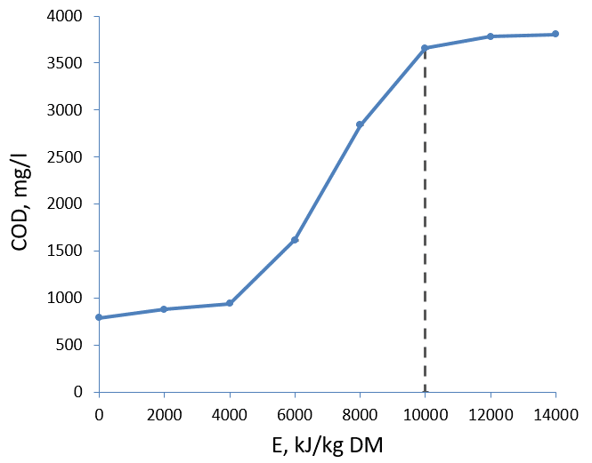

Fig. 1. Variations in the chemical oxygen consumption of the substrate (70% of cattle manure and 10 % of leaven from rumen of ruminants) as a result of ultrasonic treatment.

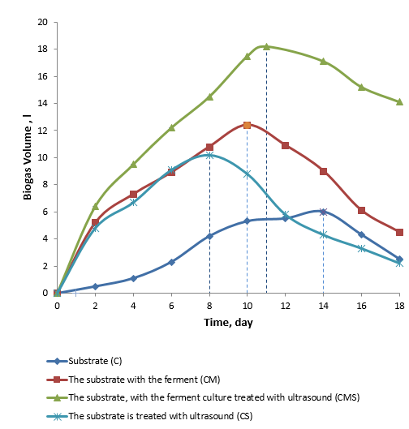

Fig. 2. The dynamics of the dissolution of OM (by the amount of released gas)

The substrate without ferment decomposed to 30 % OM on the 17th day. The maximum generation of biogas with ferment was observed on the 10th day, the substrate with the processing of ultrasound – on the 11th, and the quantity of generated gas was increased more smoothly. Then the generation of biogas from the substrate with the ferment decreased dramatically, and the generation of biogas from the substrate treated with ultrasound continued (Fig. 3).

Observations of the continuous process of methane fermentation showed that the substrate with a ferment treated with ultrasound microorganisms were characterized by high enzymatic activity, the decay of OM was 23.3 g/l of manure loading per day, the specific gas yield was 1.82 l/l per day at pH 7.5—7.80. The conventional substrate, the substrate is treated with ultrasound and the substrate with the leaven of the collapse of the OM was 18.6%, 18.9% and 19.1 g/l loading of manure per day, the specific yield of gas—0.6, of 1.02 and 1.24 g/l per day, respectively, at a pH of 7.62—8.14, of 7.48—to 7.68, of 7.36—of 7.78.

The economic efficiency of methane fermentation of manure can be calculated from the comparative heat consumption for the technological needs of a conventional substrate, with ferment and treated with ultrasound for a cattle farm.

Table 1 – The main technological indicators of the manure fermentation process in various modes

|  |  |  |  |  |  |
| --- | --- | --- | --- | --- | --- |
| Indicator | Before fermentation | After fermentation in different modes | | | |
| C | CS | CM | CMS |
| Dry matter, % | 7,7 | 5,1 | 4,5 | 4,9 | 4,3 |
| Organic matter, % | 5,8 | 4,1 | 4,05 | 4 | 4 |
| рН | 7,6 | 7,65 | 7,75 | 7,7 | 7,8 |
| COD, mg/l | 6212 | 2374 | 912 | 2537 | 842 |
| VFA, mg/l | 345 | 210 | 235 | 240 | 232 |
| Alkalinity, mg/l | 454 | 538 | 560 | 557 | 562 |

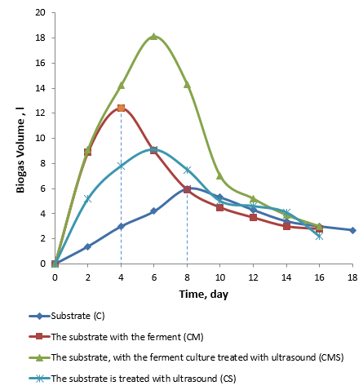

Fig. 3. Emergence of gas

**Discussion.** The use of fermentation stimulants increases the energy yield per unit volume of bioreactor, with a corresponding increase in the capacity of farms by 30%.

The results of the considered modes of operation, shown in Fig. 4, suggest that the best option is methane fermentation of manure treated with ultrasound with ferment

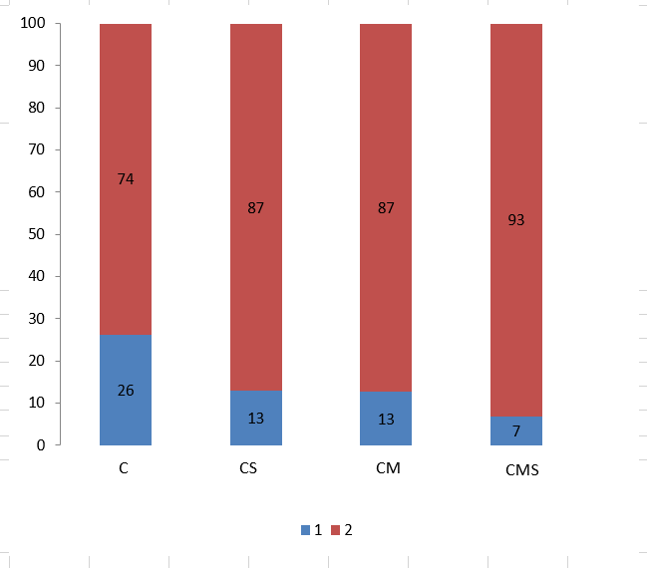

Fig.4. Thermal balance of biogas installation as a percentage

1 — heat consumption for own needs of the installation; 2 — excess heat (commercial energy).

**Conclusion.**

Decomposition of OM in the periodic regime with ferment and treated with ultrasound occurred for 8 days, conventional substrate during this time OM decomposed 3.0 times less (only 14 %).

The process of methane fermentation of the substrate treated by ultrasound in continuous and periodic modes as well as in other modes was stable, as it can be judged by the values of VFA (volatile fatty acids), alkalinity, pH, and biogas generation.

As a comparison of the efficiency of different modes of operation of methane fermentation of manure showed, the largest amount of commercial energy in the form of biogas was obtained by ultrasound treated with ferment — 3.03, 1.87 and 1.47 times more than, respectively, a conventional substrate, a substrate treated only with ultrasound and a substrate with ferment.

**REFERENCES**

1. [Yahyaoui I. (Ed.). (2018). Advances in Renewable Energies and Power Technologies, Volume 2: Biomass, Fuel Cells, Geothermal Energies, and Smart Grids, 1-37.](https://www.sciencedirect.com/science/article/pii/B9780128131855000012)

2. [Amnuaycheewa, P., Hengaroonprasan, R., Rattanaporn, K., Kirdponpattara, S., Cheenkachorn, K., & Sriariyanun, M. (2016). Enhancing enzymatic hydrolysis and biogas production from rice straw by pretreatment with organic acids. Industrial Crops and Products, 87, 247–254.](https://www.sciencedirect.com/science/article/pii/S0926669016302990#!)

3. [Xie B., Liu, H., Yan Y. (2009). Improvement of the activity of anaerobic sludge by low-intensity ultrasound. J. Environ. Manage. 90 (1), 260-264.](https://www.sciencedirect.com/science/article/pii/S0301479707003428)

[4. Alagöz B.A., Yenigün O., Erdinçler A. (2018). Ultrasound assisted biogas production from codigestion of wastewater sludges and agricultural wastes: Comparison with microwave pre-treatment. Ultrasonics Sonochemistry, 40, (B), 193-200](https://www.sciencedirect.com/science/article/pii/S1350417717302237)

5. [Franco R.T., Bayard R., Buffière P. (2018). Co-ensiling of cattle manure before biogas production: Effects of fermentation stimulants and inhibitors on biomass and methane preservation. Renewable Energy, 121, 315-323](https://www.sciencedirect.com/science/article/pii/S0960148118300351)

6. [G. Quiroga, L. Castrillón, Y. Fernández-Nava, E. Marañón , L. Negral, J. Rodríguez-Iglesias, P.. Ormaechea. (2014). Effect ofultrasound pre-treatment in theanaerobic co-digestion ofcattle manure with food waste and sludge. Bioresource Technology, 154, 74-79](https://www.sciencedirect.com/science/article/pii/S0960852413018580?via%3Dihub)

7. [Zeynali R., Khojastehpour M., Ebrahimi-Nik M. (2017). Effect of ultrasonic pre-treatment on biogas yield and specific energy in anaerobic digestion of fruit and vegetable wholesale market wastes. Sustainable Environment Research, 27, 6, 259-264](https://www.sciencedirect.com/science/article/pii/S2468203917301450)

8. [Chandrapala J, Oliver C, Kentish S, Ashokkumar M. (2012). Ultrasonics in food processing. Ultrasonics Sonochemistry, 9, 5, 975-983](https://www.sciencedirect.com/science/article/pii/S1350417712000120?via%3Dihub#!)

9. Akopyan, V.B., Ershov, Yu.A. (2016). Osnovy vzaimodeistviya ultrazvuka s biologicheskimi ob’ektami [Basics of interaction of ultrasound with biological objects]. Sumy: Moscow: YURAIT (in Russian)

10. [Bourke, P., Tiwari, B., O'Donnell, C. and Cullen, P. J. (2010). Effect of ultrasonic processing on food enzymes of industrial importance. Trends in Food Science and Technology. 21, 7, 358-367](https://www.sciencedirect.com/science/article/abs/pii/S0924224410001093)

11. [Deepanraj, V. Sivasubramanian, S. Jayaraj. (2017). Effect of substrate pretreatment on biogas production through anaerobic digestion of food waste. International Journal of Hydrogen Energy, 42, 42, 26522-26528](https://www.sciencedirect.com/science/article/pii/S0360319917325764)

12. [Zou S, Wang X, Chen Y, Wan H, Feng Y. (2016). Enhancement of biogas production in anaerobic co-digestion by ultrasonic pretreatment. Energy Conversion and Management, 112, 226-235](https://www.sciencedirect.com/science/article/pii/S0196890416000352#!)

13. [Takizawa S, Baba Y, Tada C, Fukuda Y, Nakai Y. (2018). Pretreatment with rumen fluid improves methane production in the anaerobic digestion of paper sludge. Waste Management,78, 379-384](https://www.sciencedirect.com/science/article/pii/S0956053X1830343X)

14. Frandson Rowen D. et al. Anatomy and Physiology of Farm Animals. 7th Edition. — John Wiley & Sons, 2013. — 520 p.

15. [Rasapoor M, Ajabshirchi Y, Adl M, Abdi R, Gharibi A. (2016). The effect of ultrasonic pretreatment on biogas generation yield from organic fraction of municipal solid waste under medium solids concentration circumstance. Energy Conversion and Management, 119, 444-452](https://www.sciencedirect.com/science/article/pii/S0196890416303168)

***В.Я. Федянин,*** *техника ғылымдарының докторы, профессор*

*И. И. Ползунов атындағы Алтай мемлекеттік техникалық университеті (Барнаул қ., Ресей Федерациясы)*

*Е-mail:* [fedyanin054@mail.ru](mailto:fedyanin054@mail.ru)

***А.Д.******Умурзакова,*** *техникалық* *ғылымдарының кандидаты,доцент*

*Инновациялық Еуразия университеті (Павлодар қ, Қазақстан Республикасы)*

*E-mail:* [granat_72@mail.ru](mailto:granat_72@mail.ru)

***А.Т. Жумагажинов,*** *техникалық ғылымдарының магистрі*

*Инновациялық Еуразия университеті (Павлодар қ, Қазақстан Республикасы)*

*Е-mail:* [zhumagazhinov1970@mail.ru](mailto:zhumagazhinov1970@mail.ru)

**Т. А. Смайлов*,*** *магистрант*

*Инновациялық Еуразия университеті (Павлодар қ, Қазақстан Республикасы)*

*Е-mail:* [smaylovtlek_98@mail.ru](mailto:smaylovtlek_98@mail.ru)

***Биогаз өндірісінің тиімділігіне ультрадыбыстық өңдеудің әсе***

*Бұл жұмыста ірі қара малдың (ІҚМ) қиының қоспасын ашытумен бірге ашыту кезінде биогаз алу процесіне эксперименттік ультрадыбыстық өңдеу нәтижелері ұсынылған. Анаэробты ашыту мезофильді температуралық режимде 38 С. мерзімді әсер ететін метатенкада жүзеге асырылды. Субстрат ретінде құрамында 70% ірі қара малдың қиы және 10% күйіс қайыратын жануарлардың тыртығынан ашытқыны бар қоспа қолданылды. Қоспаны ультрадыбыспен өңдеу 10 Вт/см2 әсер ету қарқындылығы және 9350 кДж/кг құрғақ заттың енгізілетін энергия мөлшері кезінде жүргізілді, бұл қатпарлану мен седиментация процестерін толығымен жоюға мүмкіндік берді.*

*Органикалық заттардың (ОЗ) ұйытқысы бар және ультрадыбыспен өңделген мерзімді режимде ыдырауы 8 тәулік ішінде орын алды, осы уақыт ішінде қарапайым субстрат ов 3,0 есе аз (барлығы 14%) ыдырады.* *Ультрадыбыспен өңделген үздіксіз және мерзімді режимдерде метанды ашыту процесі, басқа температуралар сияқты, тұрақтылығымен ерекшеленді, ол туралы мынадай мәндер бойынша анықтауға болады: ұшпа май қышқылдары (ҰМҚ), сілтілік, рН және биогаз бөлінуі.*

*Метанды ашытудың энергетикалық тиімділігі алынған отын (биогаз) көлемін және технологиялық қажеттіліктерге жылу шығынын салыстыру жолымен бағаланды.*

*Түрлі пайдалану режимдерінің тиімділігін салыстыру көрсеткендей, биогаз түріндегі тауарлық энергияның ең көп саны өңдеусіз қарағанда ультрадыбыспен өңделген режимде алынды — 3 есе көп.*

***Түйін сөздер****: ультрадыбыс,ашыту, органикалық қалдықтар, пайдалану режимі, биогаз.*

**В.Я. Федянин,** доктор технических наук, профессор

Алтайский государственный технический университет им. И.И. Ползунова (г. Барнаул, Российская Федерация)

Е-mail: [fedyanin054@mail.ru](mailto:fedyanin054@mail.ru)

**А.Д. Умурзакова,** кандидат технических наук, доцент

Инновационный Евразийский университет (г. Павлодар, Республика Казахстан)

E-mail: [granat_72@mail.ru](mailto:granat_72@mail.ru)

**А.Т. Жумагажинов**, магистр технических наук, старший преподаватель

Инновационный Евразийский университет (г. Павлодар, Республика Казахстан)

Е-mail: [zhumagazhinov1970@mail.ru](mailto:zhumagazhinov1970@mail.ru)

**Т. А. Смайлов*,*** *магистрант*

*Инновациялық Еуразия университеті (Павлодар қ, Қазақстан Республикасы)*

*Е-mail:* [smaylovtlek_98@mail.ru](mailto:smaylovtlek_98@mail.ru)

***Влияние ультразвуковой обработки на эффективность производства биогаза***

*В данной работе представлены результаты экспериментальной ультразвуковой обработки при совместном сбраживании смеси навоза крупного рогатого скота (КРС) с закваской из рубца жвачных животных на процесс получения биогаза. Анаэробное сбраживание осуществлялось в метатенке периодического действия при мезофильном температурном режиме 38 °С. В качестве субстрата использовалась смесь с содержанием 70% навоза КРС и 10 % закваски из рубца жвачных животных Обработка ультразвуком смеси проводилась при интенсивности воздействия 10 Вт/см2 и количестве вводимой энергии 9350 кДж/кг сухого вещества, что позволило полностью устранить процессы расслоения и седиментации.*

*Разложение органических веществ (ОВ) в периодическом режиме с закваской и обработанного ультразвуком произошло за 8 сут, обычного субстрата за это время ОВ разложилось в 3,0 раза меньше (всего 14 %).*

*Процесс метанового сбраживания в непрерывном и периодическом режимах обработанного ультразвуком, как и при других температурах, отличался устойчивостью, о чем можно судить по значениям: летучих жирных кислот (ЛЖК), щелочности, рН, и выделению биогаза.*

*Энергетическая эффективность метанового сбраживания оценена путем сопоставления объема полученного топлива (биогаз) и расхода тепла на технологические нужды.*

*Как показало сравнение эффективности разных режимов эксплуатации, наибольшее количество товарной энергии в виде биогаза получено в режиме обработанного ультразвуком — в 3 раза больше, чем без обработки.*

***Ключевые слова:*** *ультразвук, сбраживание, органические отходы, режим эксплуатации, биогаз.*