Dear author! Before using this Sample, be sure to read the Requirements for article formatting.

Sample article format
UDC 371.3
MРНТИ 37
A.A.Akhmetova *, D.A. Ivanov
¹Innovative University of Eurasia, Kazakhstan
² Novosibirsk State University, Russia
(e-mail: akhmetov_77@mail.ru)
or
If there is a common place of work of the authors:
A.A. Akhmetova ¹*, P.V. Danilov²
^{1,2} Innovative University of Eurasia, Kazakhstan
(e-mail: akhmetov_77@mail.ru)

(white-space)
Article title
(white-space)
Abstract
Main problem: Texttexttexttexttexttext………………………………………………………………………………
Purpose: Texttexttexttexttexttext …………………………………………………………………………………………
Methods: Texttexttexttexttexttext ………………………………………………………………………………………
Results and their significance: Texttexttexttexttexttext ………………………………………………………………
Total: 250-300 words. Use the built-in feature in Word to count words.
(white-space)
Keywords: word, word, word, word, collocation.
No more than 7 words/phrases of two words.
(white-space)
Introduction
Texttexttexttexttext…………………………………………. [1] ………………………………………...
Materials and methods
Texttexttexttexttext …………………………………………………………………………………………. [2].
Results
Texttexttexttexttext ………………………………………………… [3] …………………………….[1, P. 22].
Discussion
Texttexttexttexttext ………………………………………………………………[4]……………………… [5].
Conclusion.
Texttexttexttexttext …………………………………………………………………………………………….
Funding information (if any)
Texttexttexttexttext ………………………………………………………………………………………….....

Examples of image design
Table
Table1 – Refractory performance characteristics
Indicator | Sample № 1 | Sample № 2 | Sample № 3 | Sample № 4
(white-space before and after the table)
Picture in the form of a diagram or drawing
Picture 1 – Laboratory setup diagram
(white-space before and after the picture)
Drawing as a graph
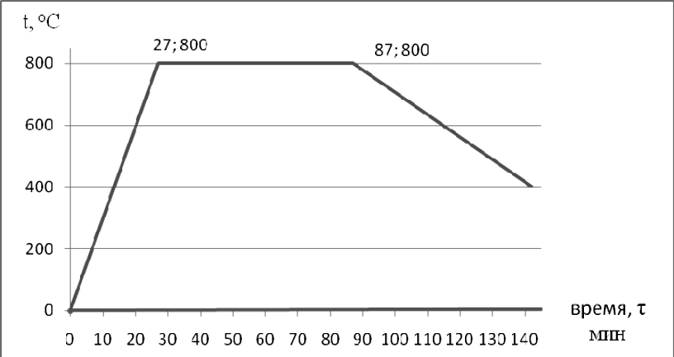
Picture 2 – Heat treatment mode of the investigated steel during normalization
Texttexttexttext, the circuit is shown in Picture 1 or as indicated in Table 1, or texttexttexttext (Picture 2).

(white-space)
THE LIST OF SOURCES
Use the examples of bibliographic descriptions posted on this site (see Requirements)
(white-space)
1 Ильяшенко С.Н. Маркетинг в примерах и задачах : учеб. пос. / С.Н. Ильяшенко. – Сумы: СумГУ, 2006. – 108с.
2 Прокопенко О.В. Роль рейтинга в образовательном процессе вуза / О.В. Прокопенко, А.М. Карминский, А.В. Клименко // Маркетинг и менеджмент инноваций. – 2011. – Т. 2, № 4. – С.141-146.
3 Ильяшенко С.Н. Маркетинг в примерах и задачах : учеб. пос. [Электронный ресурс] / С.Н. Ильяшенко. – Сумы: СумГУ, 2006. –108 с. – Режим доступа: ftp://lib.sumdu.edu.ua/rio/2006/k425253.doc.
4 Инновационный патент № 21807 РК: MПК⁸G01N 3/18. Способ термомеханических испытаний материалов и устройство для его осуществления / Приходько Е.В., Никифоров А.С., Шанов И.В. – заявка № 2008/0820.1; заявл. 10.07.2008; опубл. - 15.10.2009, Бюл. № 10. – 4 с: ил.
5 Johnson M. Basic marketing// Espacios: Venezuela. – 2020. - Vol. 40 (Issue 42), № 7(4). - P. 30-38.
(white-space)
REFERENCES
Use the transliteration samples provided on this site (see Requirements)
(white-space)
1 Iliashenko, S.N. (2006). Marketinh v primerakh i zadachakh [Marketing in examples and problems].Sumy: SumSU [in Russian].
2 Prokopenko, O.V., Karminskii, A.M., & Klimenko, A.V. (2011). Rol reitinha v obrazovatelnom protsesse vuza [Rating role in educational process of higher education institution]. Marketinh i menedzhment innovatsii. – Marketing and Management of Innovations, 2, 4, 141-146[in Russian].
3 Iliashenko, S.N. (2006). Marketinh v primerakh i zadachakh [Marketing in examples and tasks]. Sumy: SumSU. lib.sumdu.edu.ua. Retrieved from ftp://lib.sumdu.edu.ua/rio/2006/k425253.doc [in Russian].
- Innovacionnyj patent № 21807 RK: MPK⁸ G01N 3/18. Sposob termomekhanicheskih ispytanij materialov i ustrojstvo dlya ego osushchestvleniya / Prihod’ko E.V., Nikiforov A.S., Shanov I.V. - № 2008/0820.1; zayavl. 10.07.2008; opubl. 15.10.2009, Byul. № 10. – 4 s: il.
- Johnson, M. (2020). Basic marketing// Espacios: Venezuela. - Vol. 40 (Issue 42), № 7(4). - P. 30-38.
(white-space)
A.A.Akhmetova¹*, D.A. Ivanov²
¹Working place name, Country
²Working place name, Country
(white-space)
Title of the article in Kazakh
Мәтінмәтін мәтінмәтін мәтінмәтін мәтінмәтін мәтінмәтін мәтінмәтін мәтінмәтін мәтінмәтін мәтінмәтін.
Түйінсөздер: сөз, сөз, сөз, сөз тіркесі.
A. Akhmetov^{1*}, D. Ivanov²
¹Working place name, Country
²Working place name, Country
(white-space)
Title of the article in English
Texttexttexttexttexttexttexttexttexttexttexttexttexttexttexttexttexttexttexttexttexttexttexttexttext text texttext .
Keywords: word, word, word, word, word combination.
(white-space)

Information about authors:
Ахметов А.A.– PhD, доценті Инновациялық Еуразия университеті, Павлодар қ., Қазақстан Республикасы. Ахметов А.А.– PhD, доцент Инновационного Евразийского университета, г. Павлодар, Республика Казахстан. Akhmetov, А. - PhD, Associate Professor of Innovative University of Eurasia, Pavlodar c., Republic of Kazakhstan. E-mail: akhmetov_77@mail.ru.
Иванов Д.А. – педагогика ғылымдарының докторы, Новосібір мемлекеттік университетінің профессоры, Новосібір қ., Ресей. Иванов Д.А. - доктор педагогических наук профессор Новосибирского государственного университета, г. Новосибирск, Россия. Ivanov, D. - doctor of pedagogical Sciences, Professor, Novosibirsk State University, Novosibirsk с., Russia. E-mail: IvDA@mail.ru
(white-space)
Date of receipt of the manuscript to the editor: indicated by the executive secretary of the journal.

Pages in the article are not numbered.

